**FPT ACADEMY INTERNATIONAL**



## FPT – APTECH COMPUTER EDUCATION

**Cosy Air-conditioners**

|  |  |  |  |
| --- | --- | --- | --- |
| **Center Name** | | FPT – Aptech – HCM2  Address: 590 Cach Mang Thang Tam, District 3, Ho Chi Minh City | |
| **Instructor** |  | Ms. Le Mong Thuy |  |
| **Class** |  | T1.2303.M0 |  |
| **Group** |  | 5 |  |
| **Group members** | | **Name** | **Student ID** |
|  |  | Nguyen Ho Anh Ngoc | Student1459121 |
|  |  | Nguyen Anh Khoa | Student1459131 |
|  |  | Trinh Duy Anh | Student1462835 |
| **Duration** | Start date | 19th June 2023 |  |
| End date | 26th July 2023 |  |

**This is to certify that**

**Mr.:**

Nguyen Anh Khoa

Nguyen Ho Anh Ngoc

Trinh Duy Anh

**has successfully designed & developed**

eProject: Cosy Air-conditioners website

**Submitted by:**

Nguyen Anh Khoa

**Date of issue:**

**Authorized Signature:**

**TABLE OF CONTENTS**

****FPT – APTECH COMPUTER EDUCATION 1****

****TABLE OF CONTENTS**** ****2****

****ACKNOWLEGMENT**** ****3****

****SYNOSIS**** ****3****

****PROBLEM DEFINITION**** ****3****

****CUSTOMER'S REQUIREMENTS SPECIFICATIONS (CRS) 4****

****Business/Project Objective**** ****4****

****Hardware/ Software Requirements**** ****5****

****SCOPE OF THE WORK (IN BRIEF) 6****

****Architecture and design of the system 7****

****Diagram of the website 8****

****TASK SHEET REVIEW 1 9****

****SITE MAP 10****

****MOCK OF THE WEBSITE 1********1****

***1. Homepage 1******1***

***2. Product 1******2***

***3. Blog 1******3***

***4. About Us 1******4***

***5. Contact US 1******5***

***6. Service 1******6***

***7. Sign In/ Sign Up 1******7***

****TASK SHEET REVIEW 2 18****

WEBSITE DESCRIPTION ****1********9****

RESPONSIVE****28****

[****JAVASCRIPT DESCRIPTION****](#Javascript) ****30****

****TASK SHEET REVIEW 3**** ****47****

# ACKNOWLEGMENT

On behalf of team members. I would like to thank everyone who supported my team to successfully complete this eProject report. Especially, our teacher, she has supported us a lot since we started studying at FPT Aptech. With this eProject, she guided us very meticulously, enthusiastically and strictly. With her guidance, we were able to successfully complete this project. Besides, I also want to thank all the team members, each of whom worked hard to complete the eProject in earnest during the month of working together. Finally, our group would like to say thank you to my classmates and family for sharing and creating for the group the best environment to focus on the project, motivating the members to achieve their goals.

# SYNOSIS

COSY AIRCONDITIONERS is selling various types of AIR-CONDITIONERS. The company advertises by distributing the pamphlets, advertising on television and so on. Due to rapid development in internet field, the company decides to launch a website where people will get all the information about the various products available with them easily.

You are supposed to create a website for them with the below mentioned requirement specifications.

The website is to be developed for the Windows Platform using HTML5, JavaScript and Geolocation. The site should work well in all leading browsers including Chrome, IE, Firefox etc.

# PROBLEM DEFINITION

The Web site is to be created based on the following requirements.

1. The Home Page should be created making use of Sections with a suitable logo.
2. Home Page should contain details of Air Conditioners with suitable images.
3. The site should display a menu which will contain the options for brief introduction about the various air conditioners available, location of the shop and any other information if required.
4. The information should be categorized according to the brand names of the products like if a User wants to see only “WHIRLPOOL” products or any other companies products then he/she can click on a Link/button/menu etc and can see only that Brand products.
5. When a user selects any particular brand, a list of products for that brand will be displayed
6. A brief summary of features of individual products should be displayed on the Web Page along with the product but detailed Features should be stored in Individual Word documents which can be downloaded or viewed by the User who wishes to see the same.
7. The user should also be able to compare the various products of different as well as similar brands.
8. There should be a “Contact Us” page which will have the Address of the Company which is as follows and the mail address which when clicked will invoke the local mail client from where they can send an email. Address of the Company should be displayed using GeoLocation API (eg. GoogleMaps).

# CUSTOMER'S REQUIREMENTS SPECIFICATIONS (CRS)

**Client: Cosy Air-conditioners**

### Business/Project Objective:

The company advertises by distributing the pamphlets, advertising on television and so on. Due to rapid development in internet field, the company decides to launch a website where people will get all the information about the various products available with them easily.

You are supposed to create a website for them with the below mentioned requirement specifications.

The website is to be developed for the Windows Platform using HTML5, JavaScript and Geolocation. The site should work well in all leading browsers including Chrome, IE, Firefox etc.

**Input to the system:**

- Searching products based on types, brands, prices.

- Feedback about the quality of products.

**Output from the system:**

- Perform search based on: brand, product type,

- Display results for each type of product according to the search content.

- Display product information by price, specifications, brand, image, color, model...

- Display the special information of the product.

- Display the comparison of selected products.

- Display products of the same type, same brand, other related products.

- Display a button so that customers can download the product's catalog

- Customers can also download the price list of products on the website

- Site should be able to provide brief introduction/history about the shop under About Us page.

- The location of the shop under Contact-Us page.

- Displays FAQ and allows users to email directly to the company

**Process**:

* + - * Validate data input from users.
      * Filter data

**Expected delivery date:** 26-July-2023.

List of deliverables:

- Document Word, PDF.

- User Guide.

- Source code.

### Hardware/ Software Requirements:

* **For developer**

**Hardware**

* + Intel Pentium 4 processor or higher
  + 01 Gigabytes of RAM or higher

**Software**

* + Windows 7 OS or higher
  + Adobe Dreamweaver
  + Web browsers such as IE, Chrome or Firefox are supporting HTML5, CSS3 and Javascript.
* **For web users**

**Hardware**

* + Intel Pentium 4 processor or higher
  + 512 Megabytes of RAM or higher

**Software**

* + Windows XP OS or higher
  + Web browsers such as IE, Chrome or Firefox are supporting HTML5, CSS3 and Javascript.

# SCOPE OF THE WORK (IN BRIEF)

After a long and detailed discussion, our group has decided to create a website contain the following webpages:

1. ***Homepage***: There is a search bar to search for products, display promotional information, best-selling products and introduce COSY AIRCONDITIONERS
2. ***Product***: Displays all available products based on the brand name category. In the above categories, products can be filtered by capacity and price.
3. ***Blog***: Display articles, news, equipment installation instructions...
4. ***About Us***: Display the information of the company, clients’ review and about us.
5. ***Contact Us***: Display the address of the company, Map and allow customers to request any information they want to COSY AIRCONDITIONERS.
6. ***Service***: Displays user inquiries, product documents, and product price lists for user downloads, freight services, and equipment installation.
7. ***Sign In/ Sign Up***: Allow users sign up or sign in to the website.

# ARCHITECTURE AND DESIGN OF THE SYSTEM

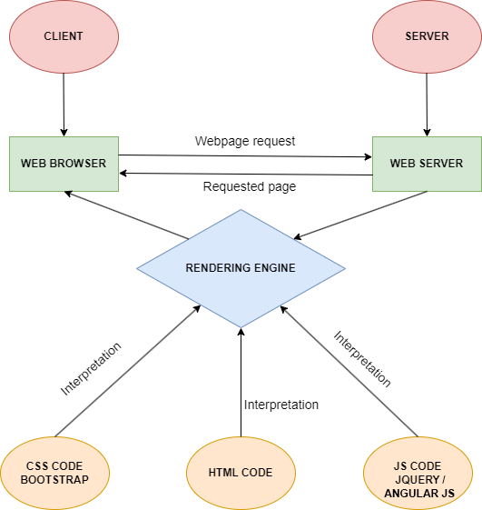

# 

# DIAGRAM OF THE WEBSITE

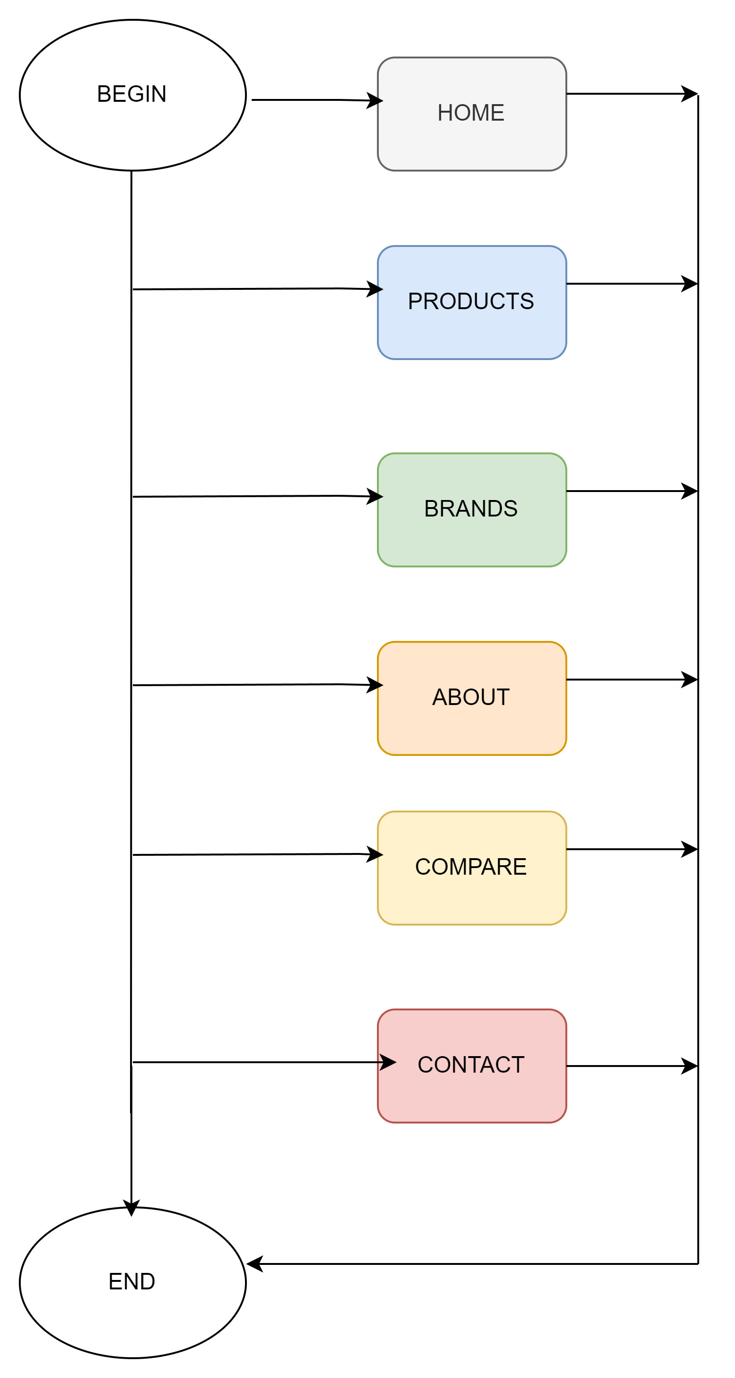



# TASK SHEET REVIEW 1

|  |  |  |  |  |  |  |  |
| --- | --- | --- | --- | --- | --- | --- | --- |
| **Project Ref. No.:**  **eP/Advertisement Portal Management**  **System/01** | | **Project Title:** | **Activity Plan Prepared By:** | **Date of Preparation of Activity Plan:** | | | |
| **Sr.**  **No.** | **Task** | **Actual**  **Start**  **Date** | **Actual Days** | **Team**  **Mate Names** | **Status** |
| 1 | Problem Statement | COSY AIR-CONDITIONERS | Anh Khoa | 19-June-23 | 1 | Anh Khoa | Completed |
| 2 | Analysis of Harvel Electric requirements about the website | 19-June-23 | 1 | Anh Ngoc | Completed |
| 3 | The scope of the work (in brief) | 19-June-23 | 1 | Anh Ngoc | Completed |
| 4 | Architecture and design of the system | 19-June-23 | 1 | Anh Khoa | Completed |
| 5 | Diagram of the website | 19-June-23 | 1 | Duy Anh | Completed |
| 6 | Task Sheet | 19-June-23 | 1 | Anh Khoa | Completed |

|  |  |
| --- | --- |
| **Date:** | |
| Signature of Instructor:  **Ms. Le Mong Thuy** | Signature of Team Leader:  **Nguyen Anh Khoa** |

# SITE MAP

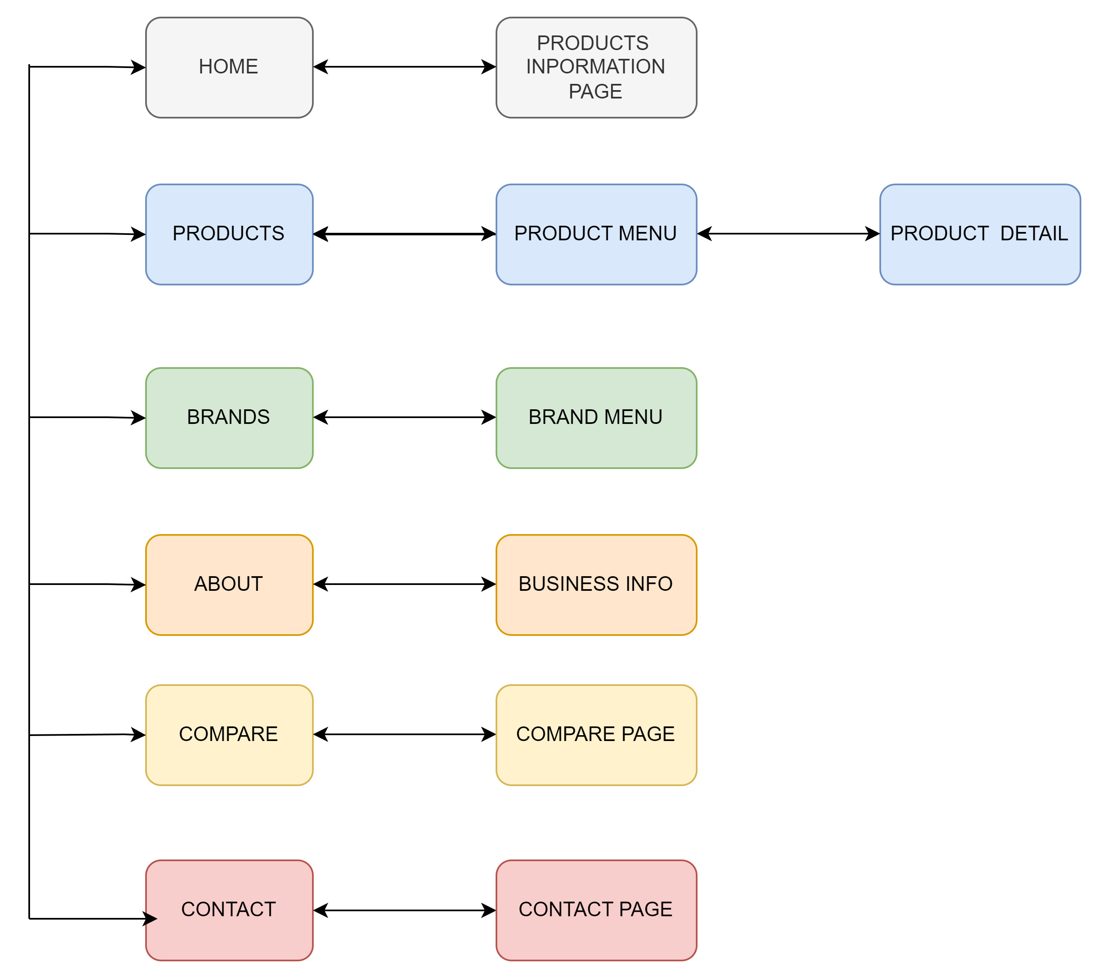

# MOCK OF THE WEB SITE

1. **Homepage**

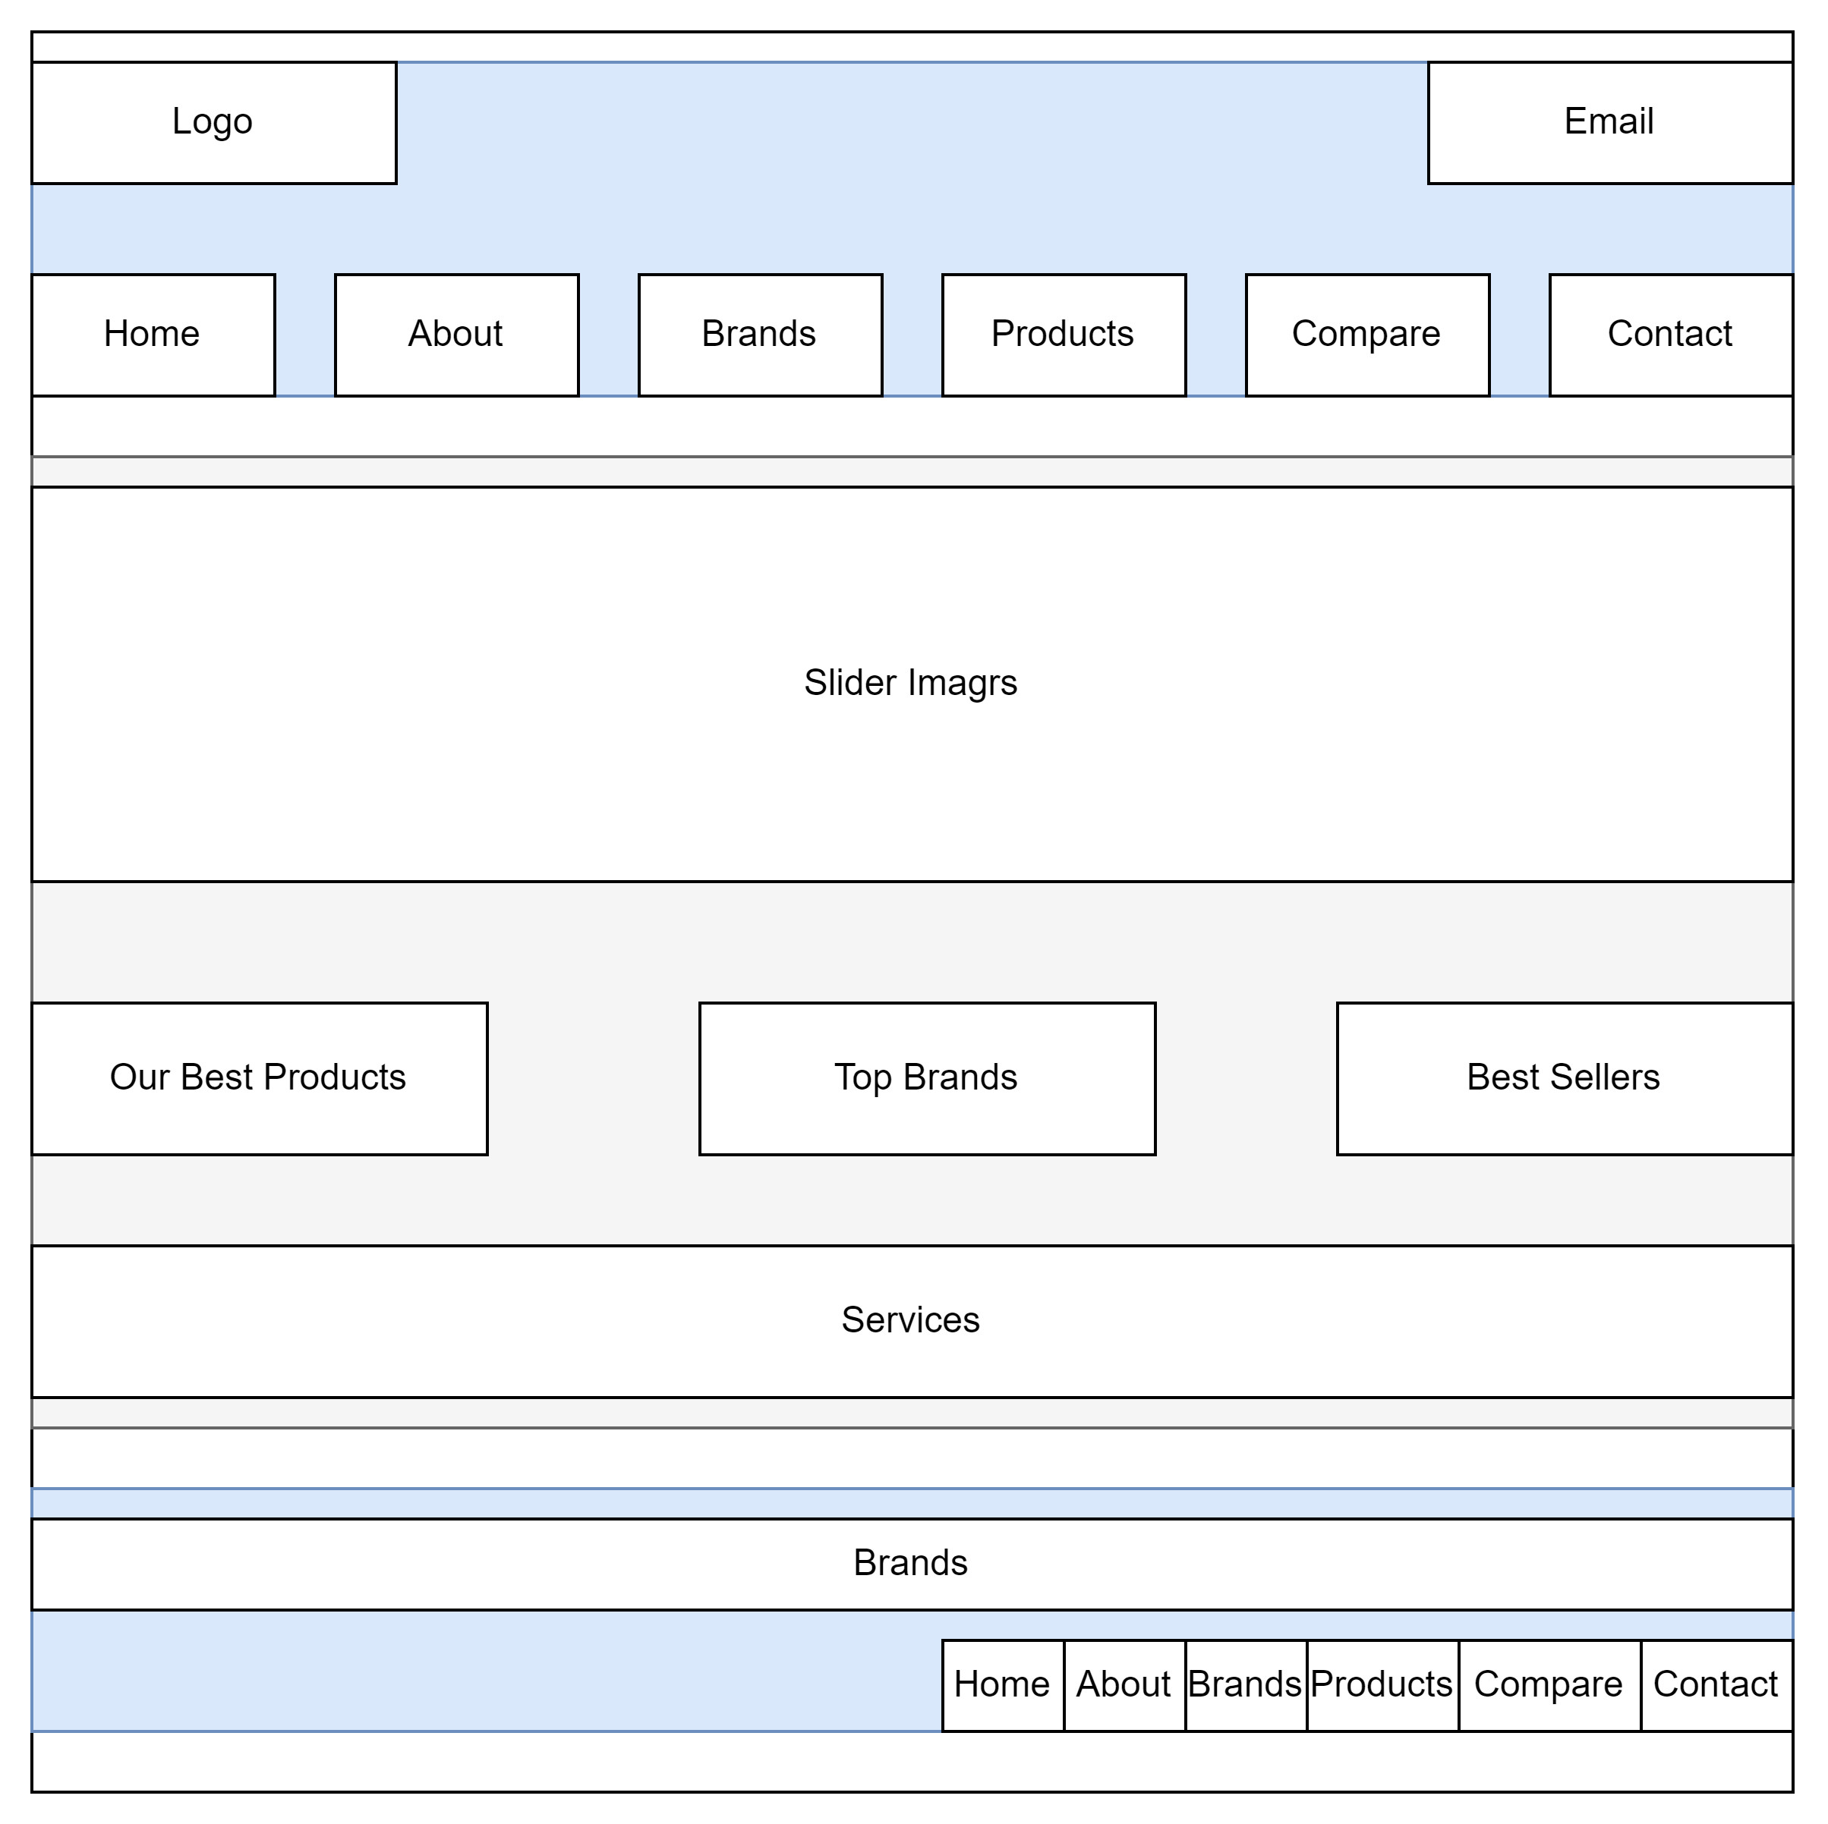

1. **Product**

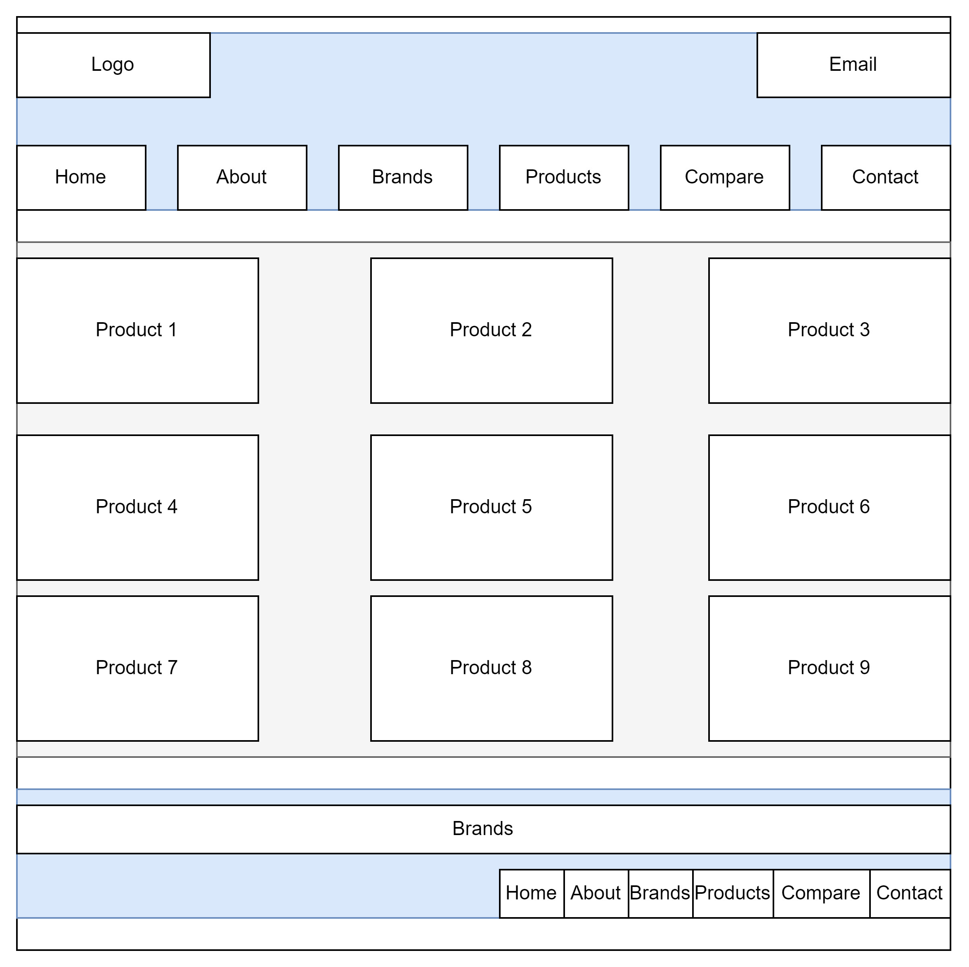

1. **Brands**

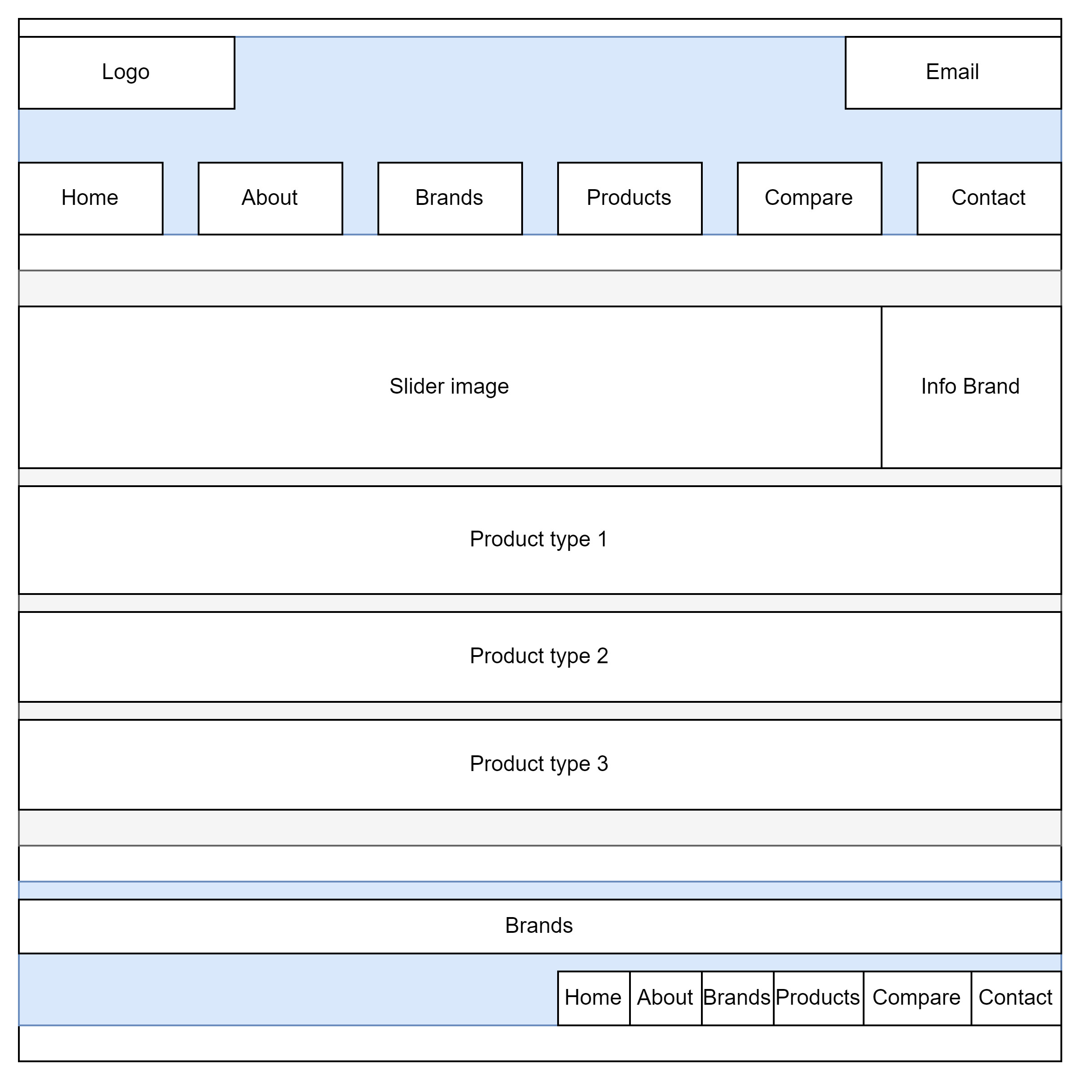

1. **About Us**

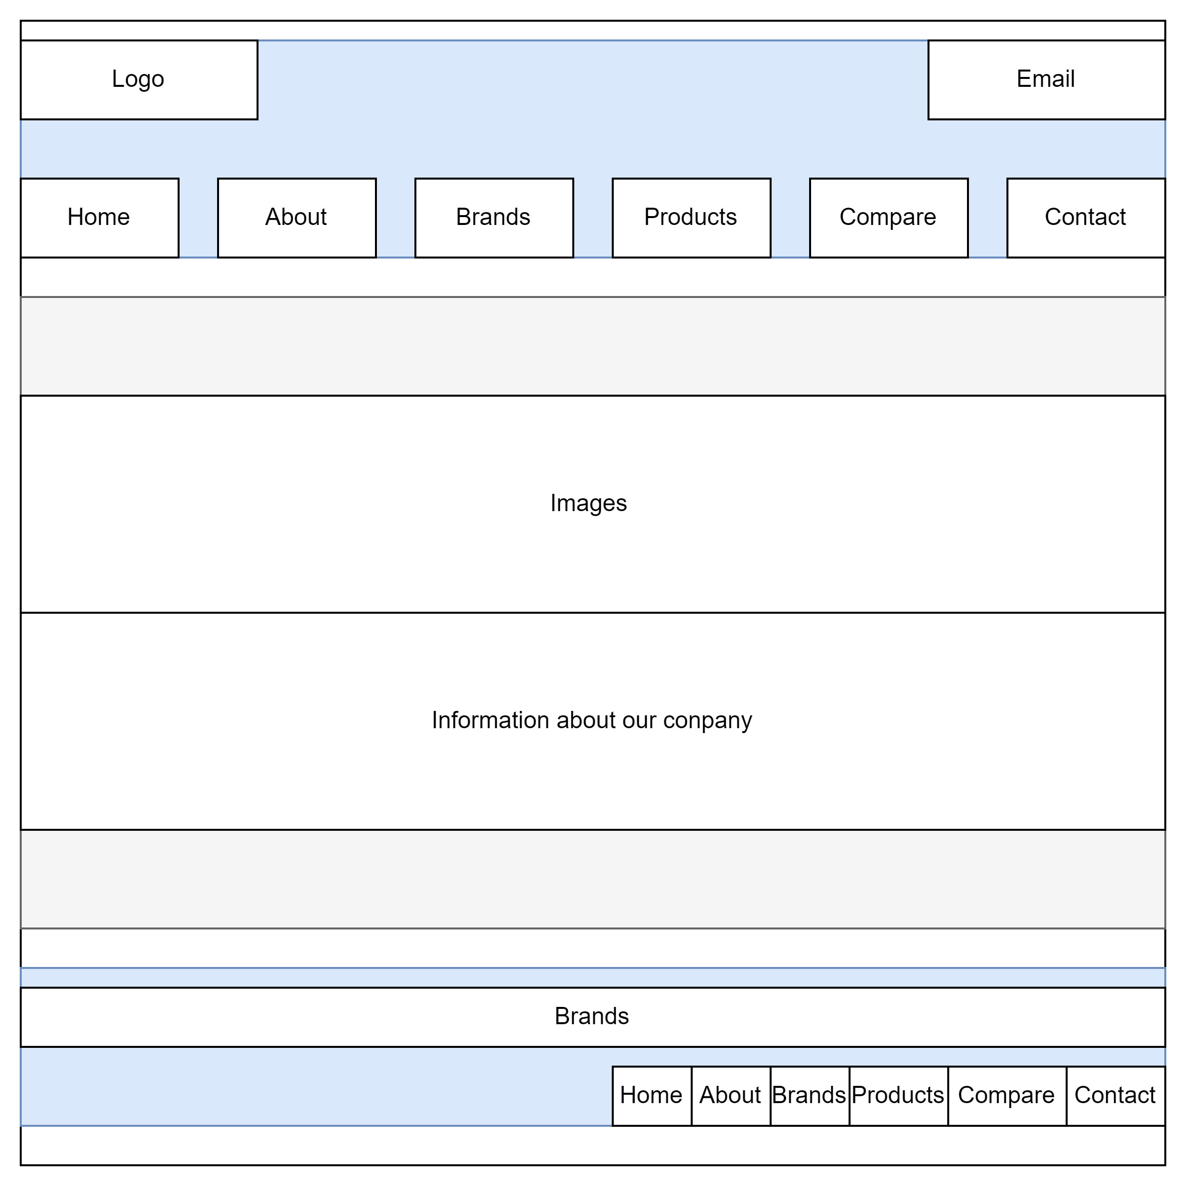

1. **Contact Us**

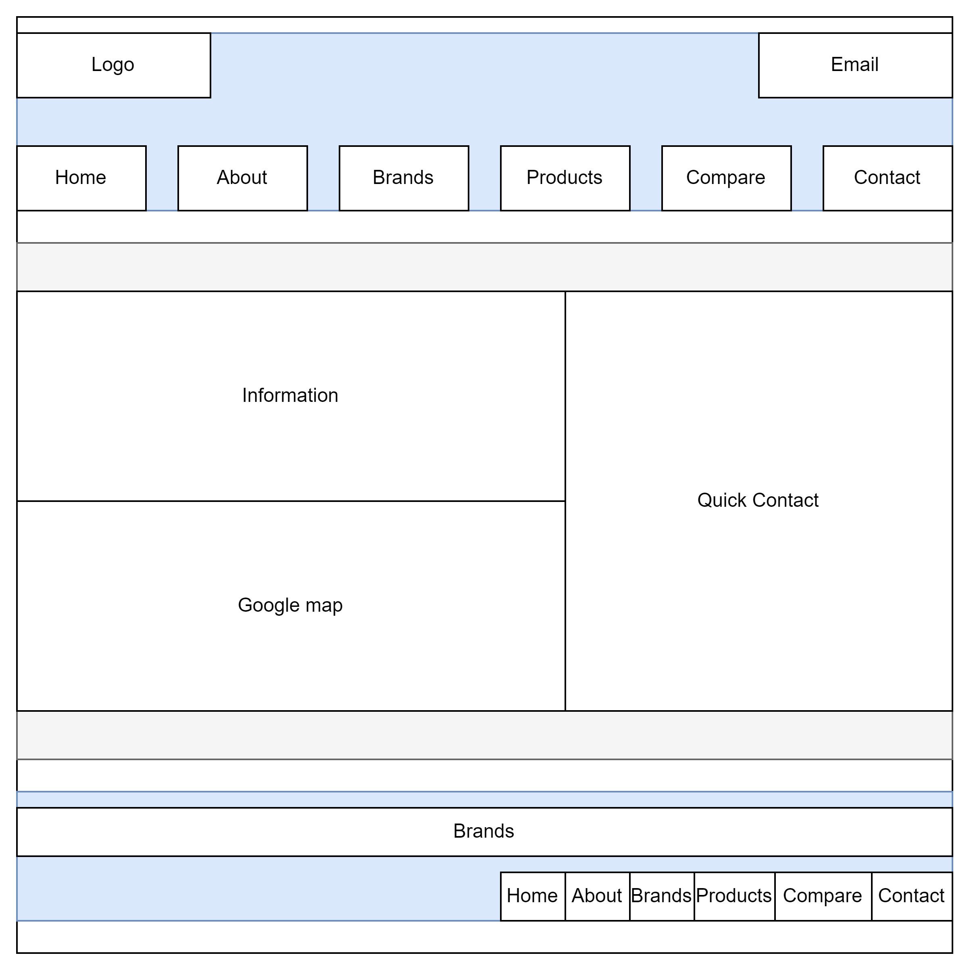

1. **Compare**

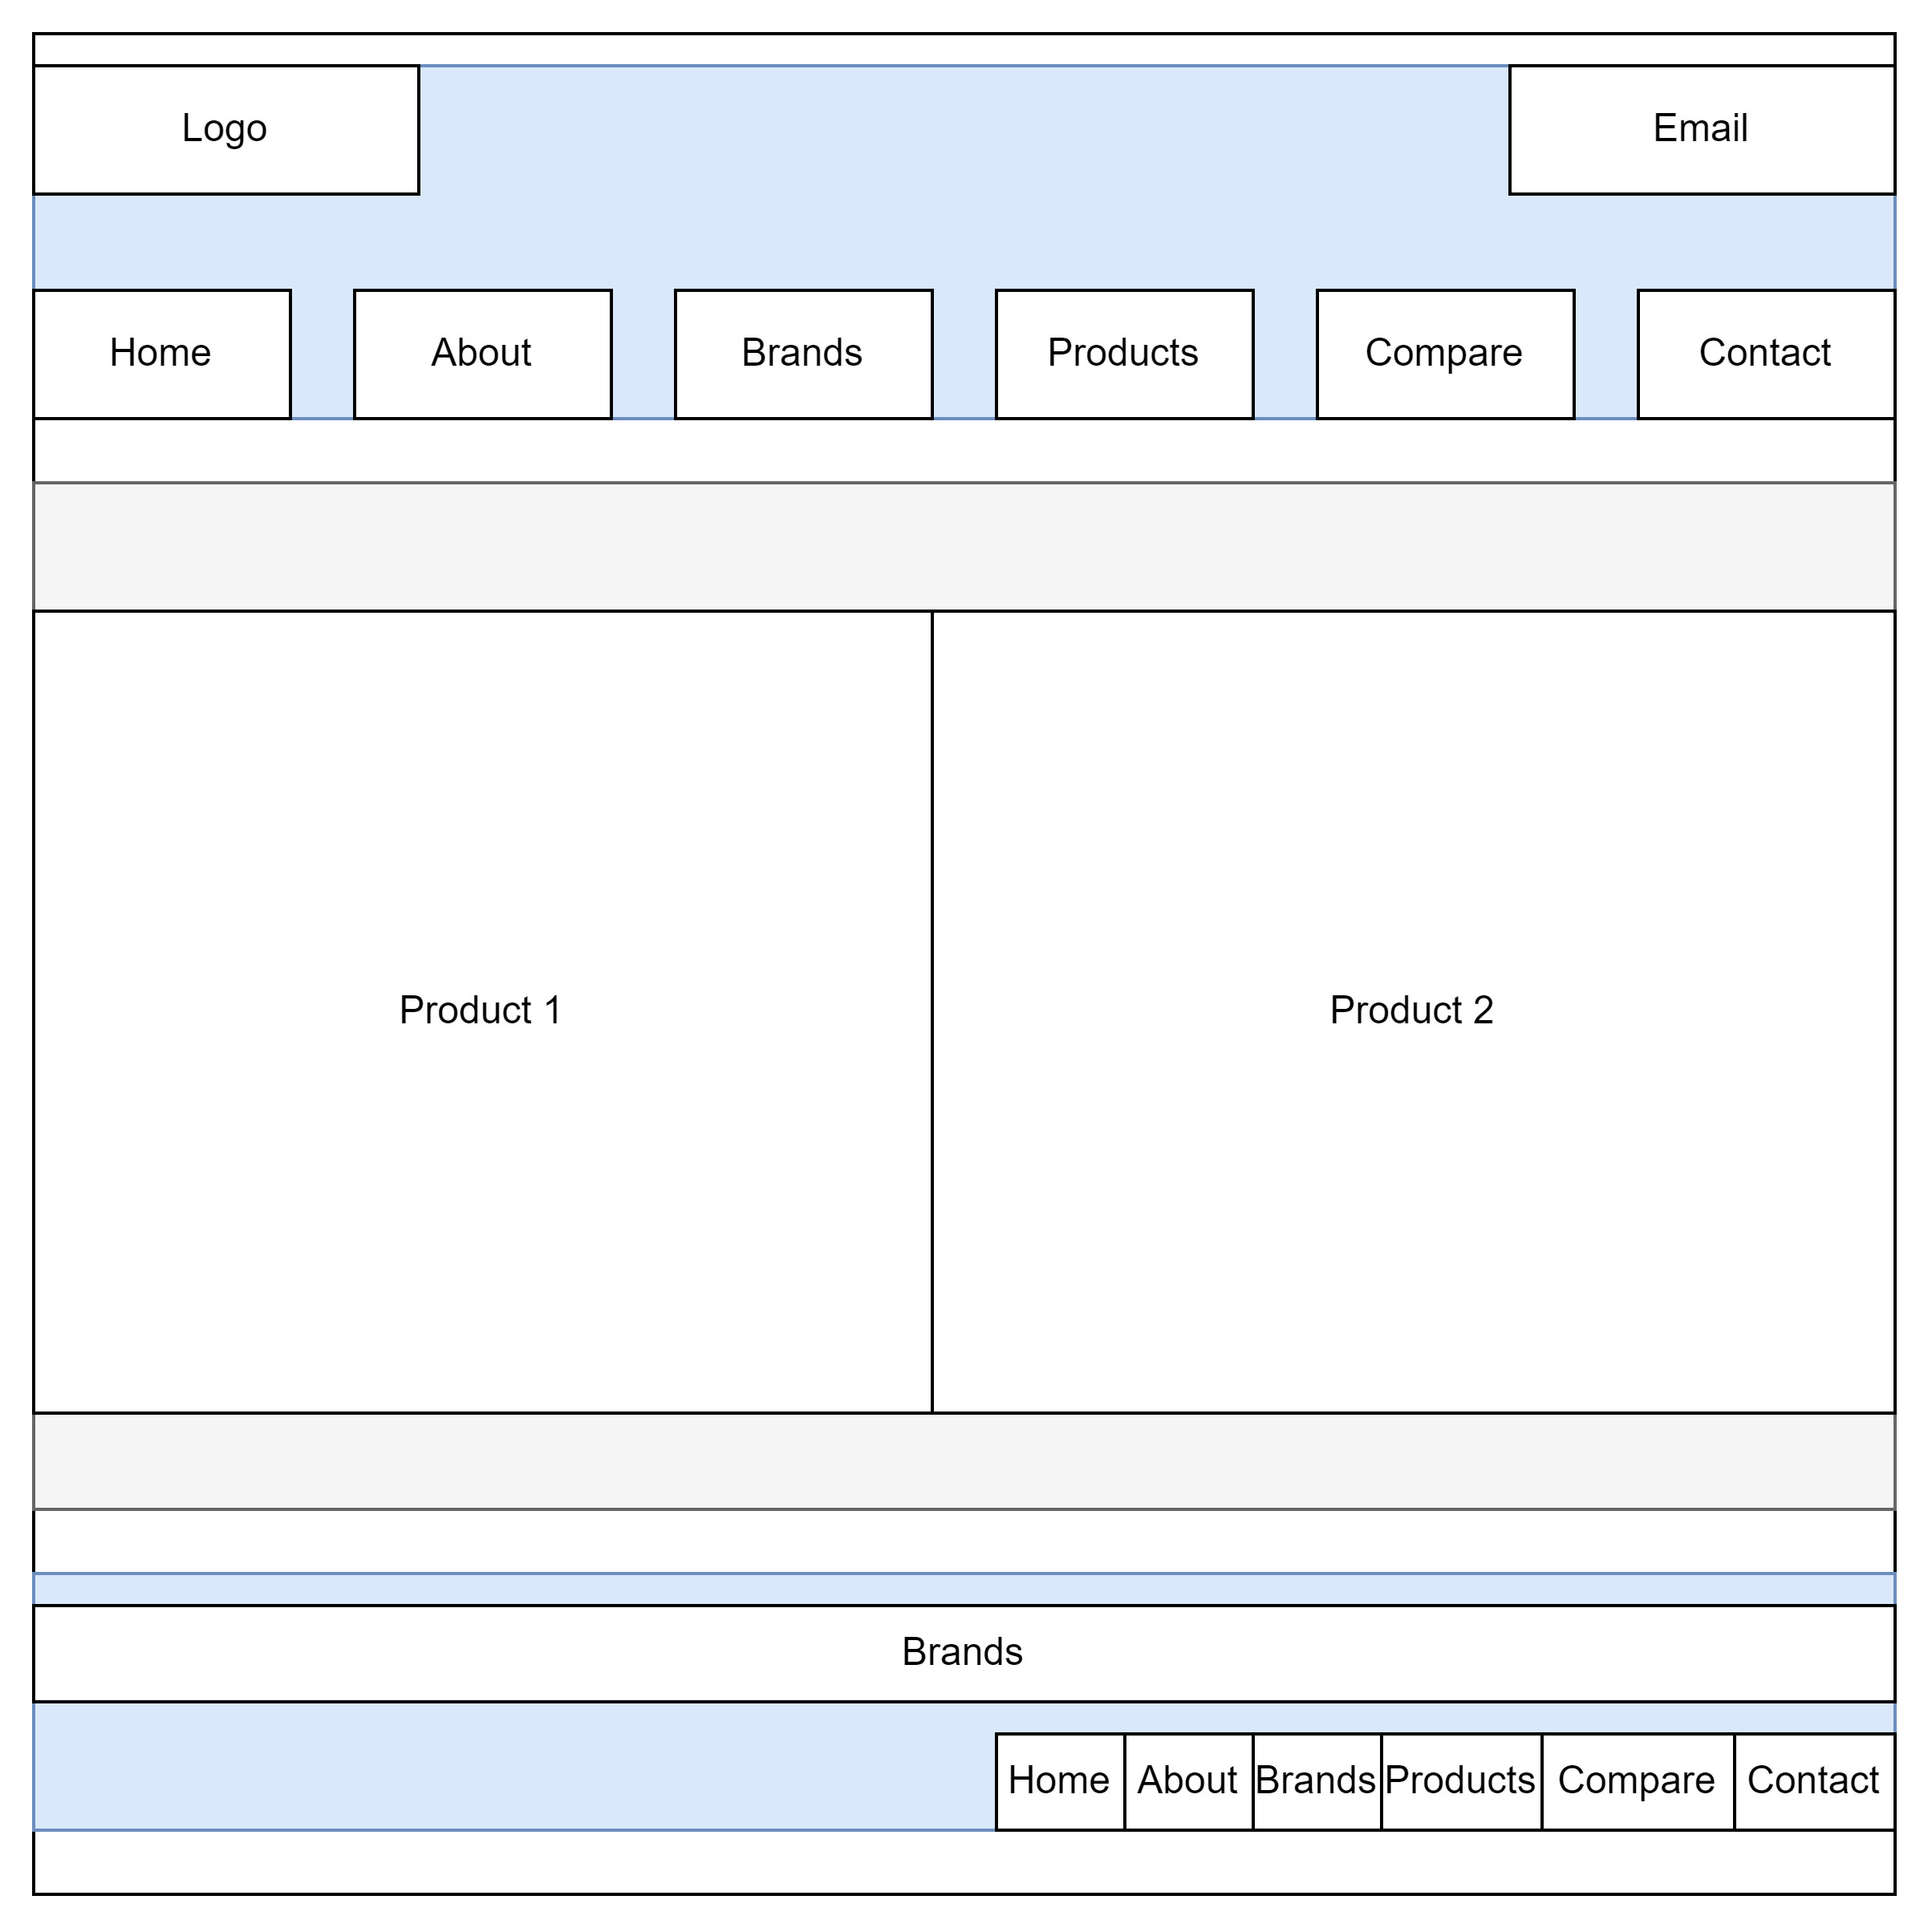

# 

# TASK SHEET REVIEW 2

|  |  |  |  |  |  |  |  |
| --- | --- | --- | --- | --- | --- | --- | --- |
| **Project Ref. No.:**  **eP/Advertisement Portal Management**  **System/01** | | **Project Title:** | **Activity Plan Prepared By:** | **Date of Preparation of Activity Plan:** | | | |
| **Sr.**  **No.** | **Task** | **Actual**  **Start**  **Date** | **Actual Days** | **Team**  **Mate Names** | **Status** |
| 1 | Site Map | COSY AIR-CONDITIONERS | Anh Khoa | 19-June-23 | 1 | Anh Ngoc | Completed |
| 2 | Mock of the website | 19-June-23 | 2 | Anh Ngoc | Completed |
| 3 | Task sheet | 19-June-23 | 2 | Anh Khoa | Completed |

|  |  |
| --- | --- |
| **Date:** | |
| Signature of Instructor:  **Ms. Le Mong Thuy** | Signature of Team Leader:  **Nguyen Anh Khoa** |

# WEBSITE DESCRIPTION

1. **Homepage**
2. Description

Home page displays following information:

- Slide show programs, services and product promotions

- Feature product.

- Popular Brand.

- Some information about the website.

1. Screen shot

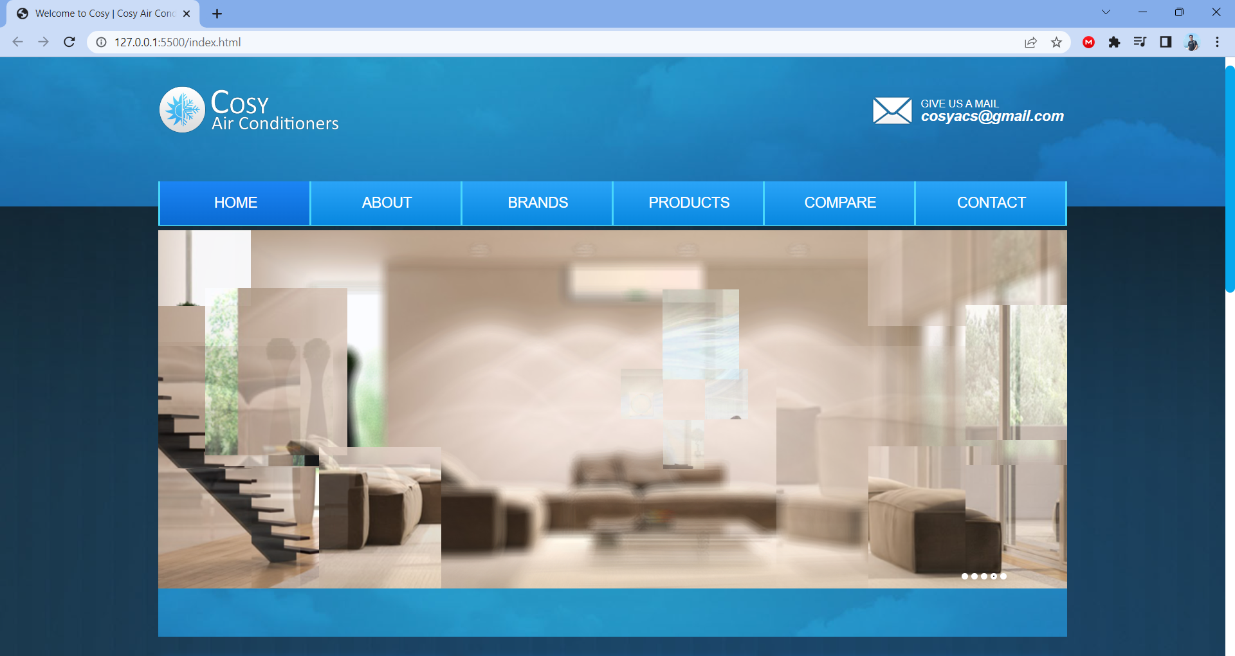

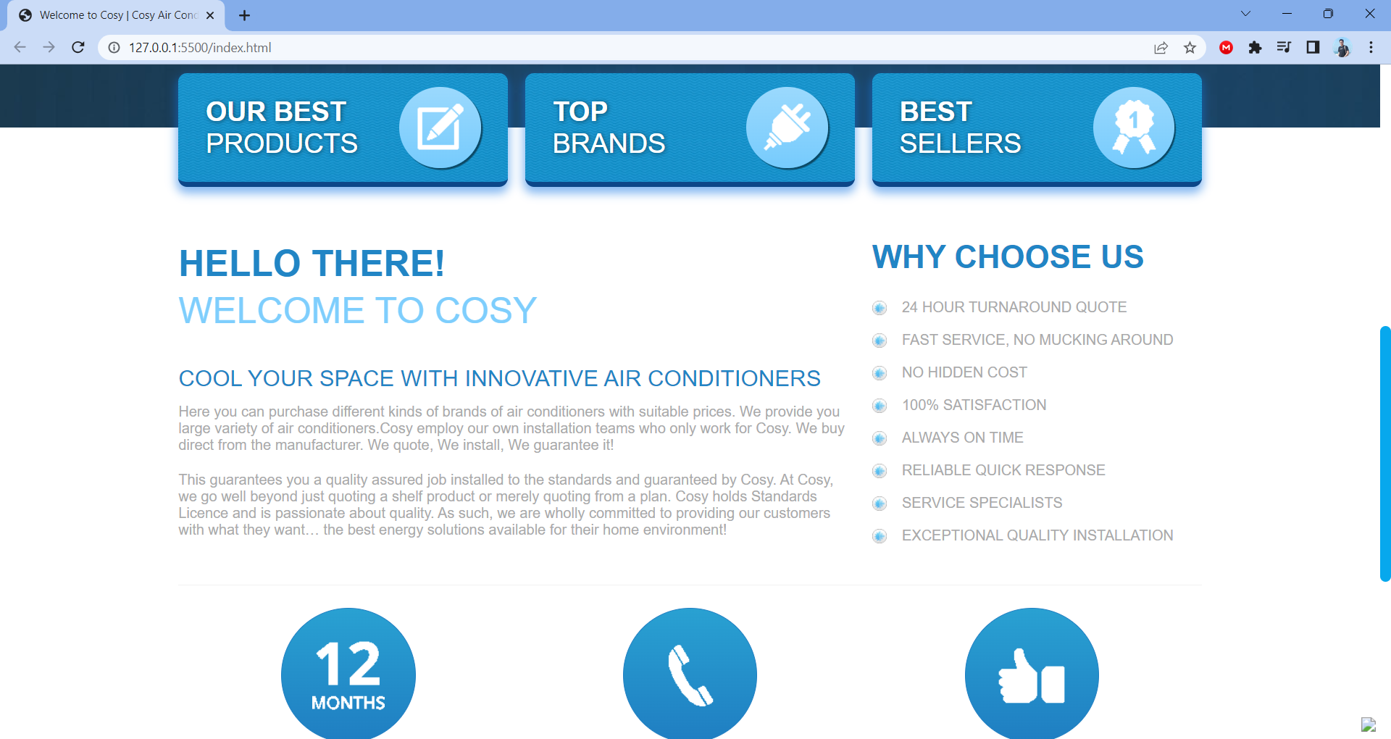

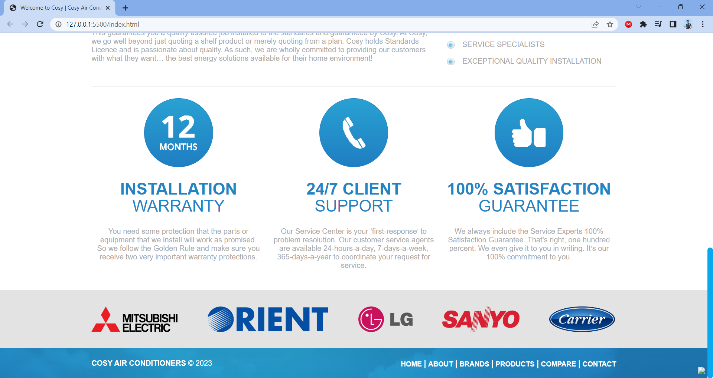

1. **Product**
2. Description

This product page displays following information:

- All product that being sold at Cosy Airconditioners, when clicking on quick-view item, it will show the detail of that item.

- Products can be compared with products of the same category

- Menu filter to easily find items based on categories.

- Product can sort by price and by name.

1. Screen shot
2. **Compare**
3. Description

The compare page displays necessary information in order to let customer compare chosen products.

b) Screen shot

1. **About Us**
2. Description

- This page displays information about the history of our company, our service and vision that we aim.

1. Screen shot

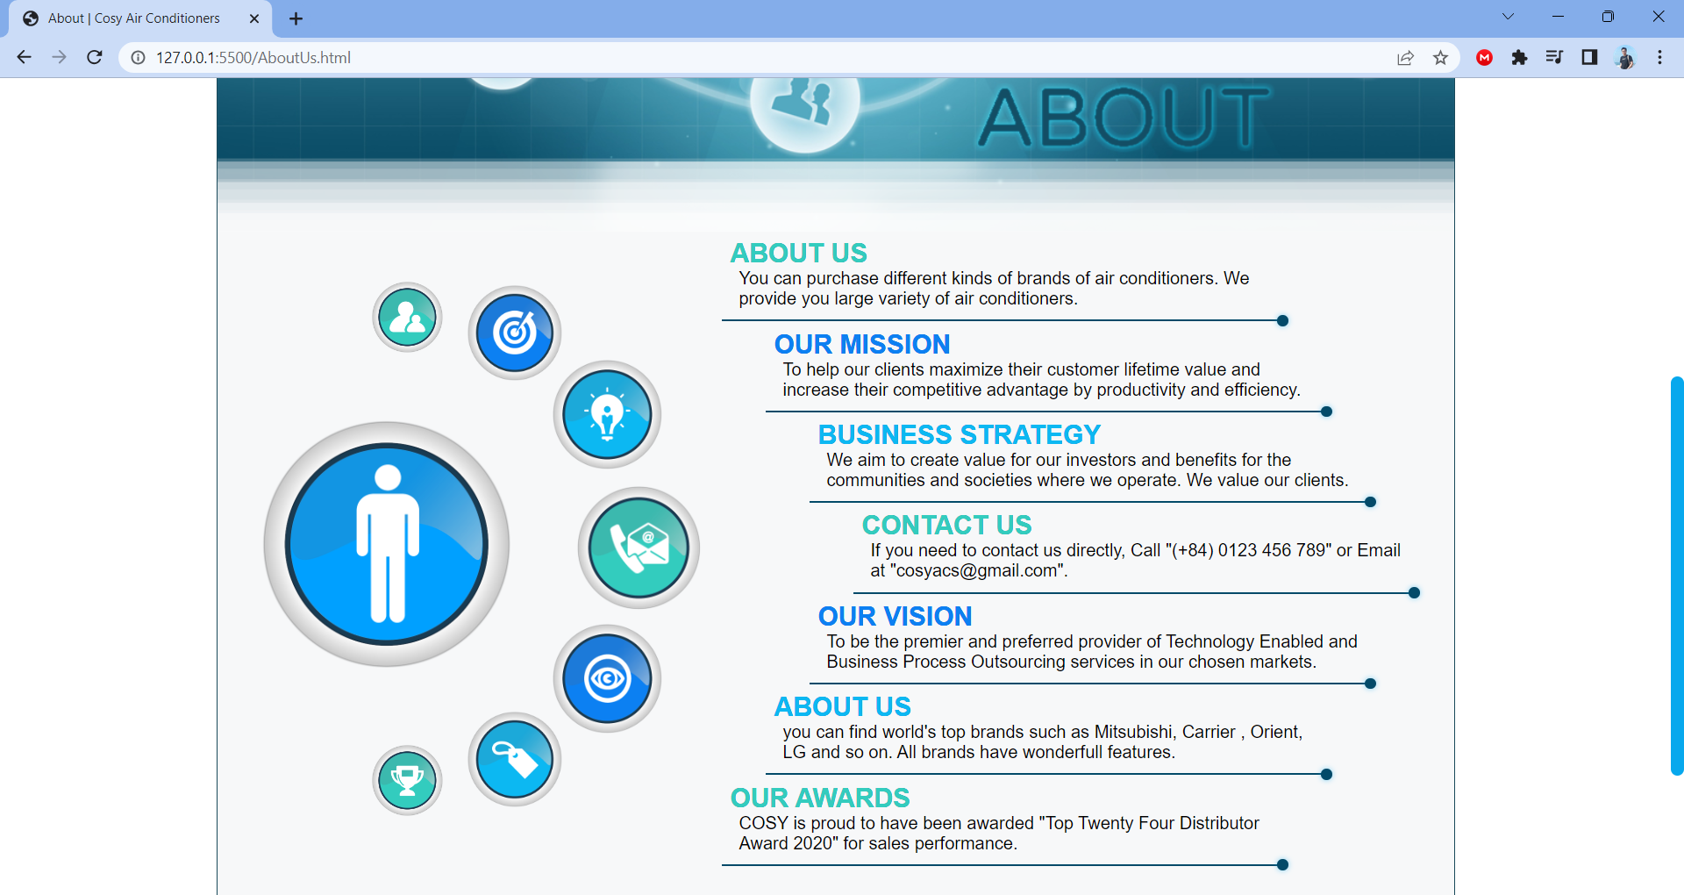

1. **Contact Us**
2. Description

This page displays contact information: location, telephone number, email and a quick contact form for customer

1. Screen shot

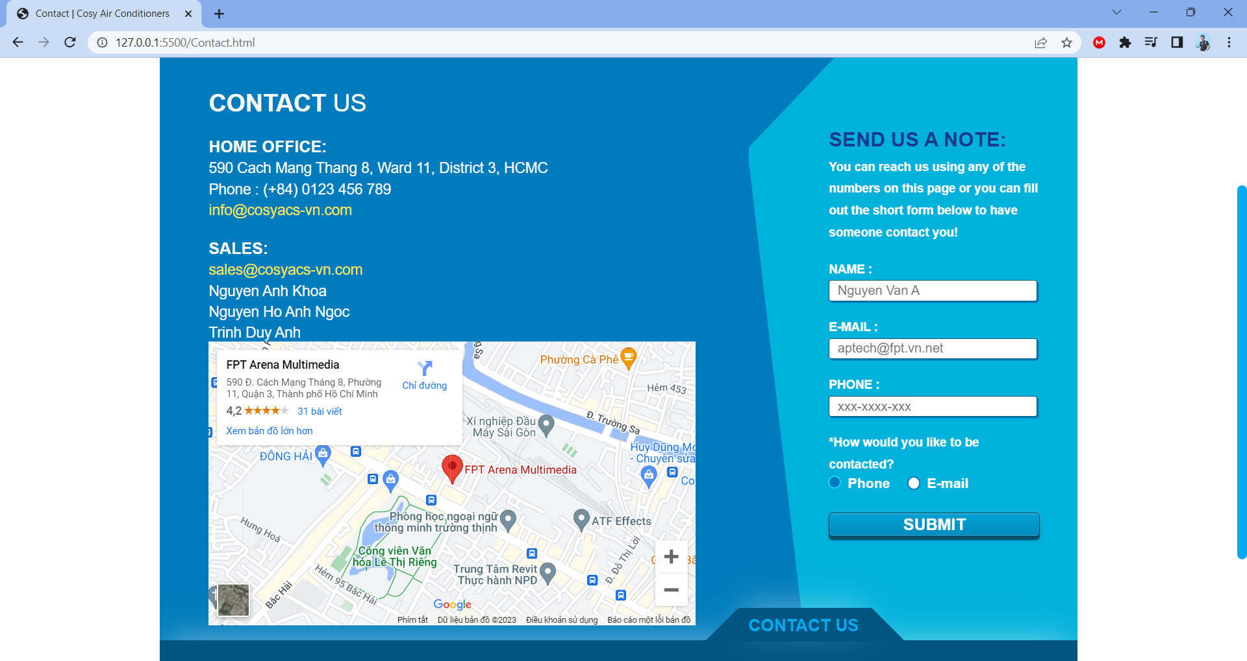

**RESPONSIVE**

The page has responsive feature for small screen device such as smart phone, tablet, etc.

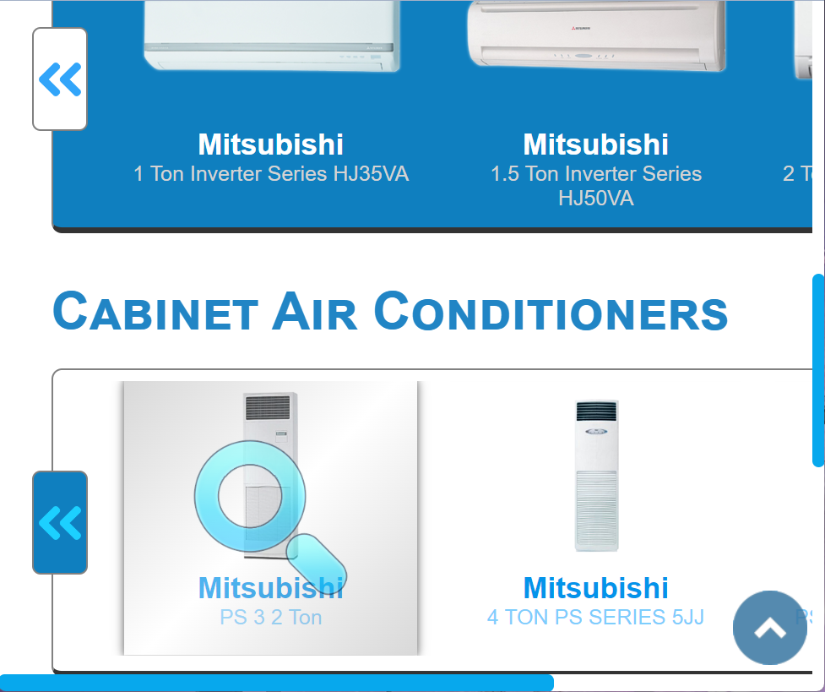

**JAVASCRIPT DESCRIPTION**

1. **Slider Javascript**
2. Description

This script used slick package (carousel) to display the products on the website.

1. Screen shot

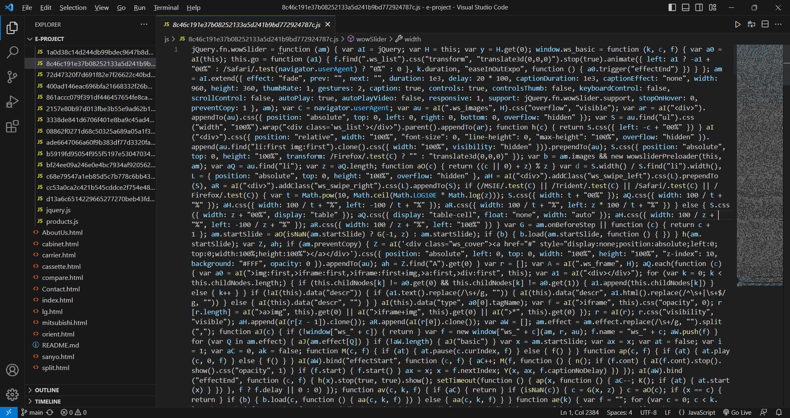

1. **Compare Javascript**
2. Description

This script is used to compare products of the same category

1. Screenshots

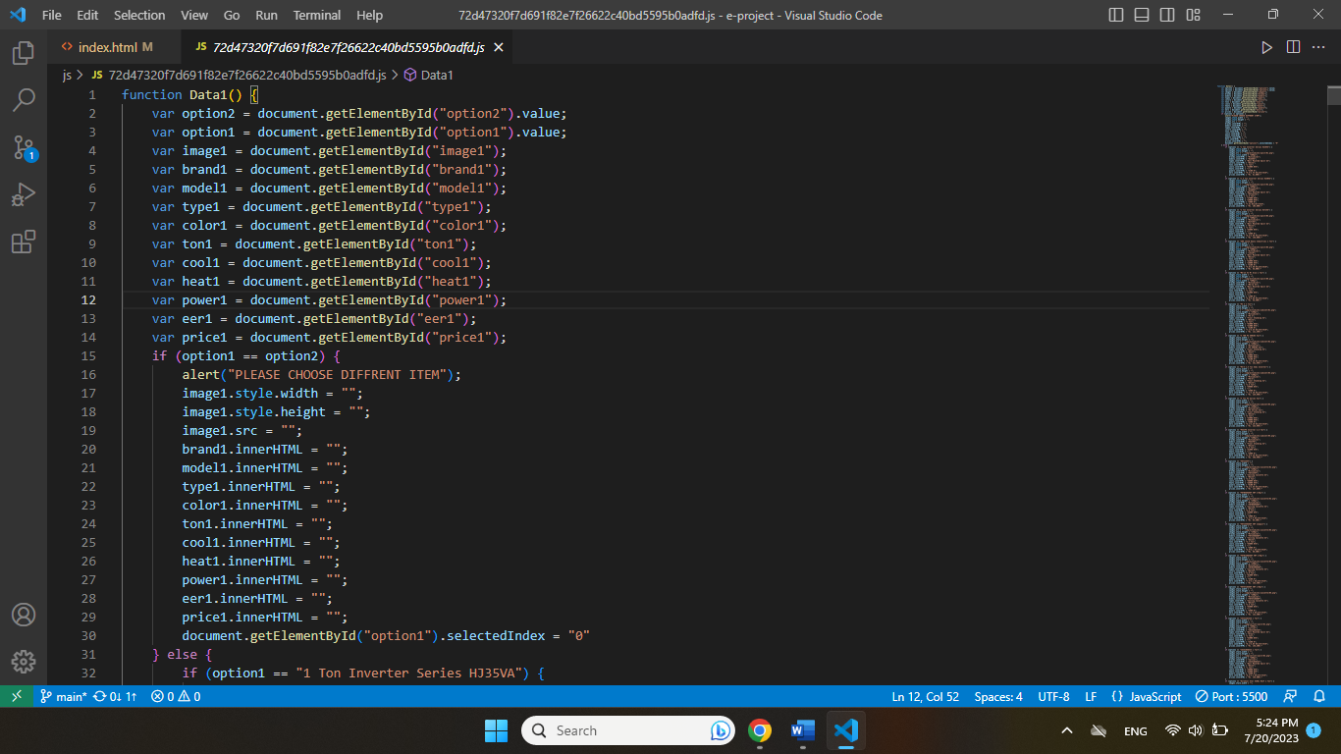

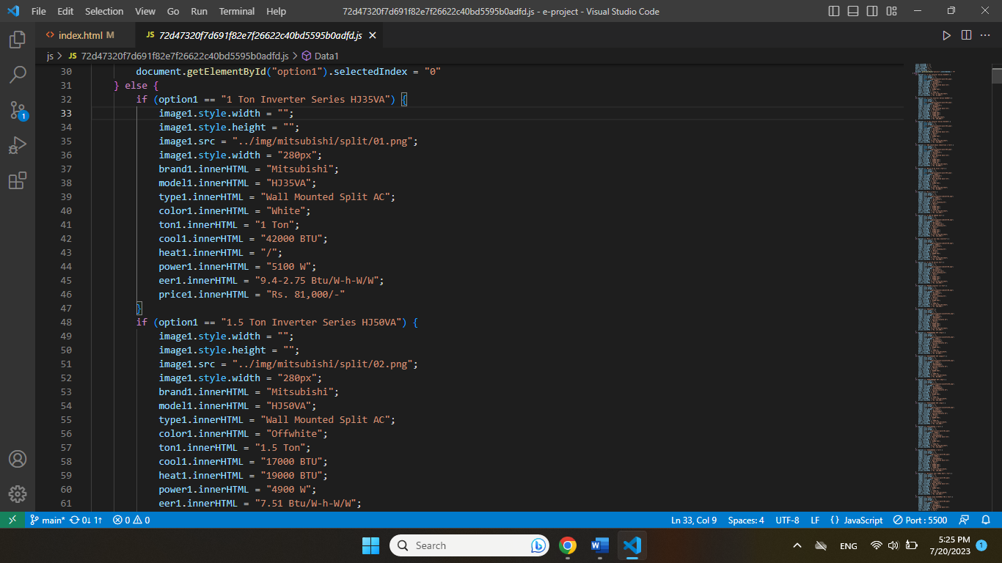

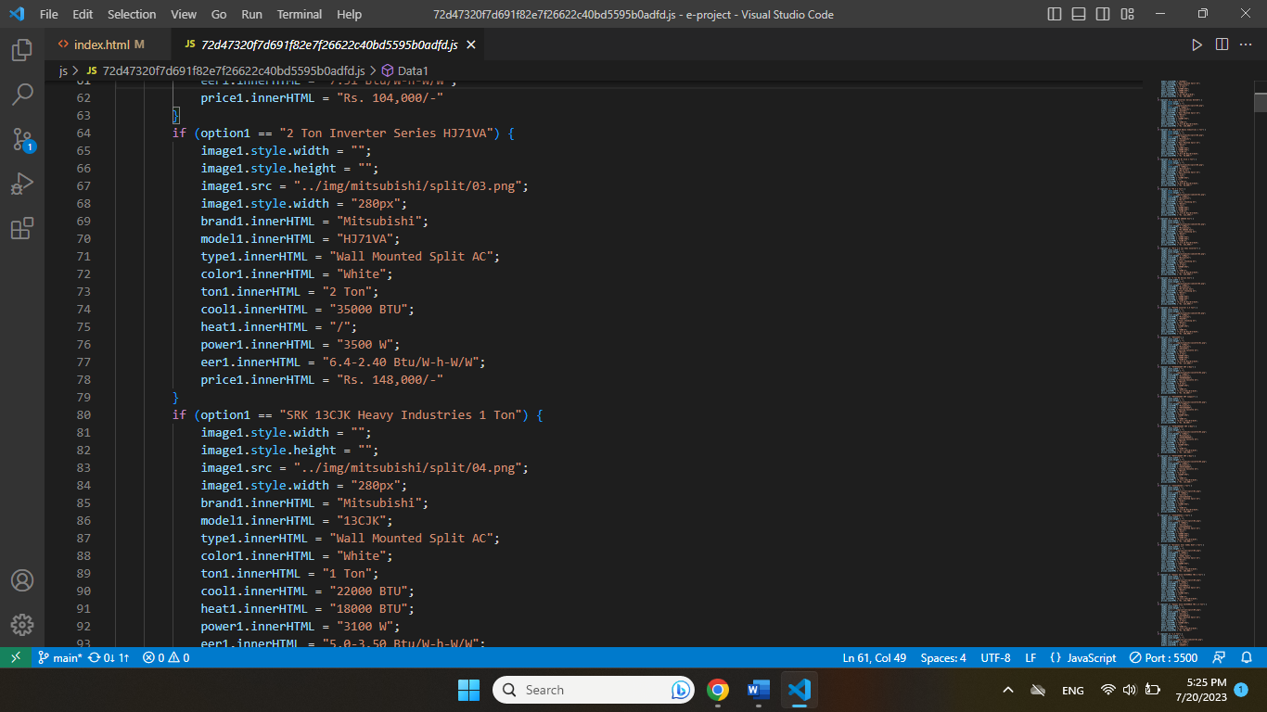 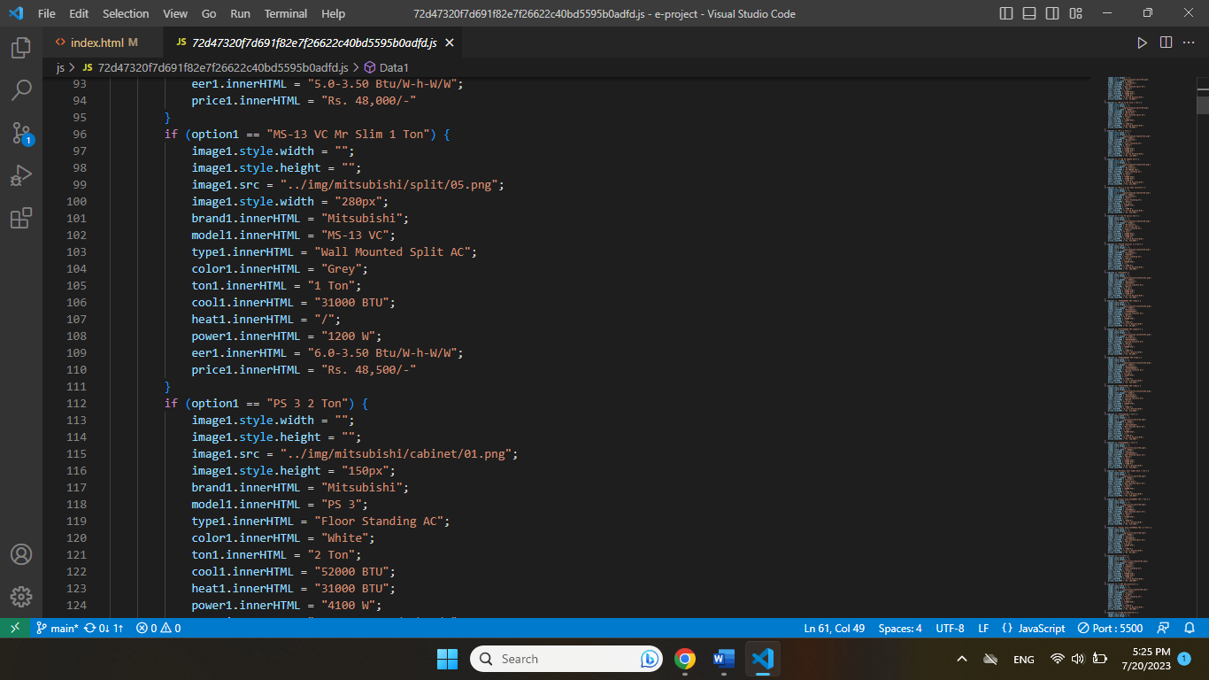 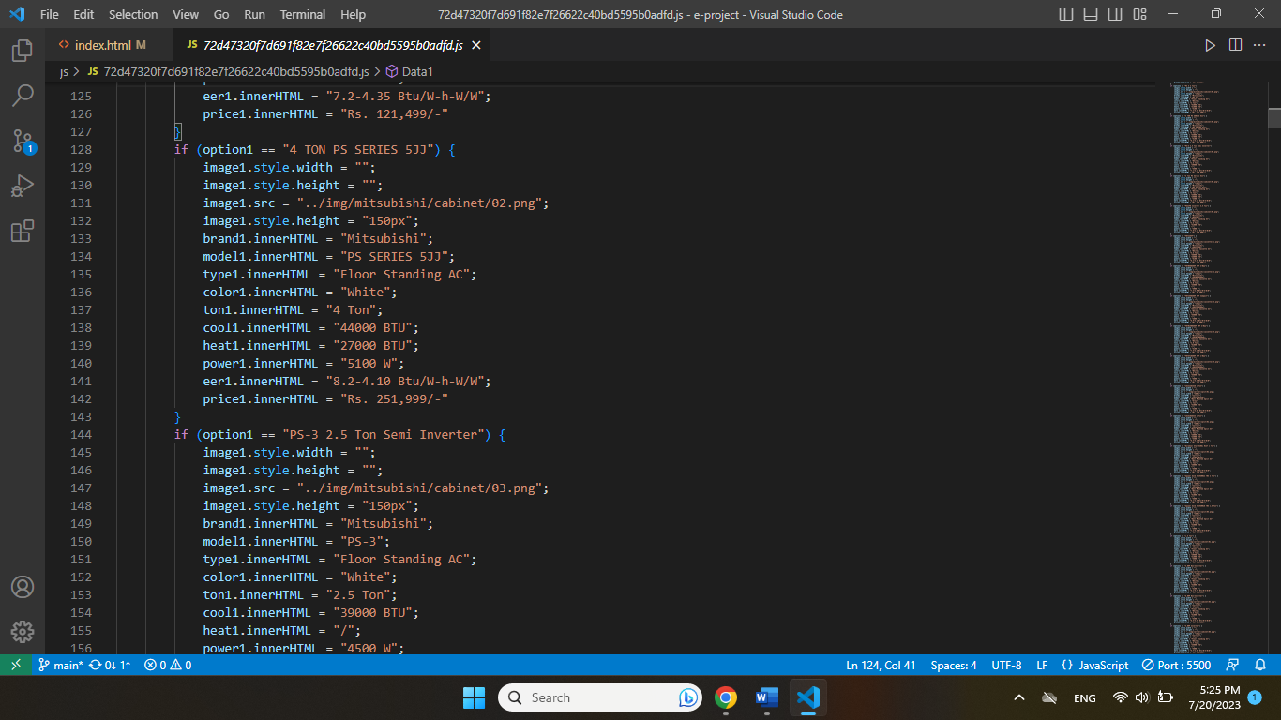 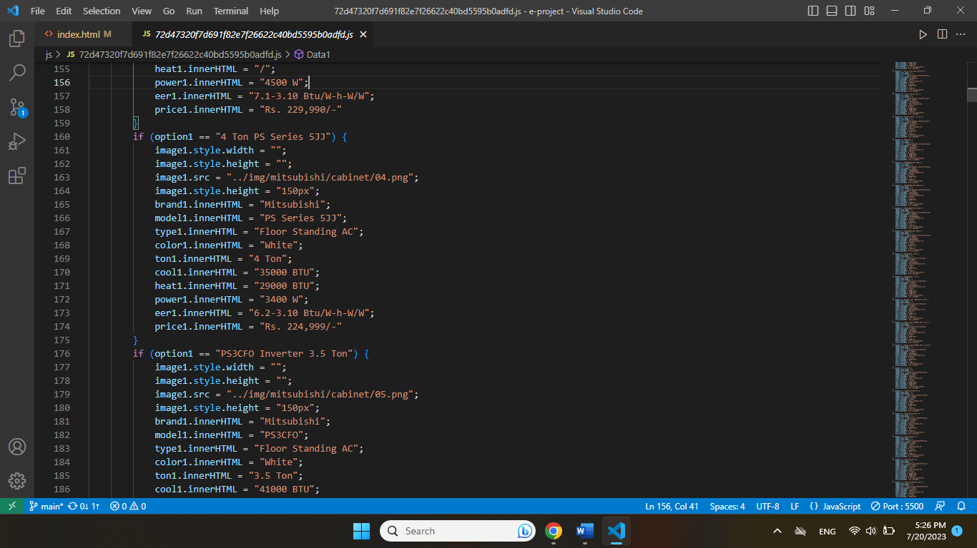 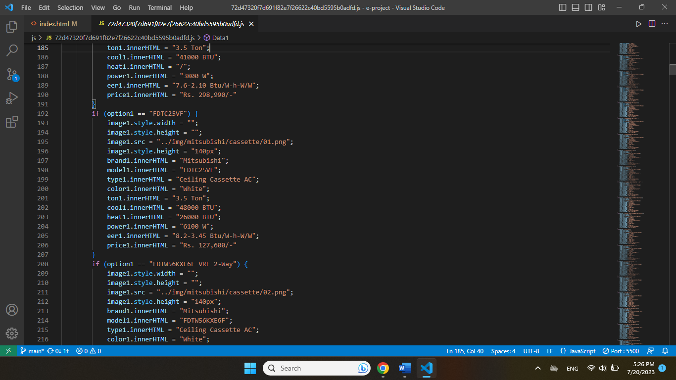 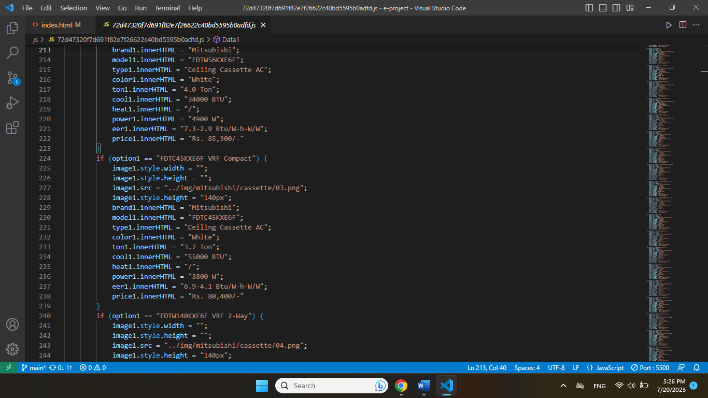 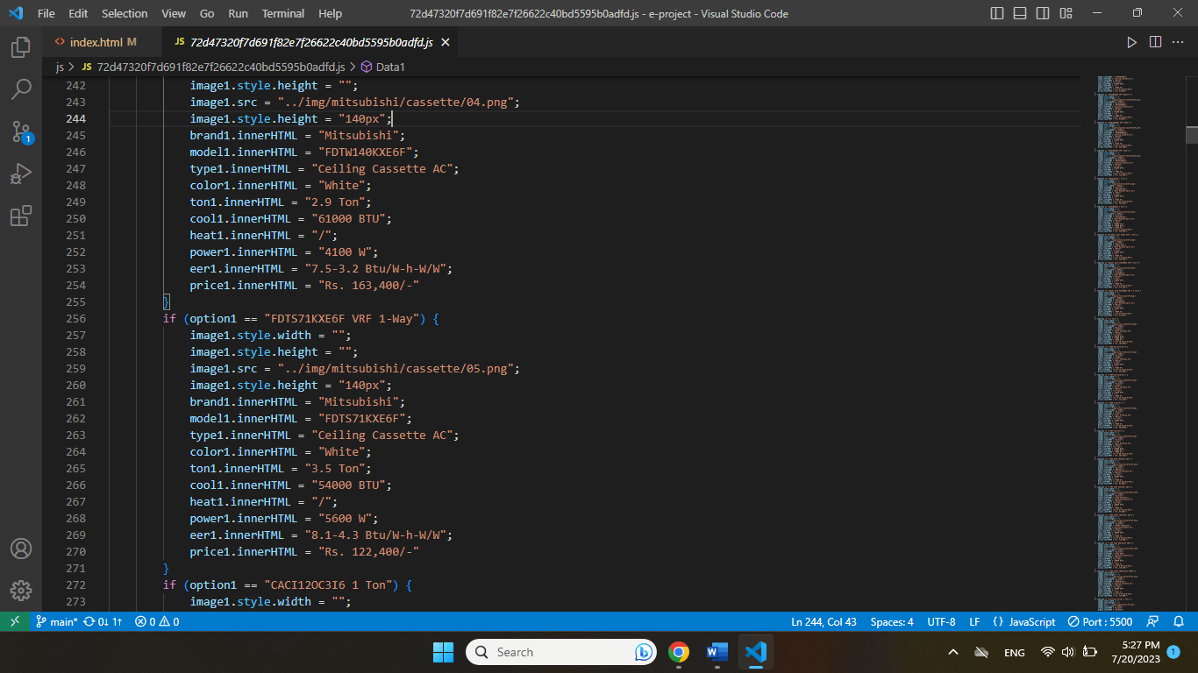 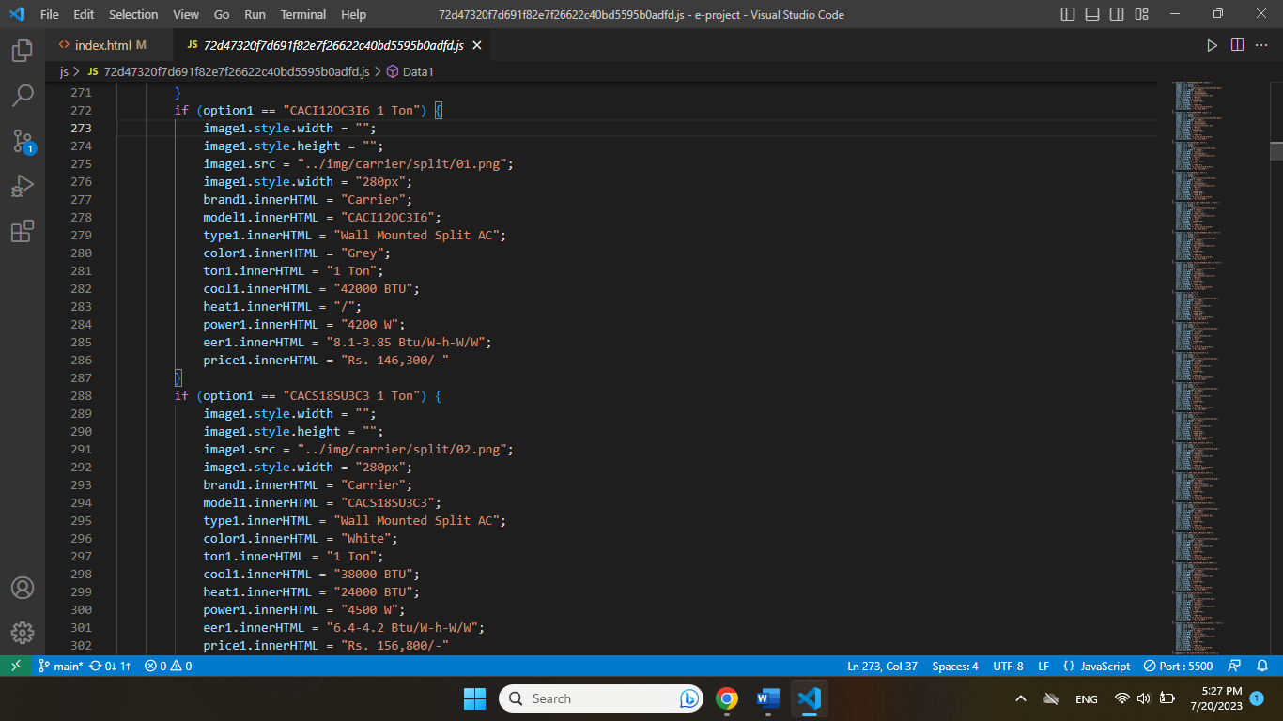 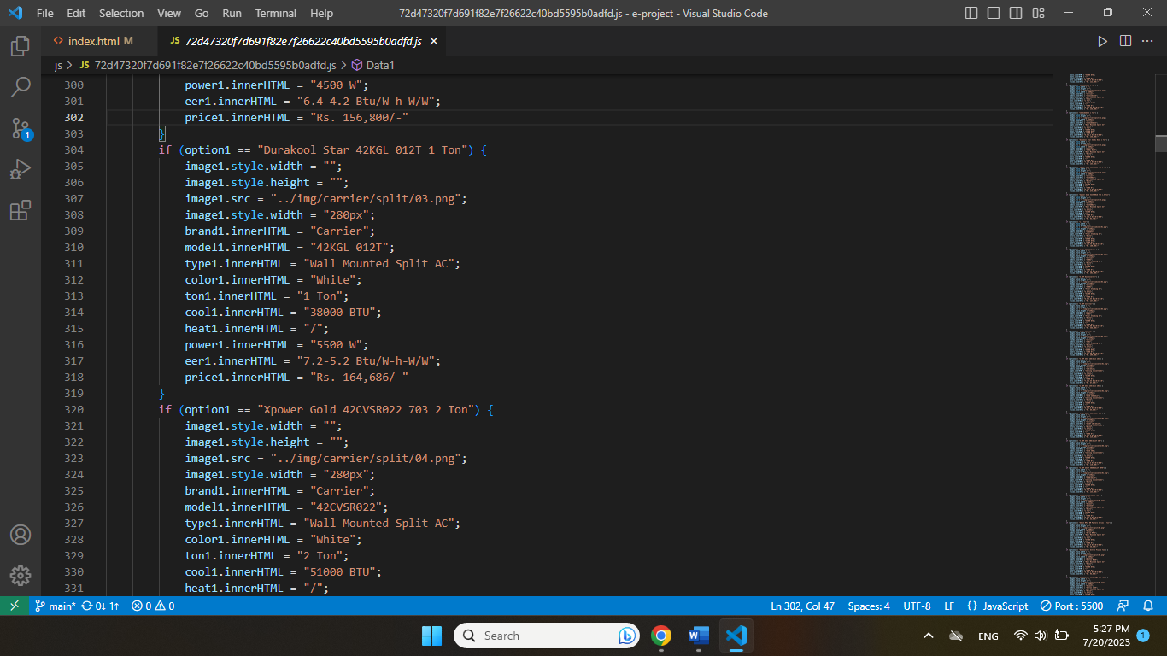 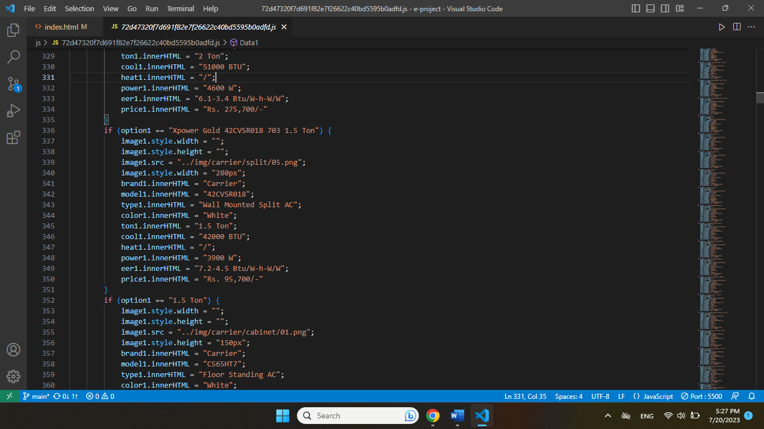 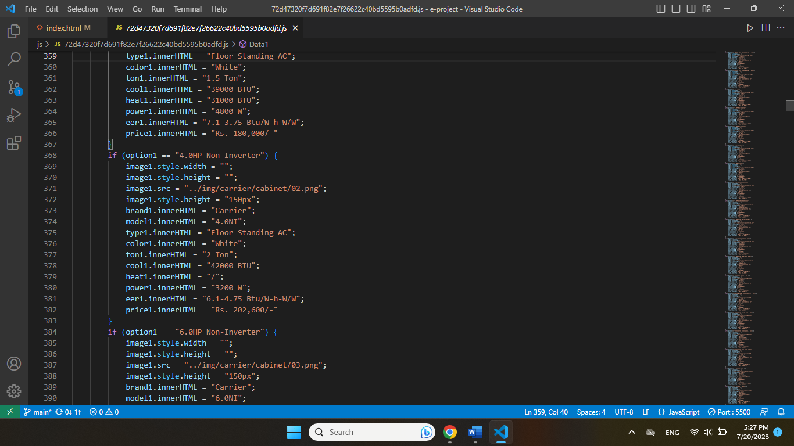 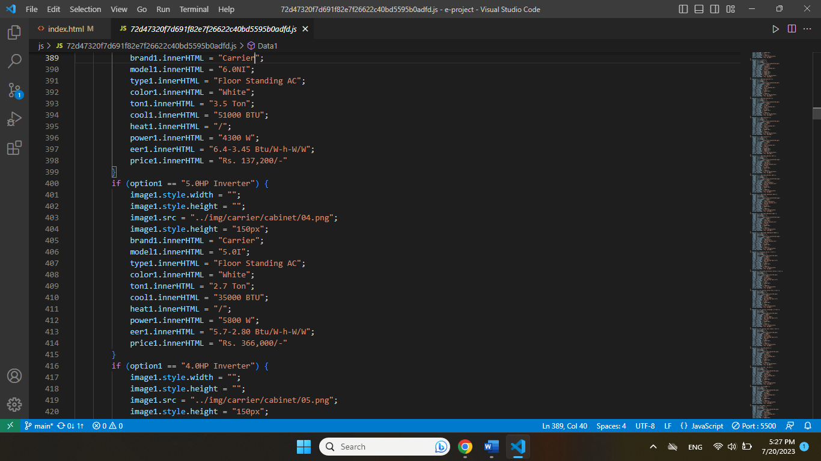 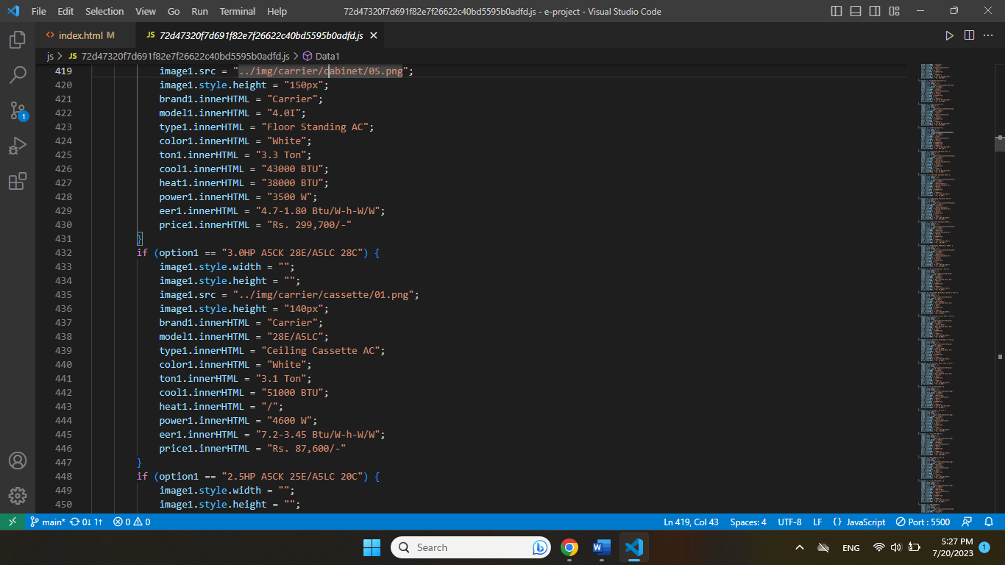 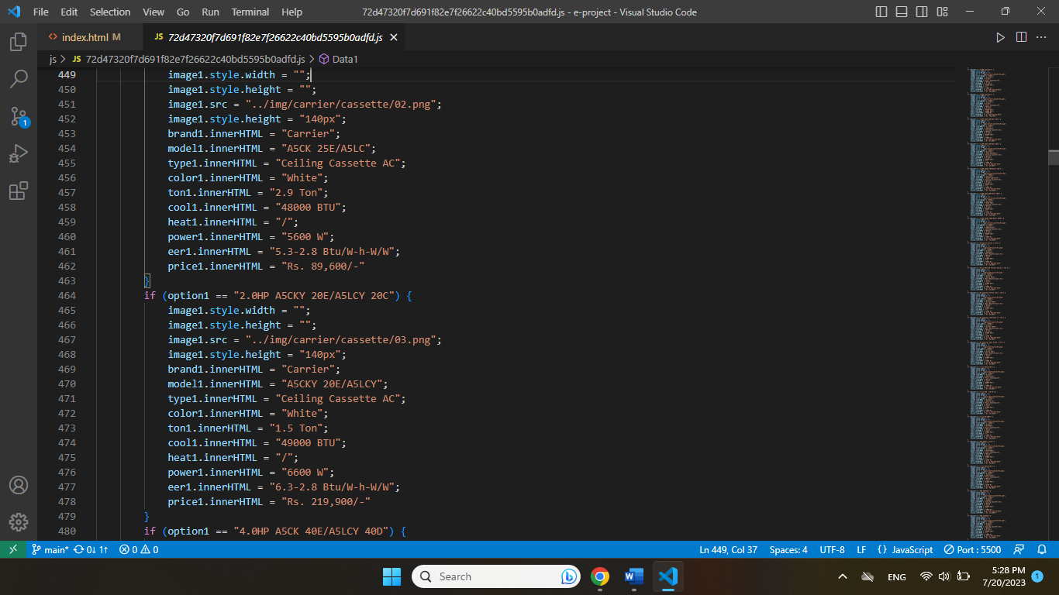 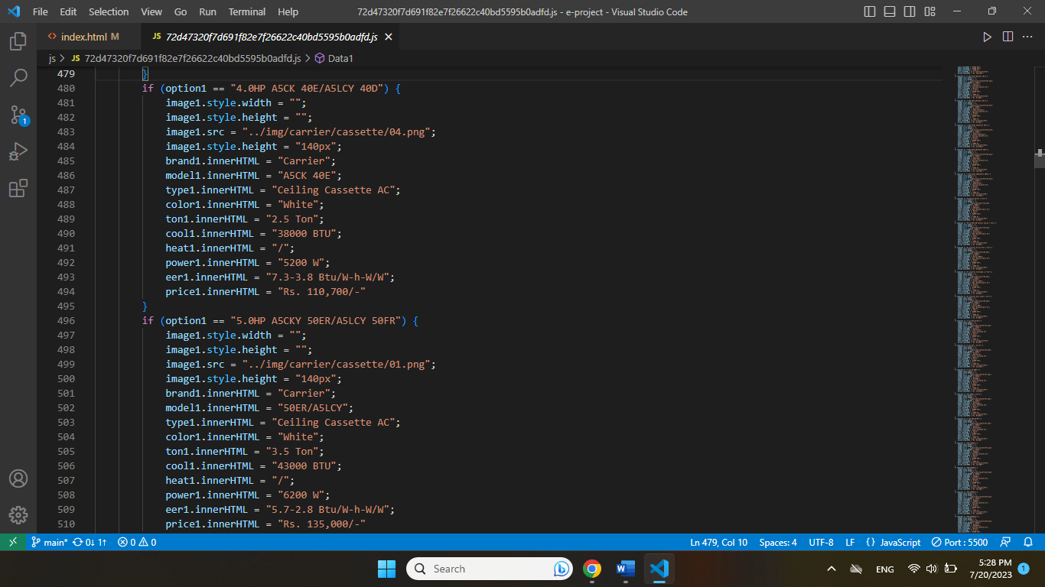 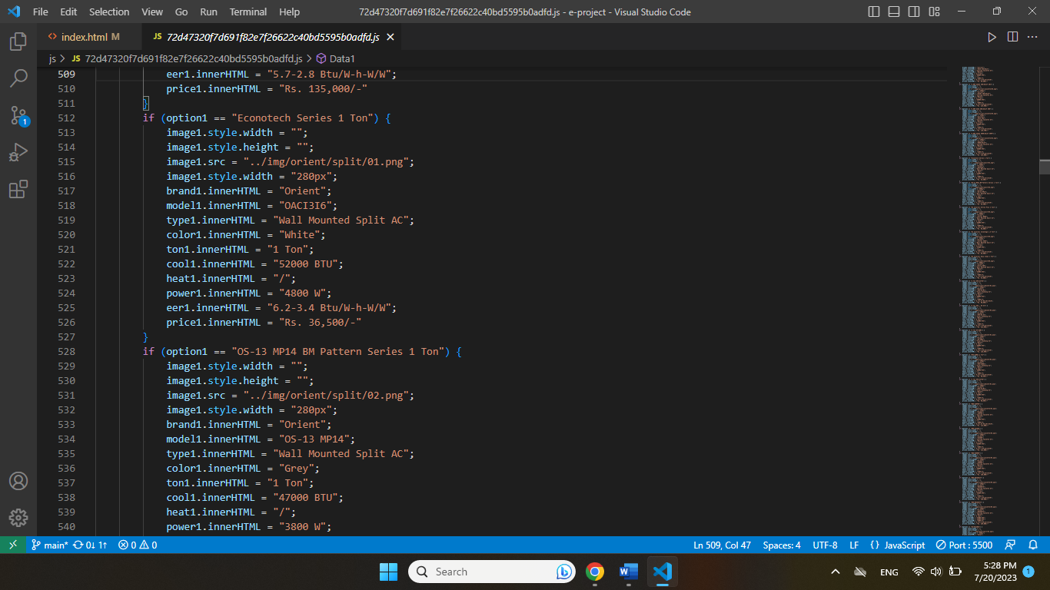 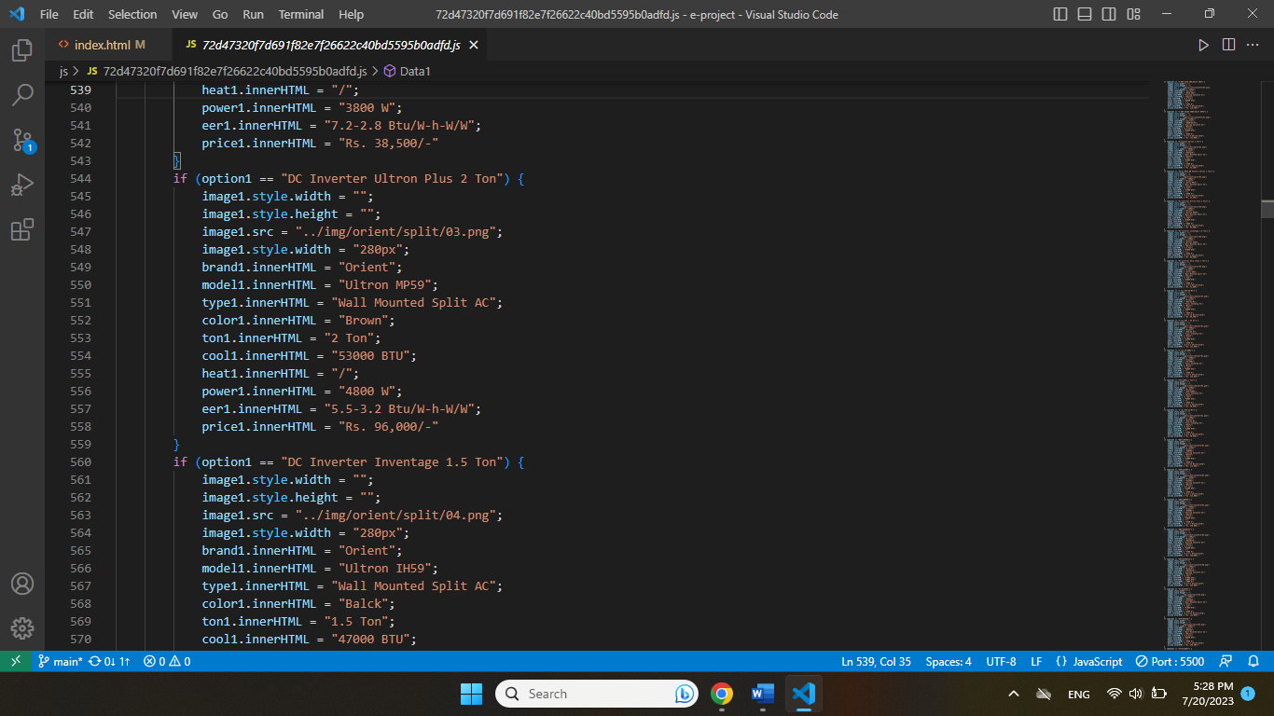 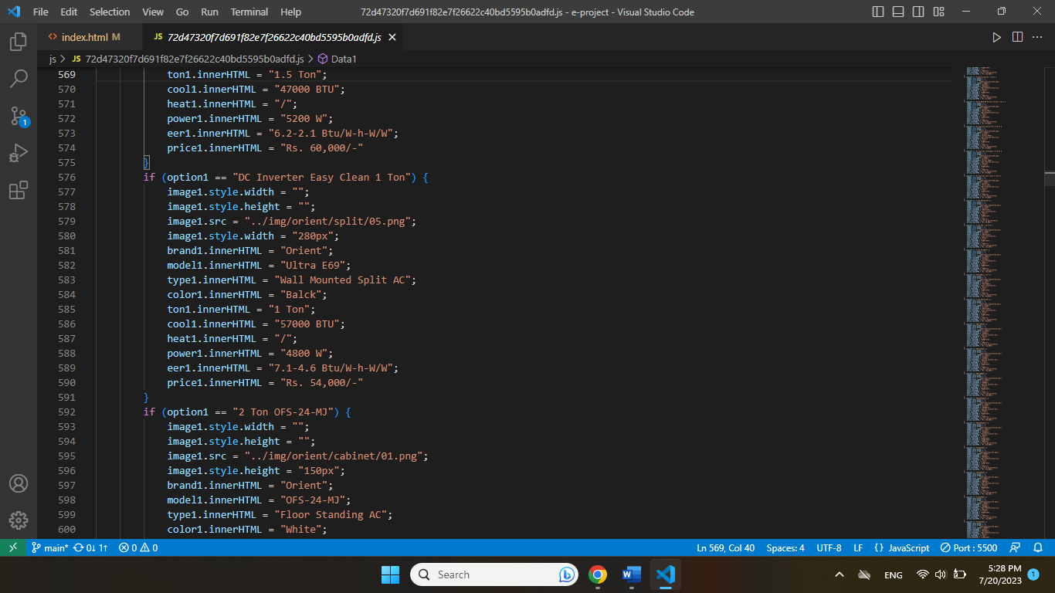 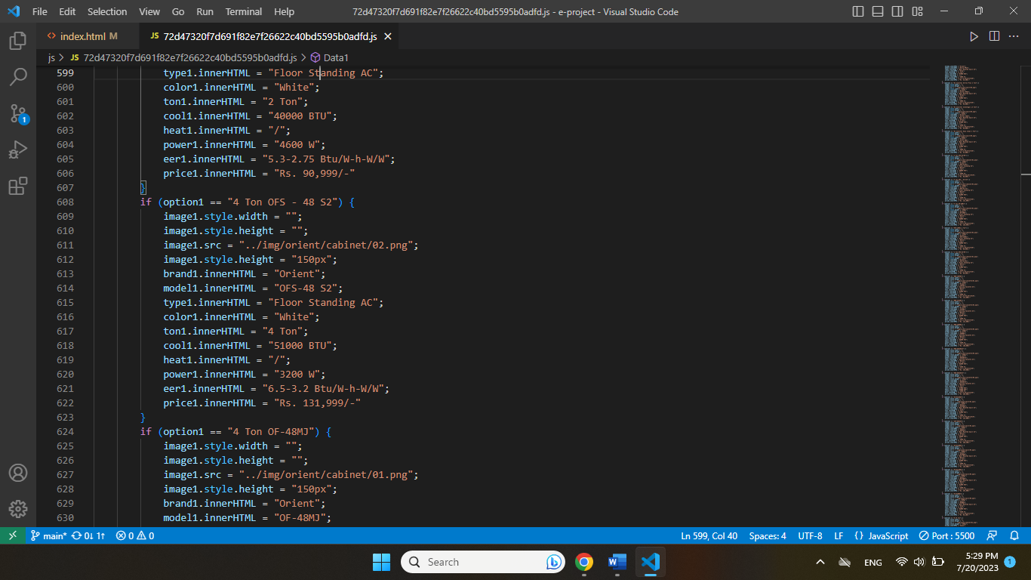 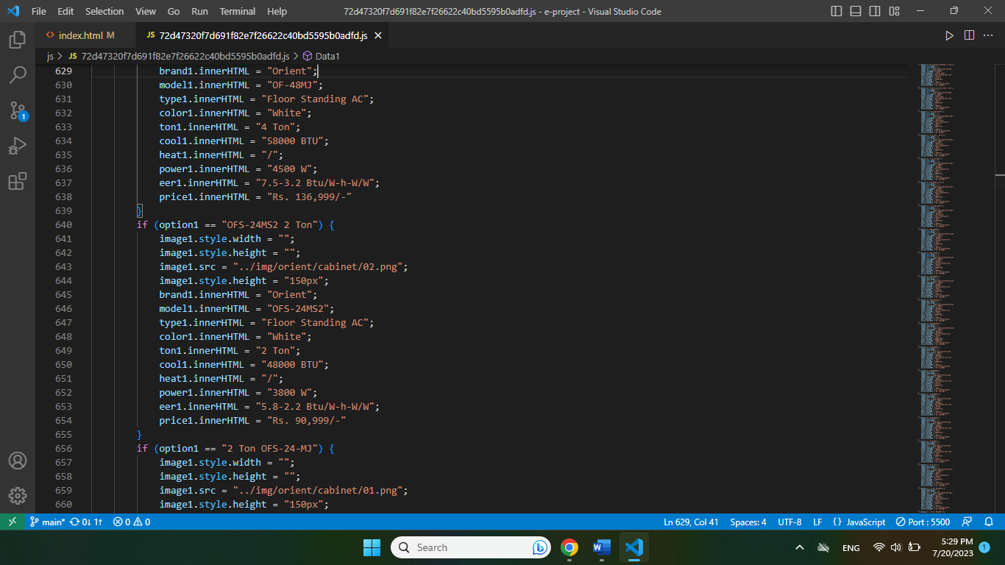 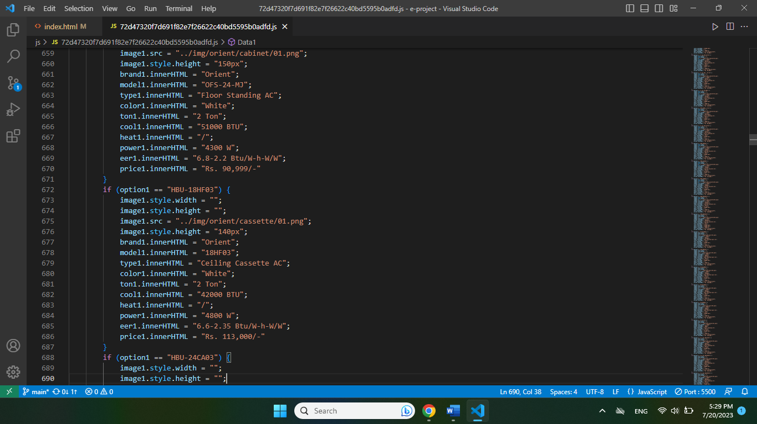 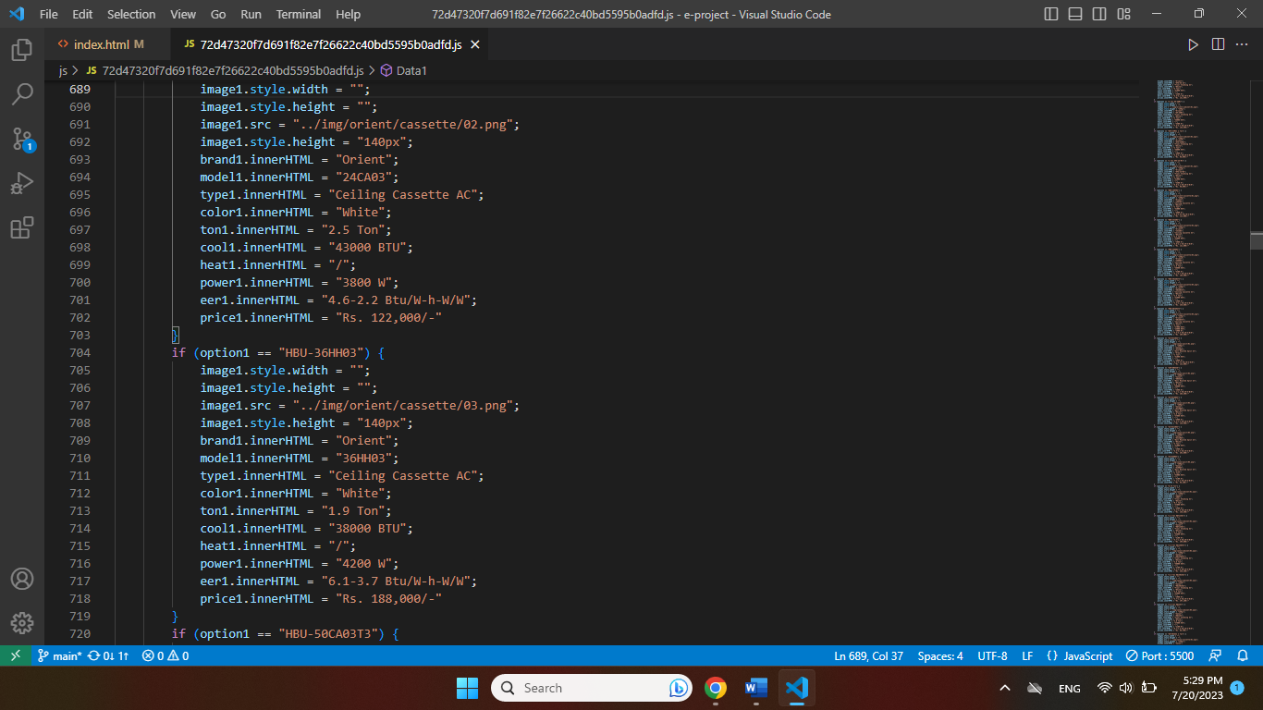 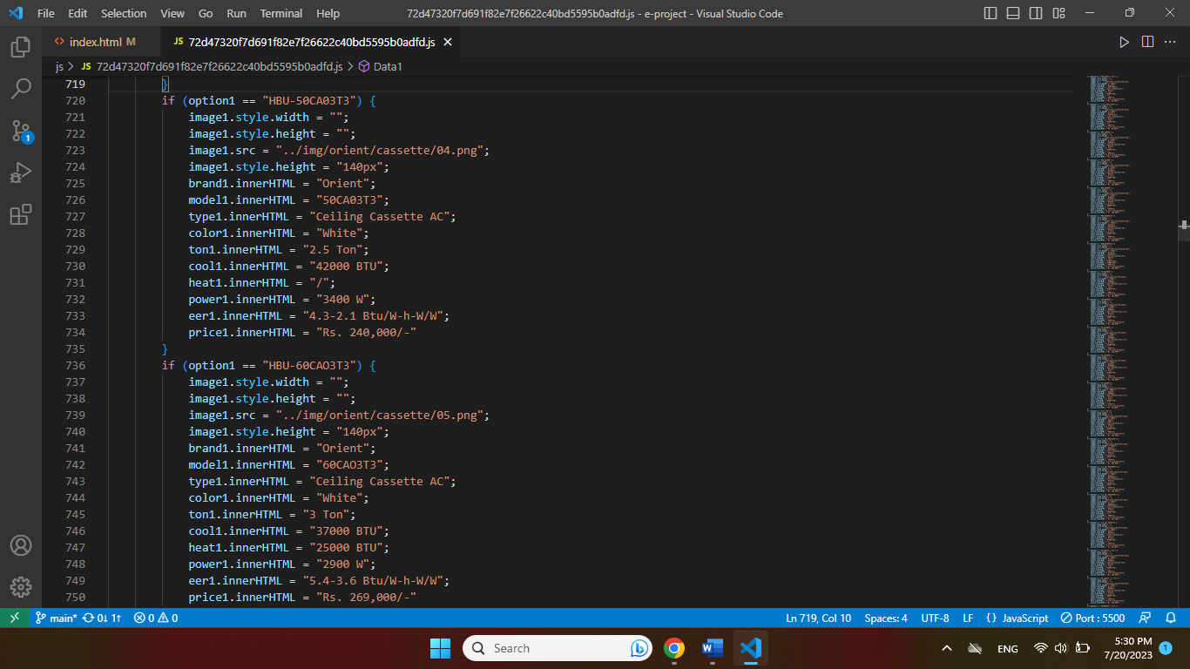 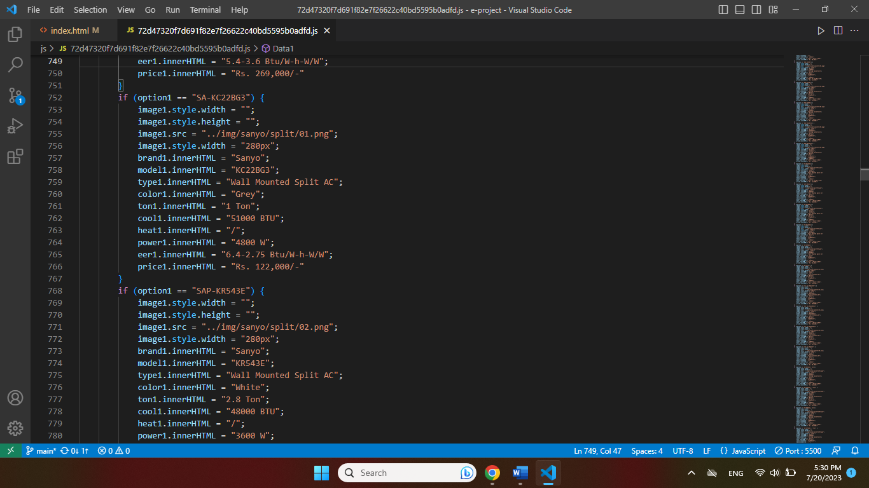 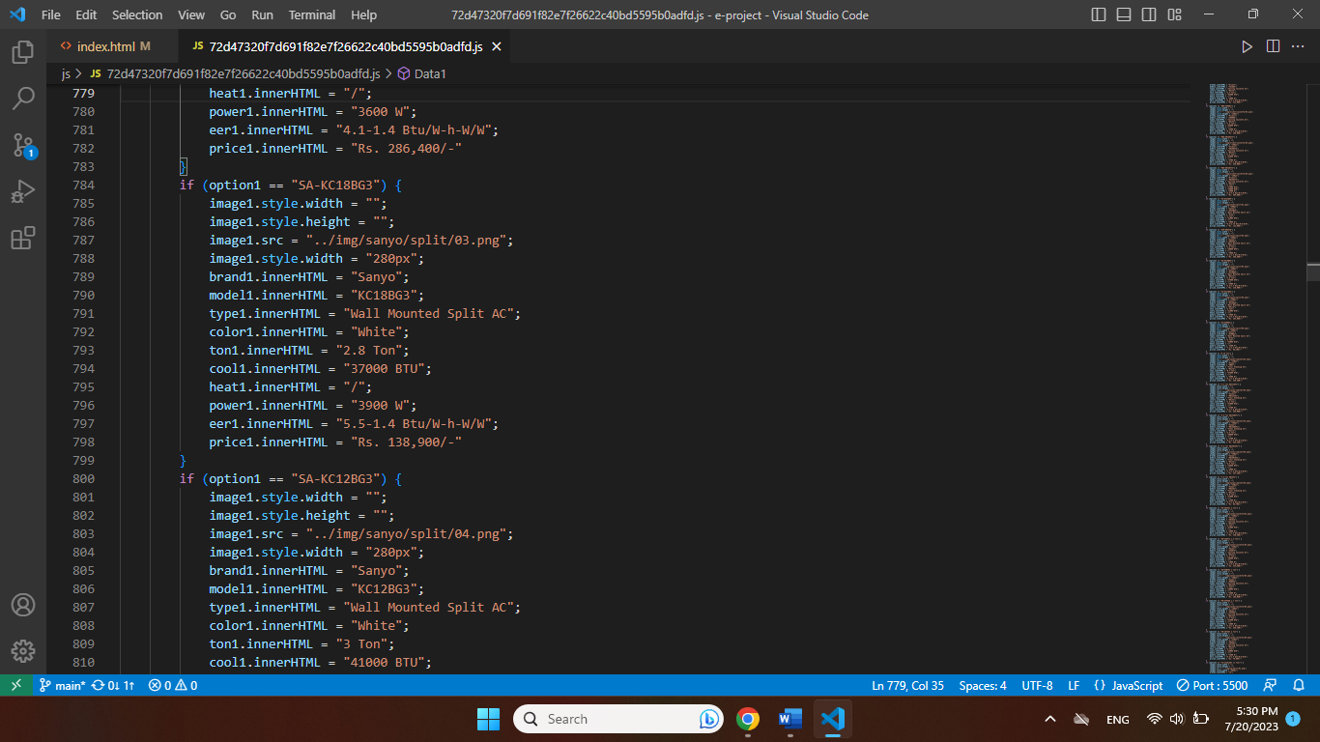 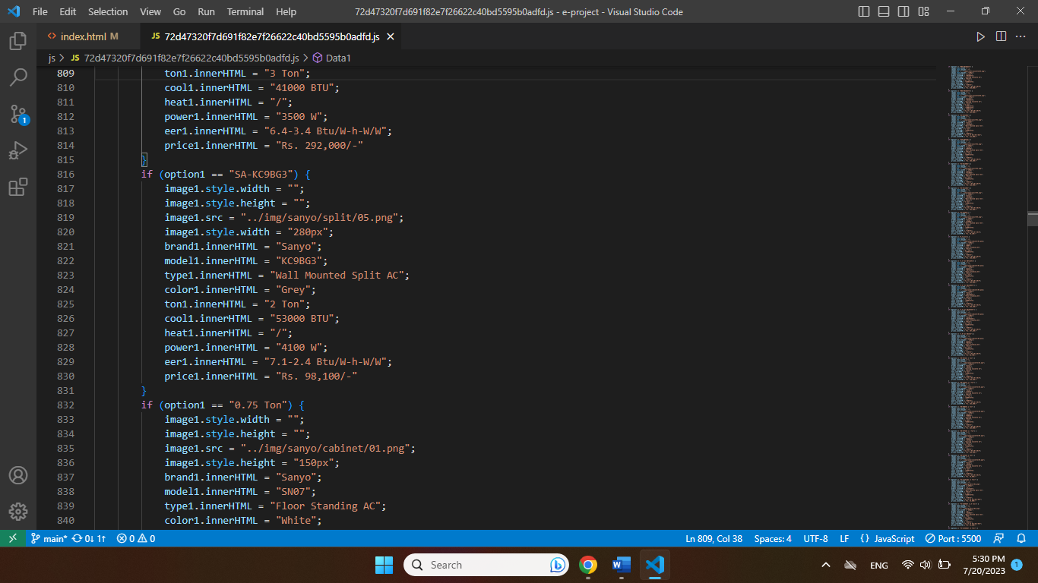 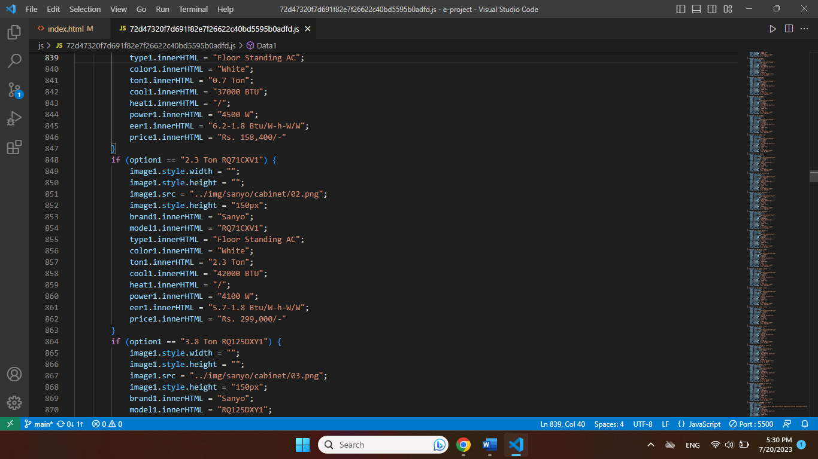 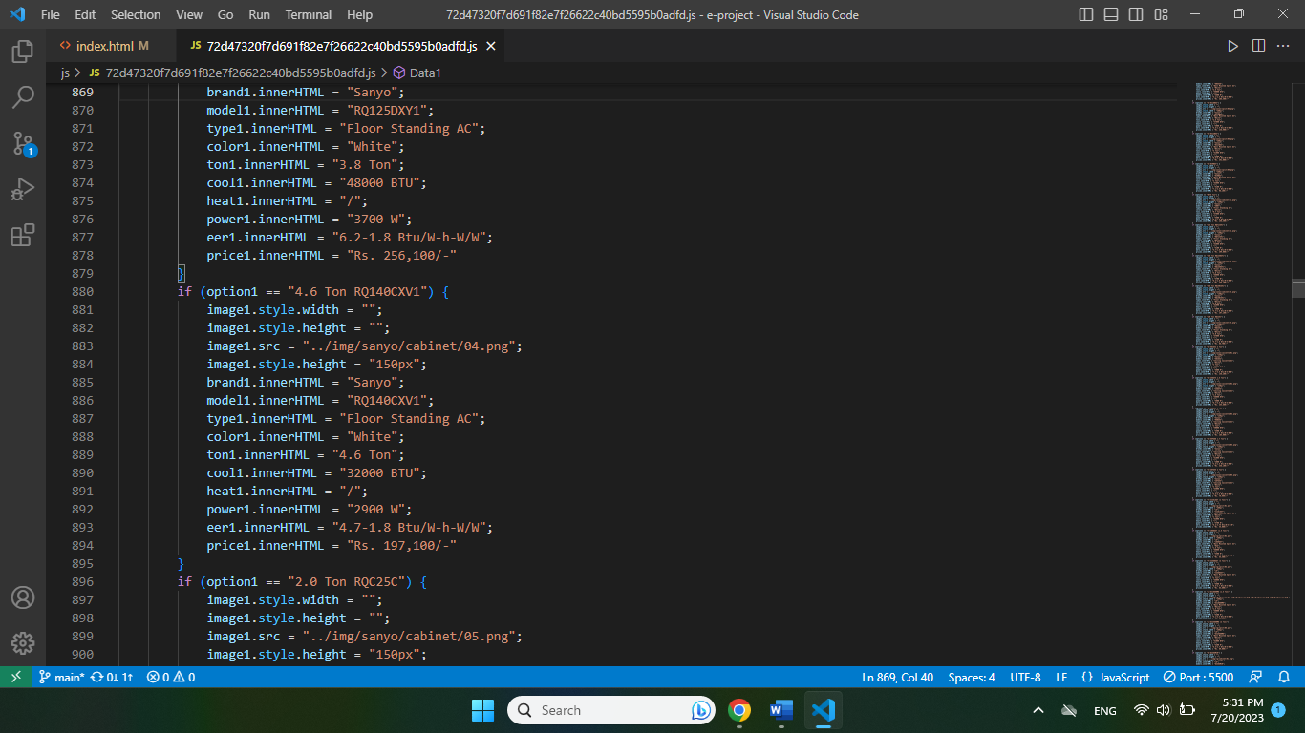 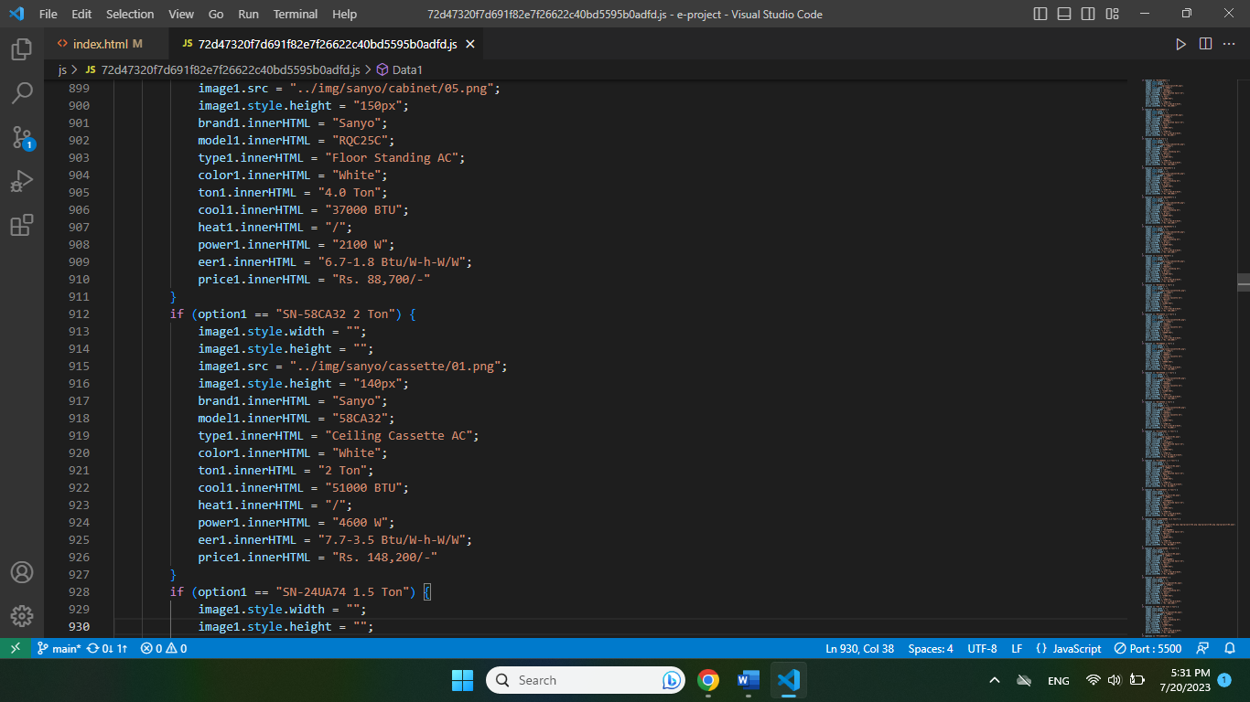 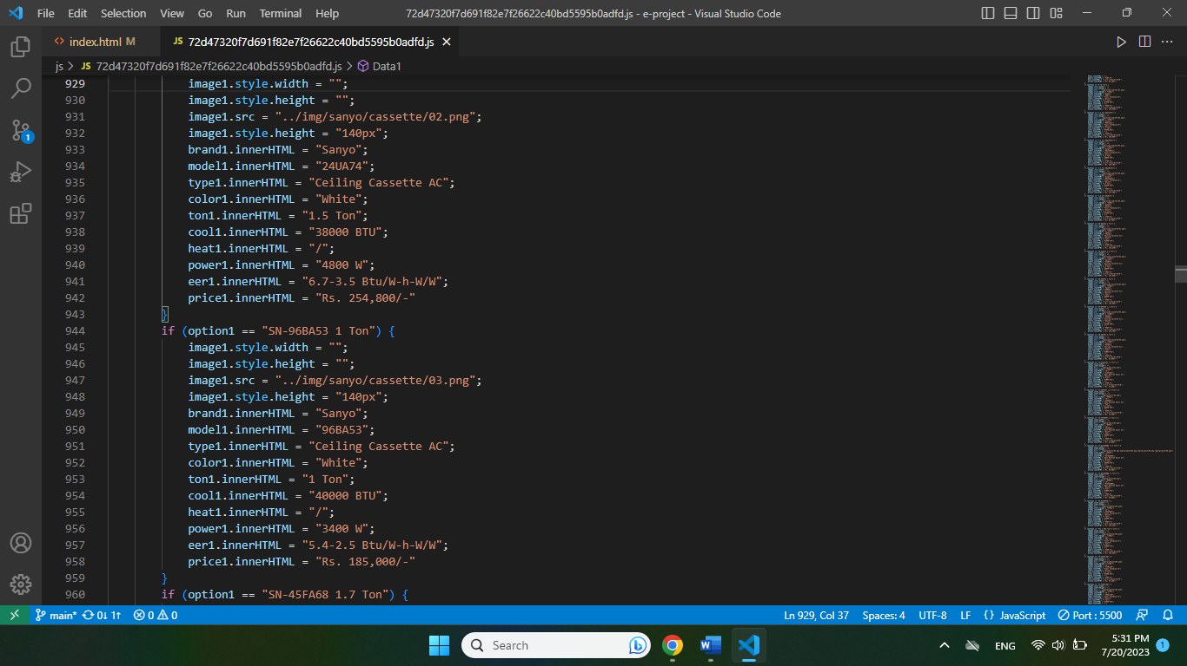 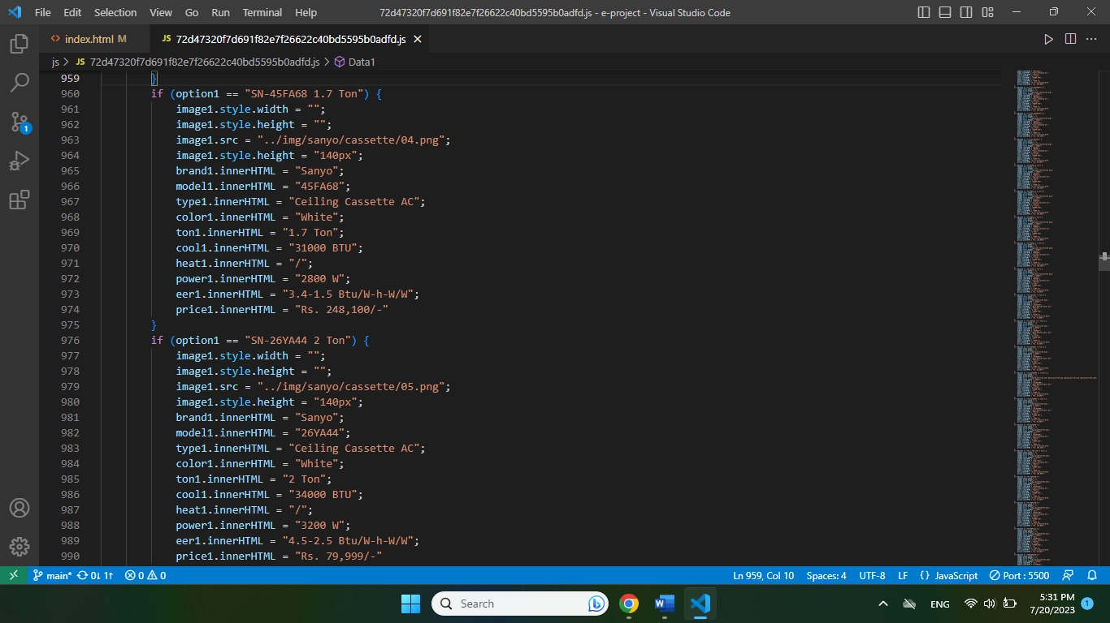 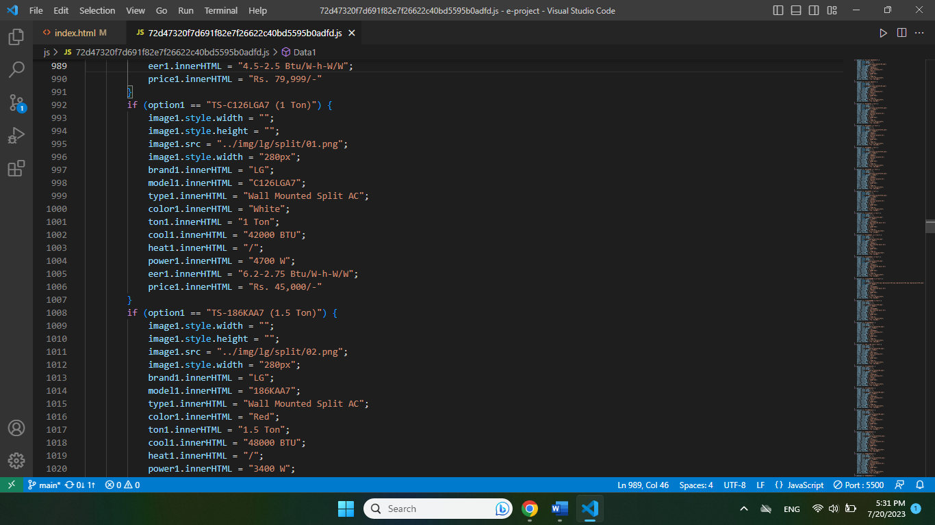 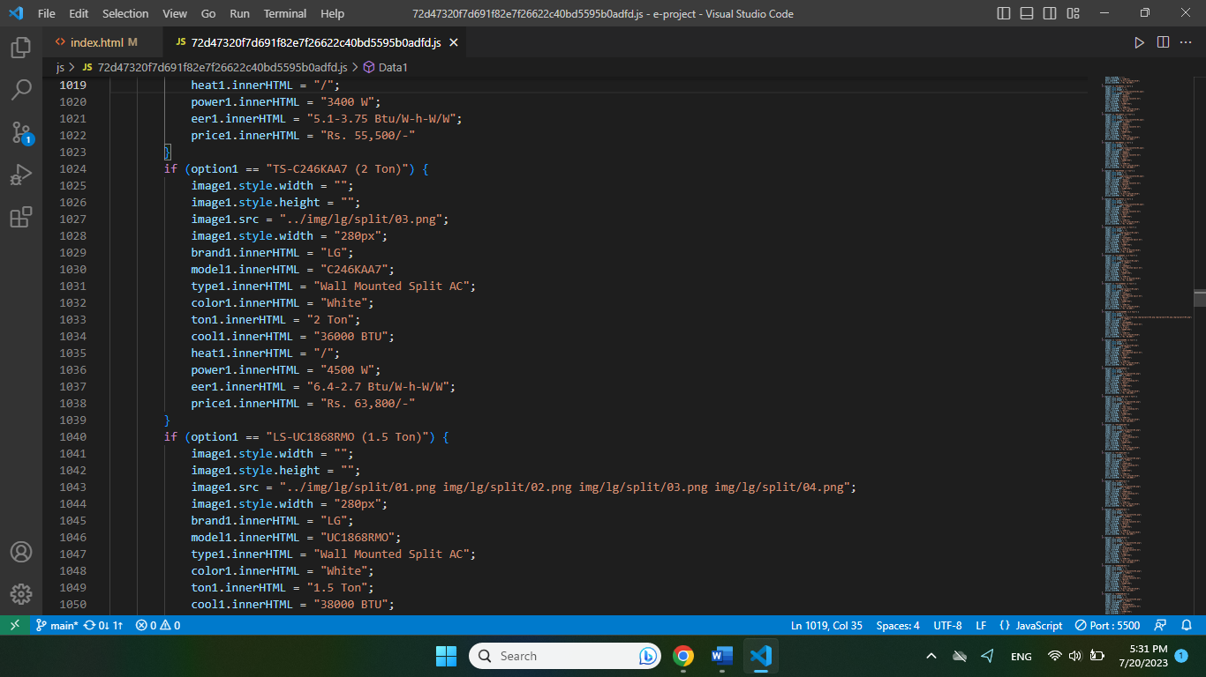 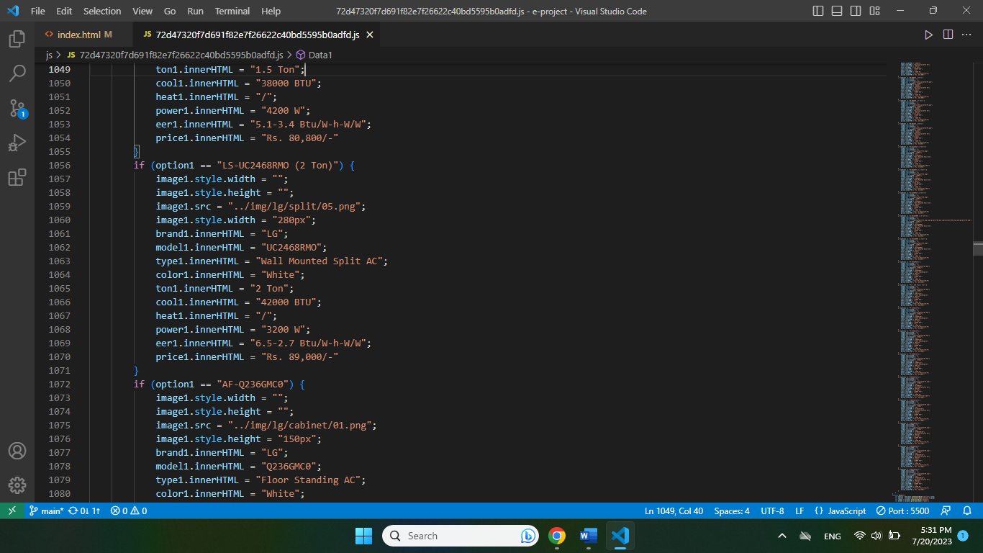 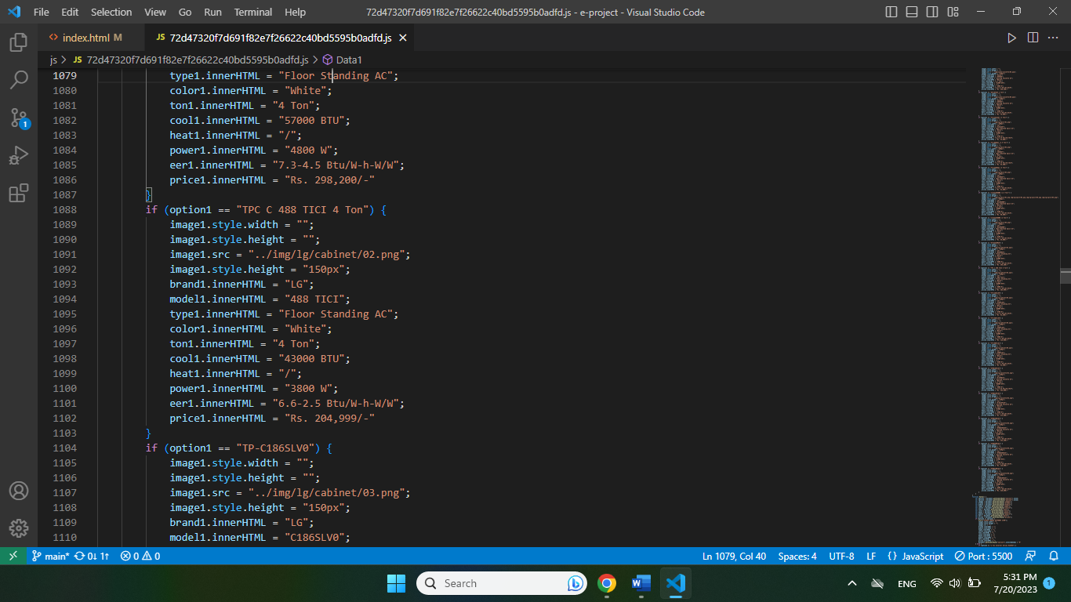 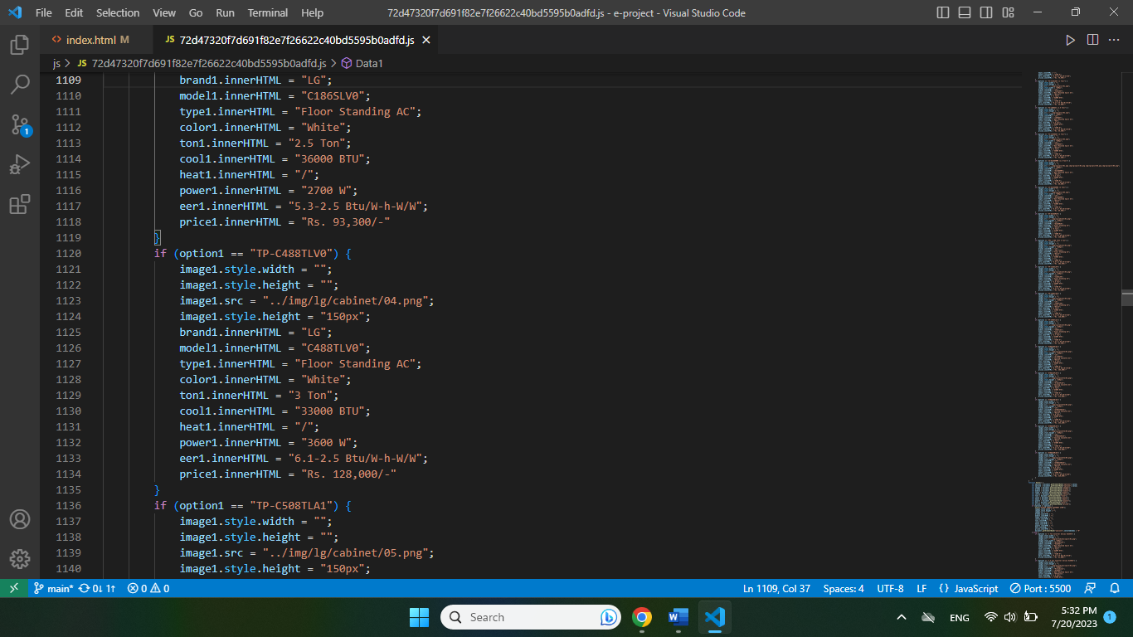 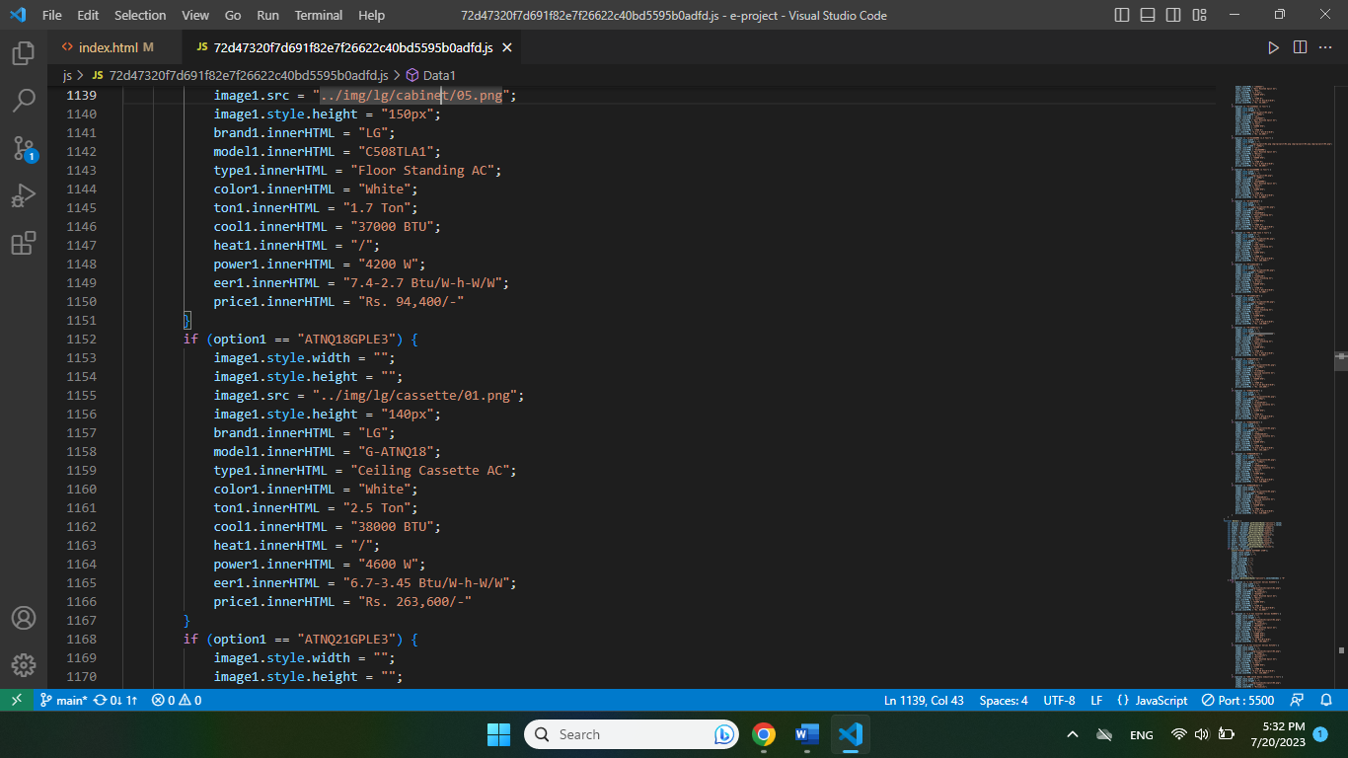 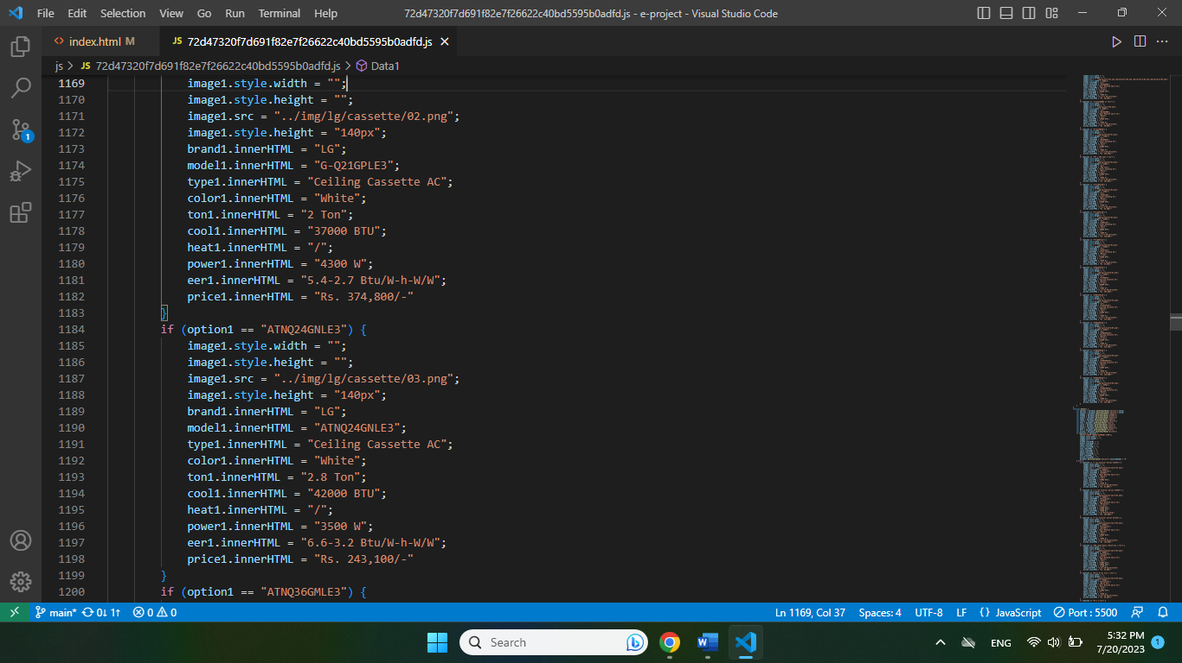

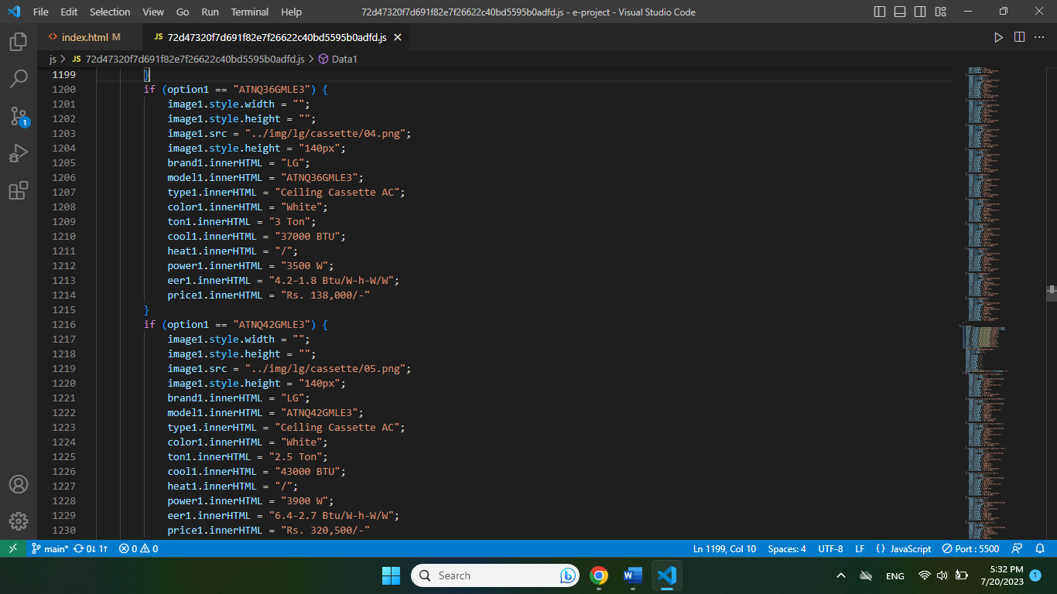 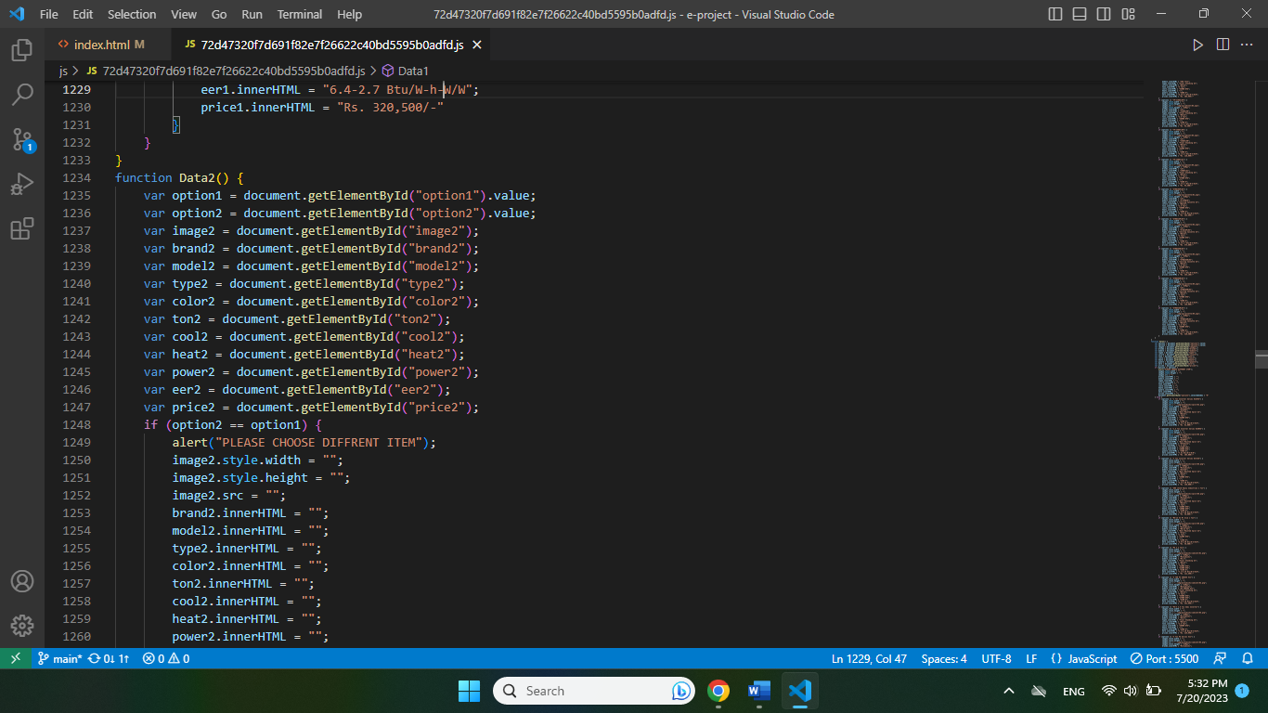 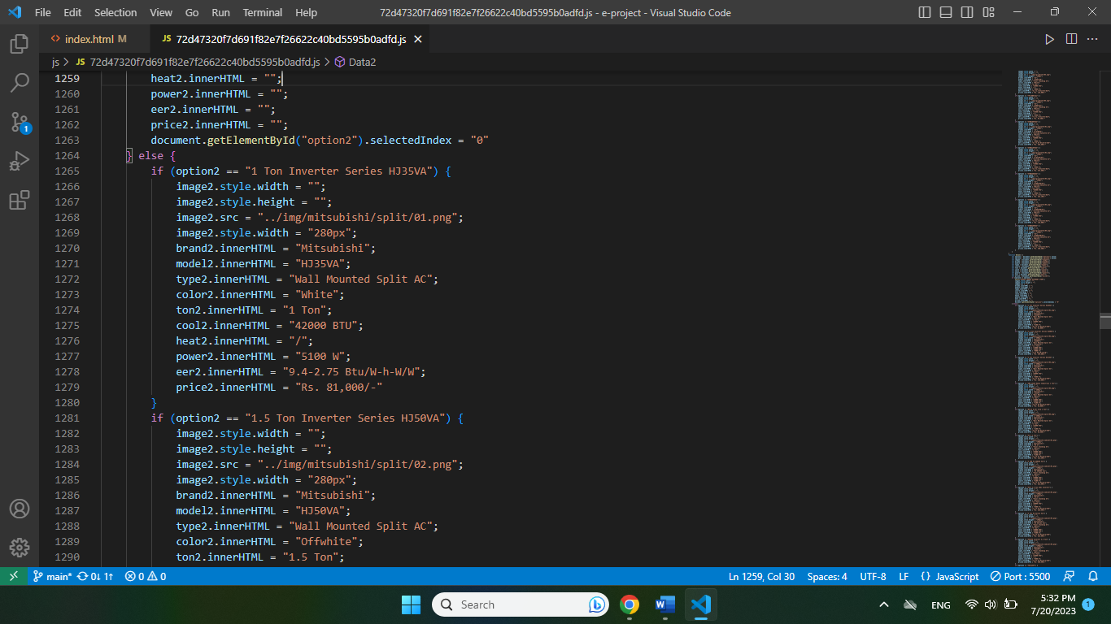 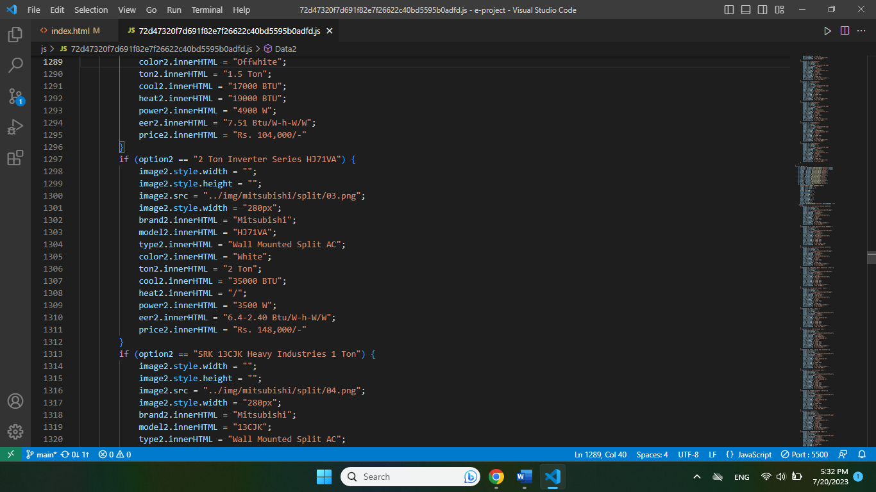 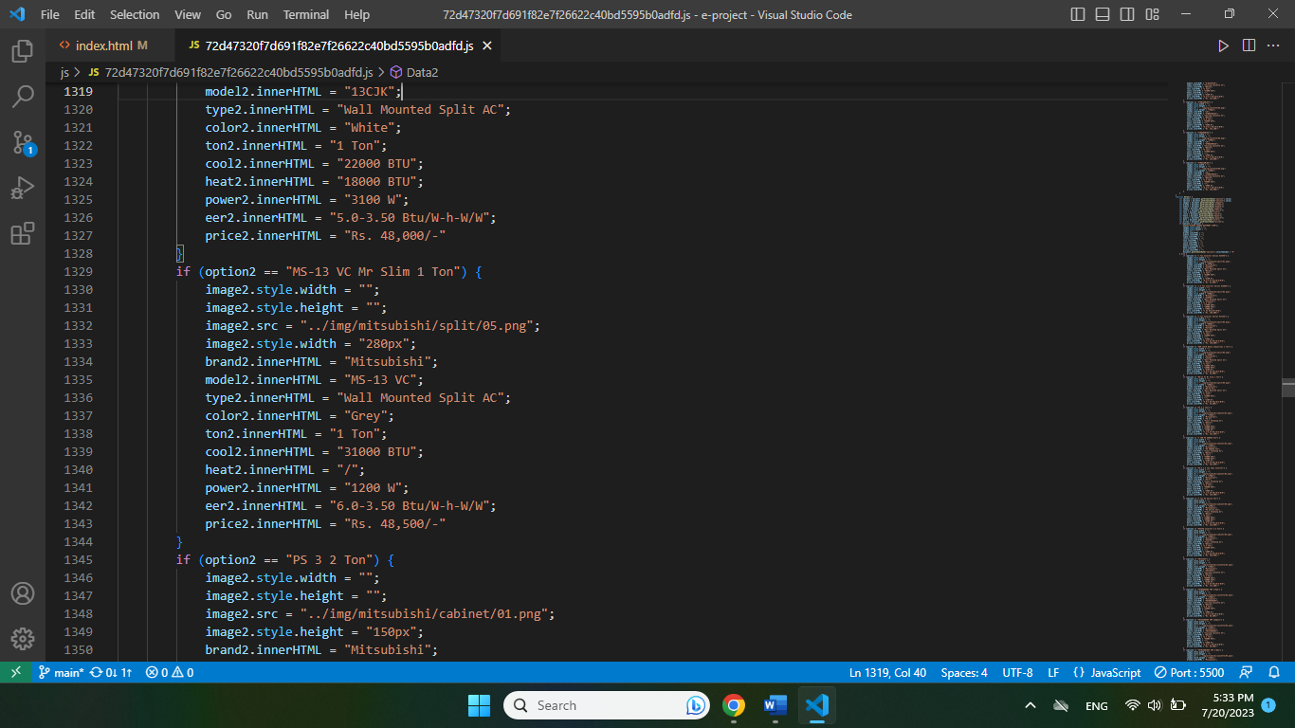 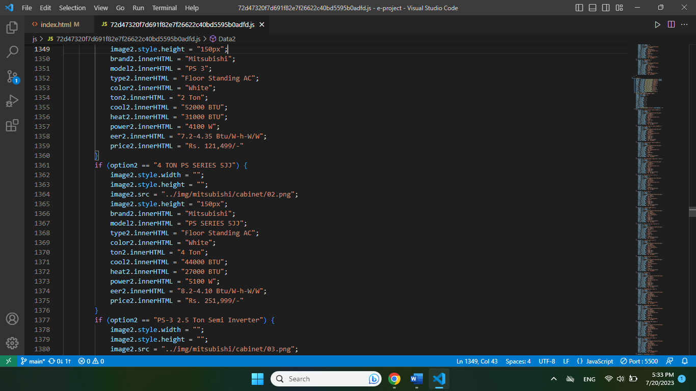 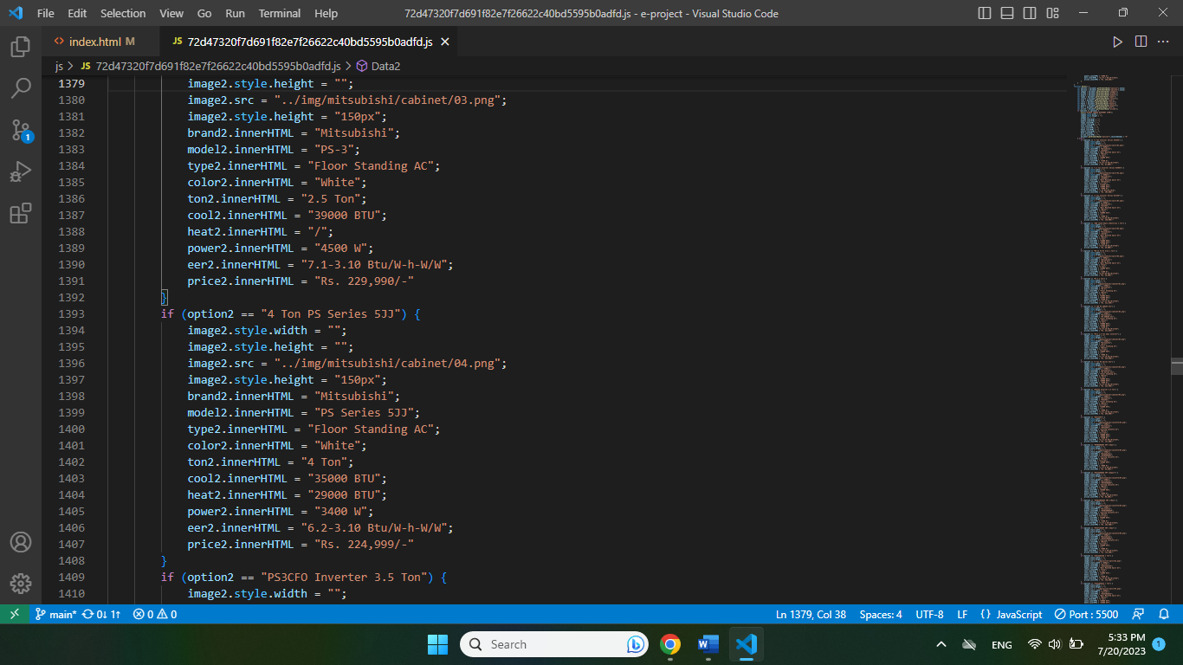 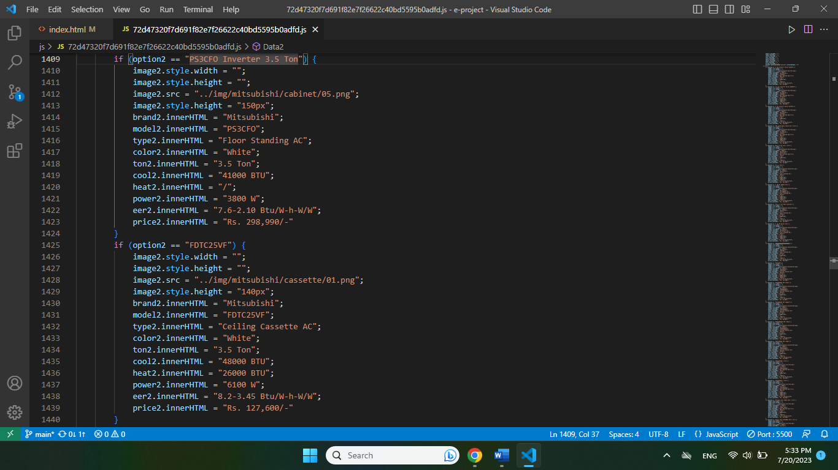 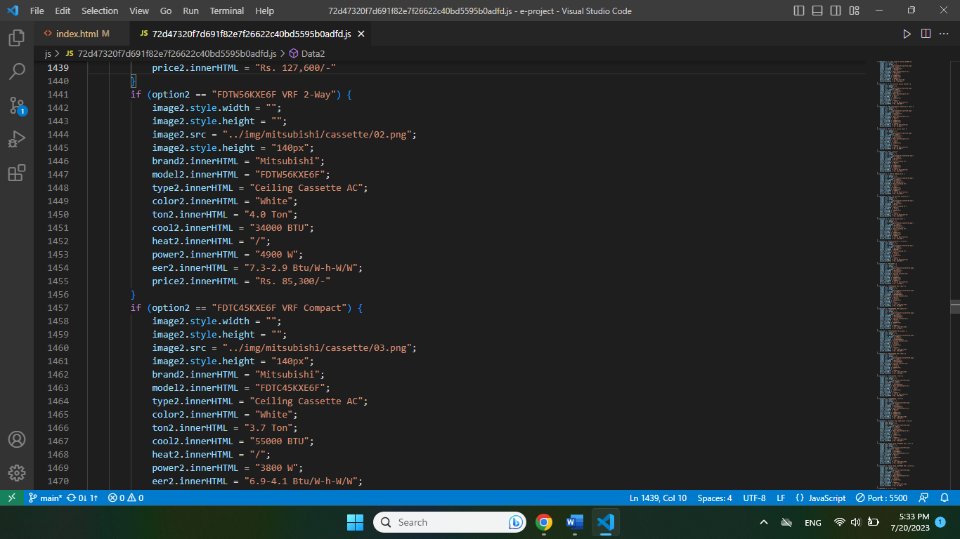 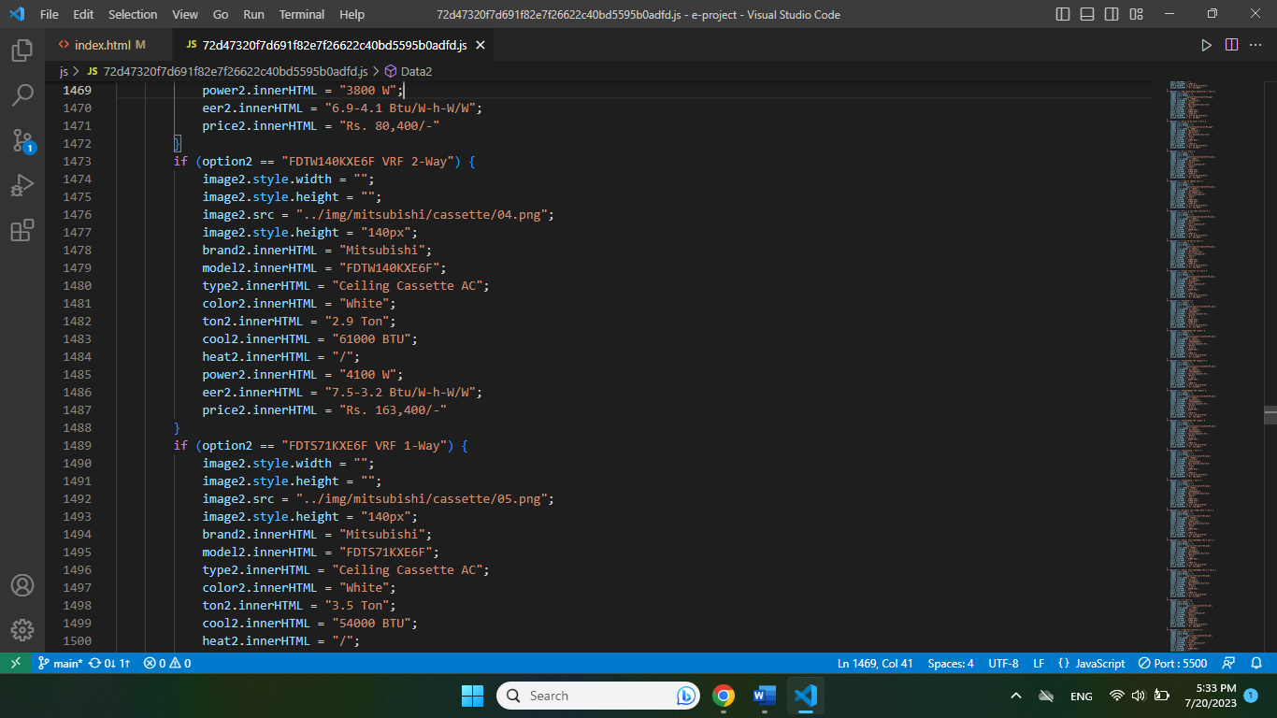 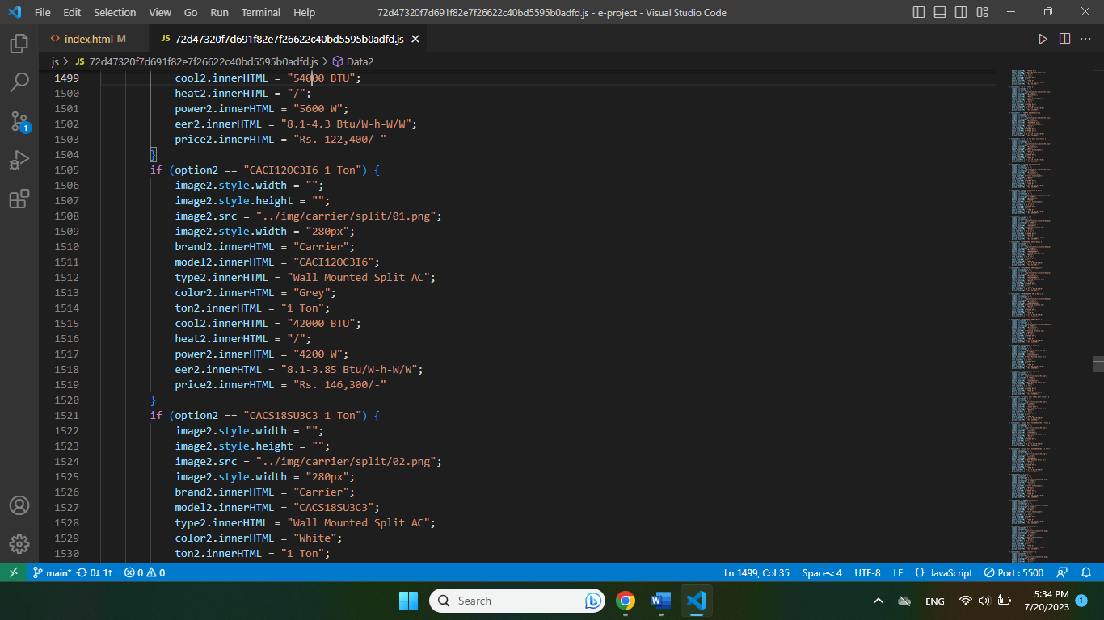 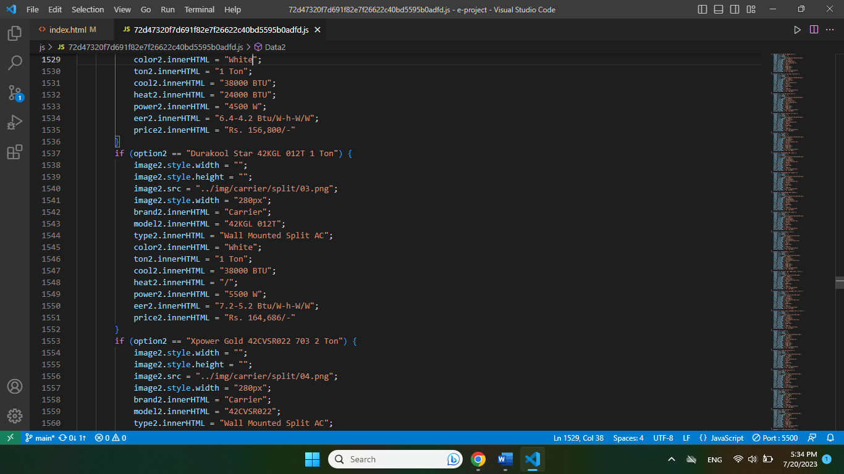 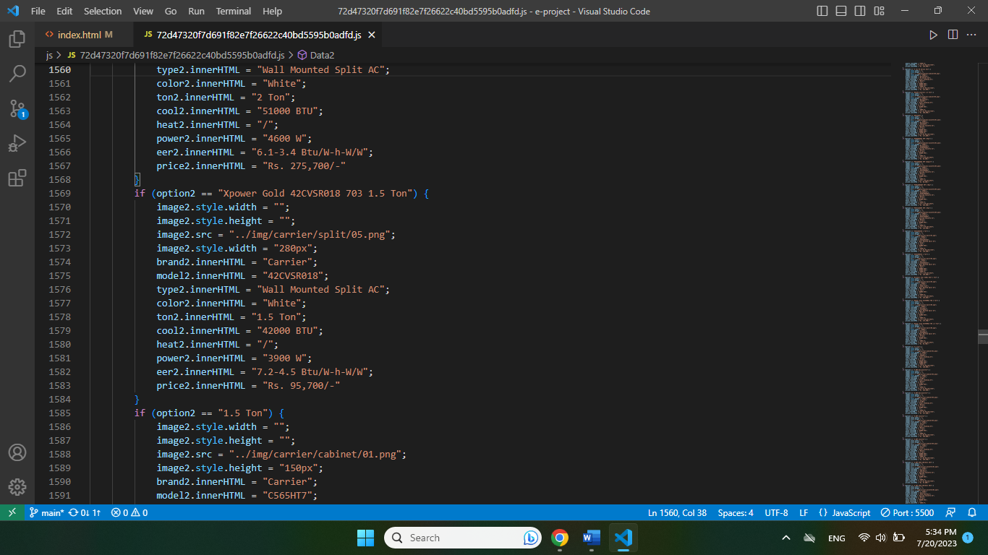 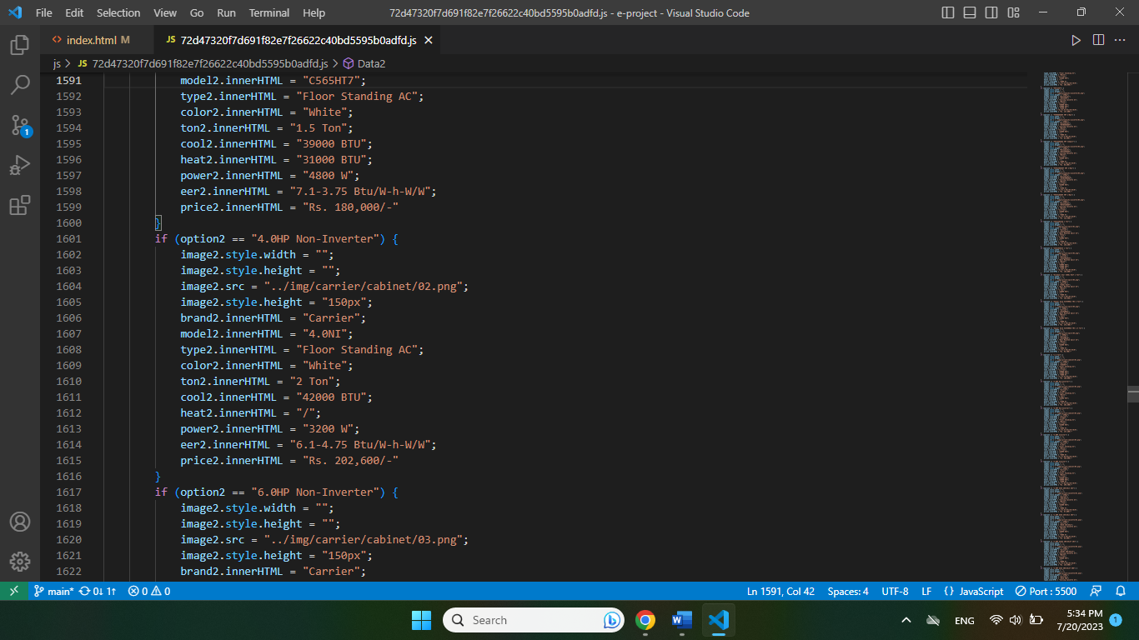 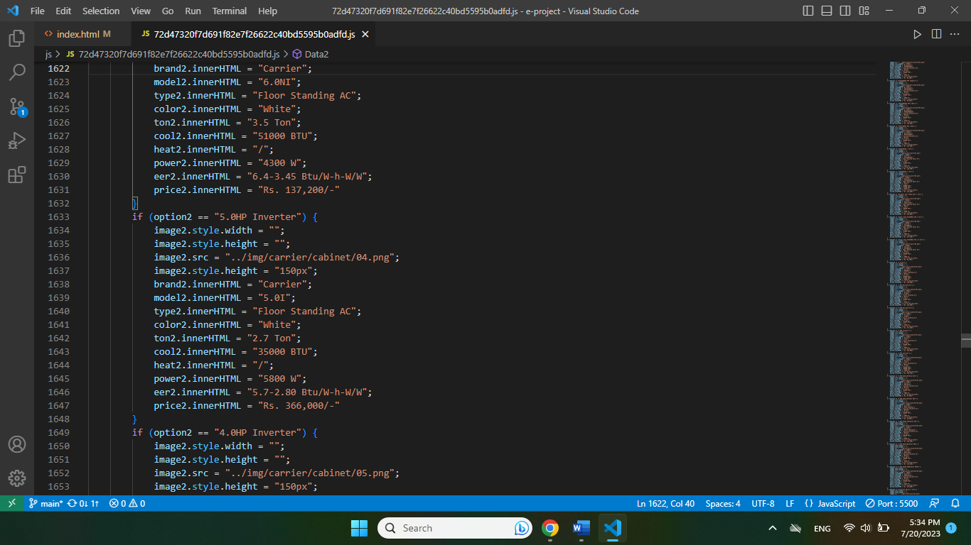 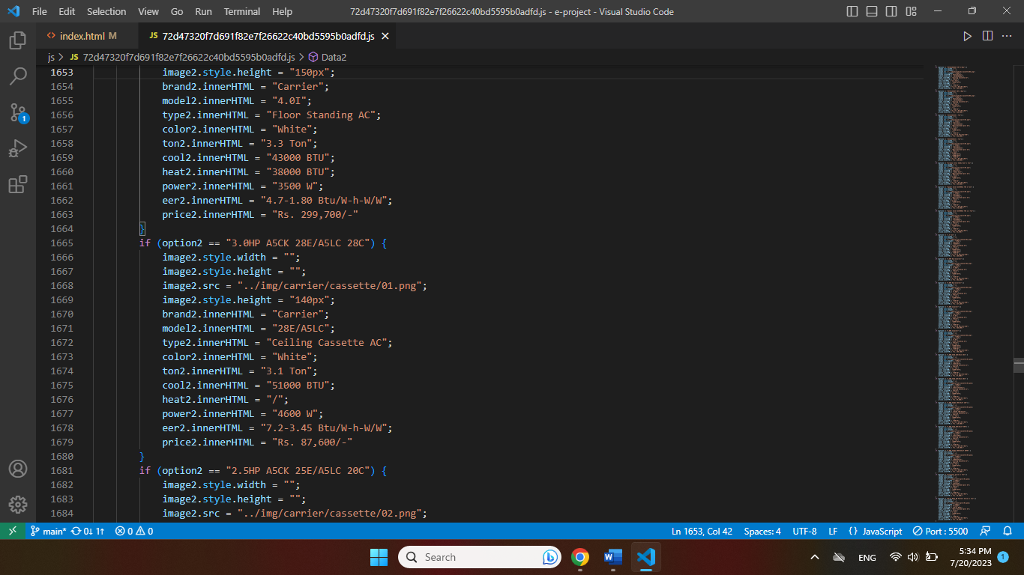 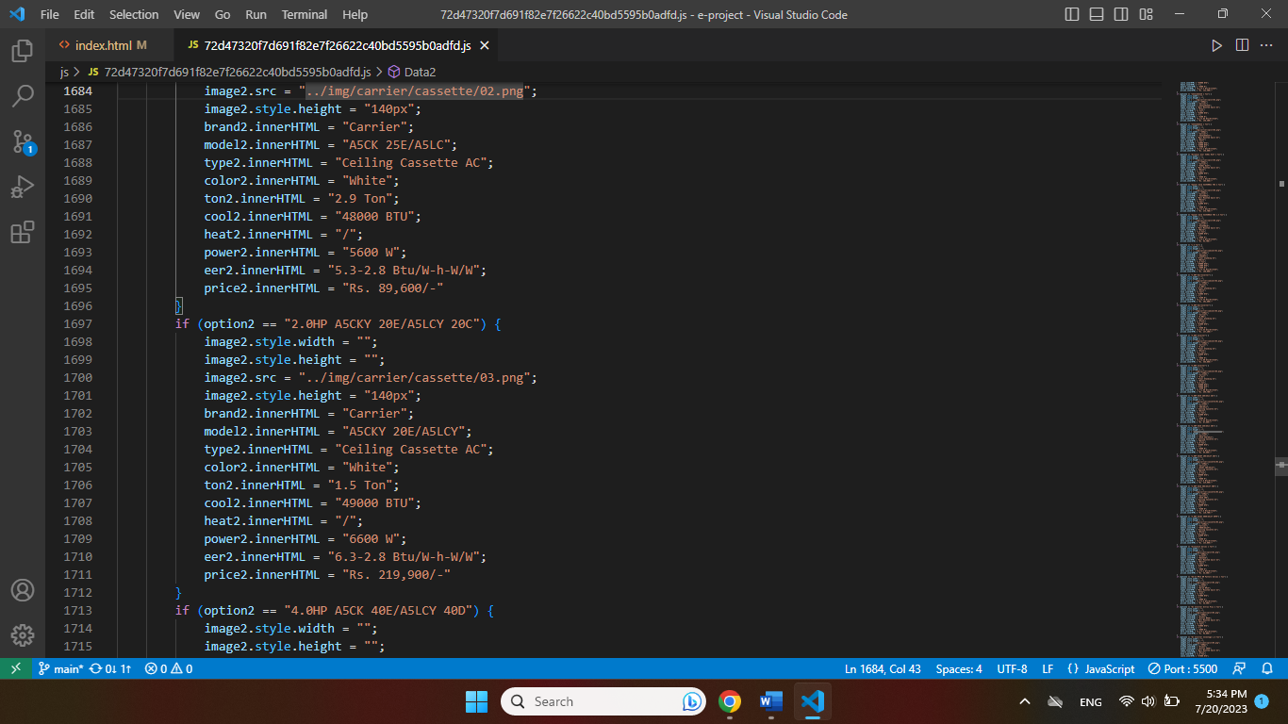 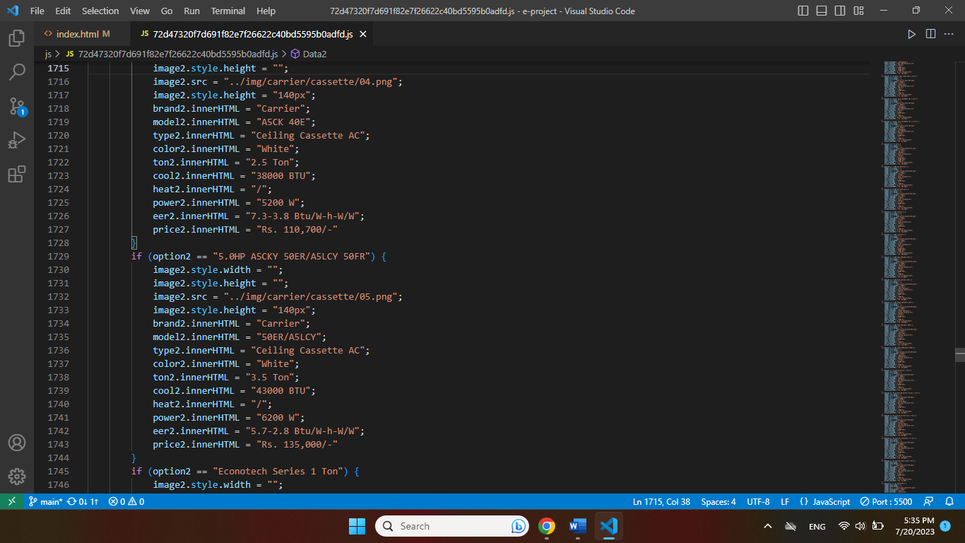 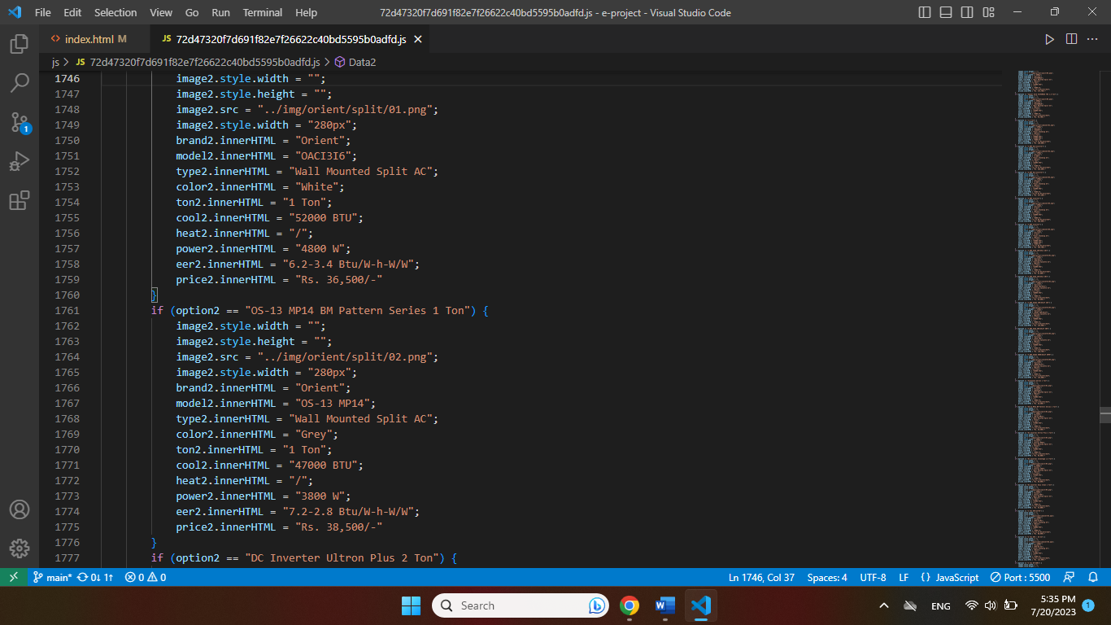 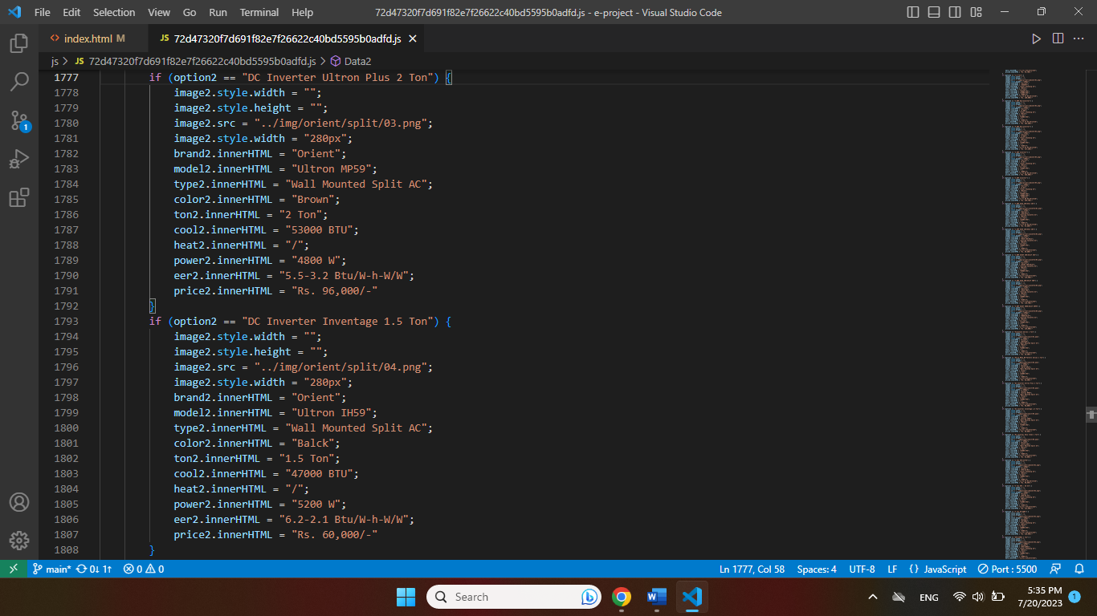 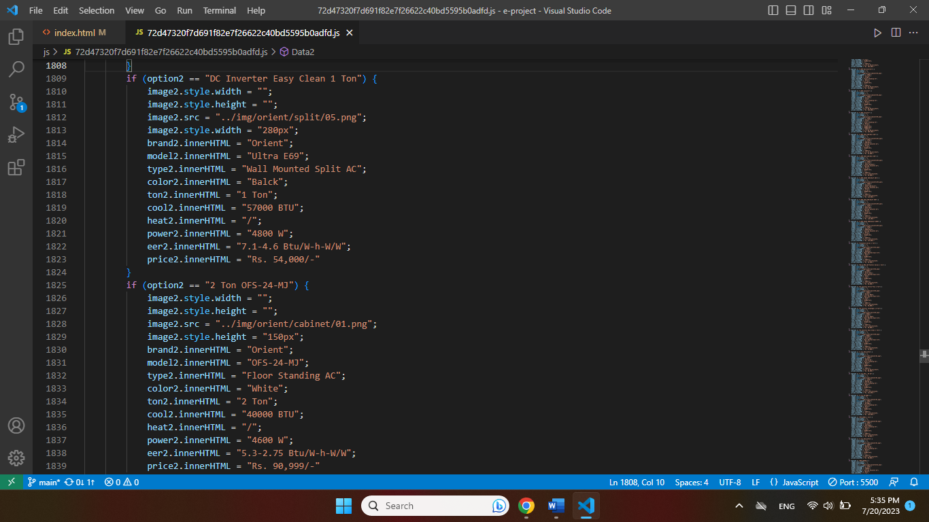 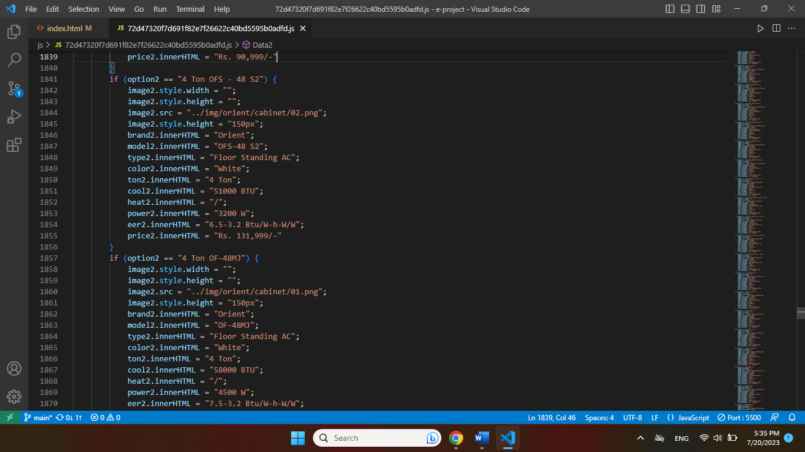 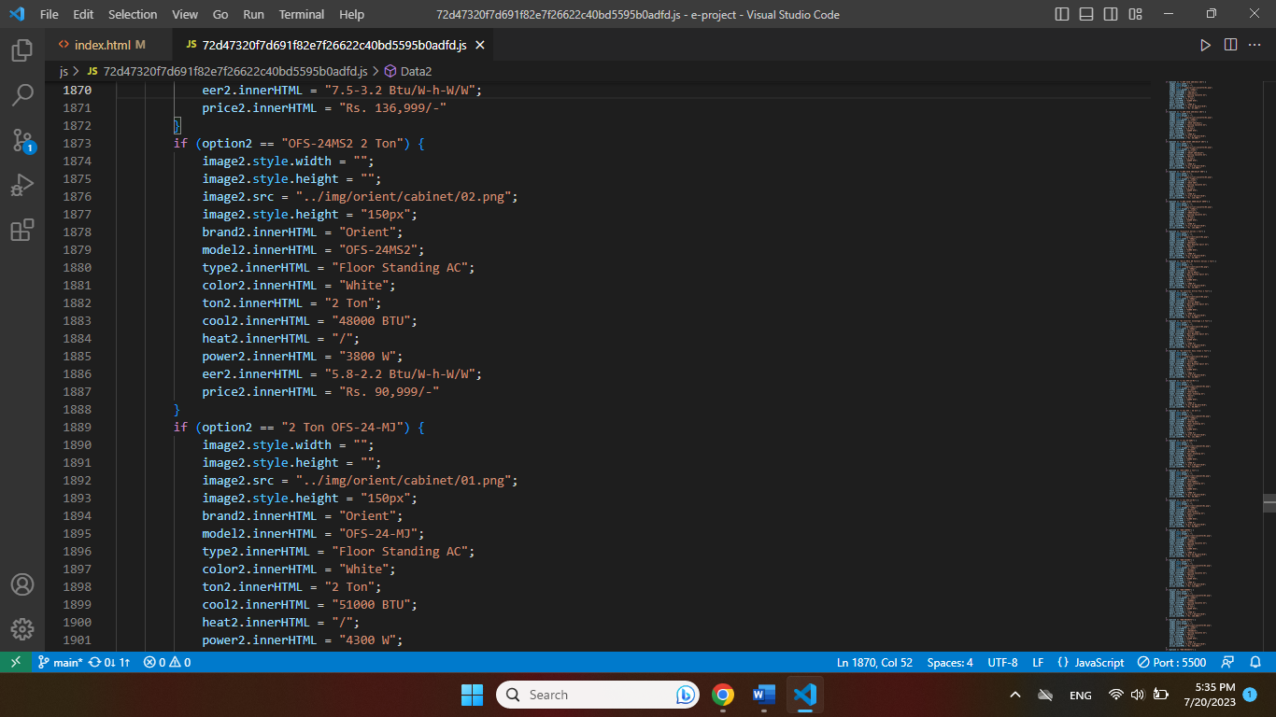 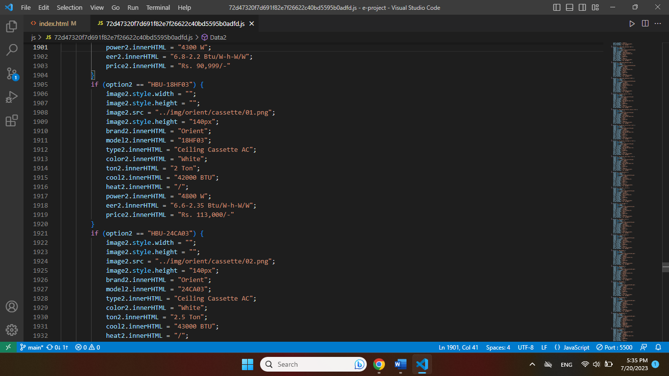 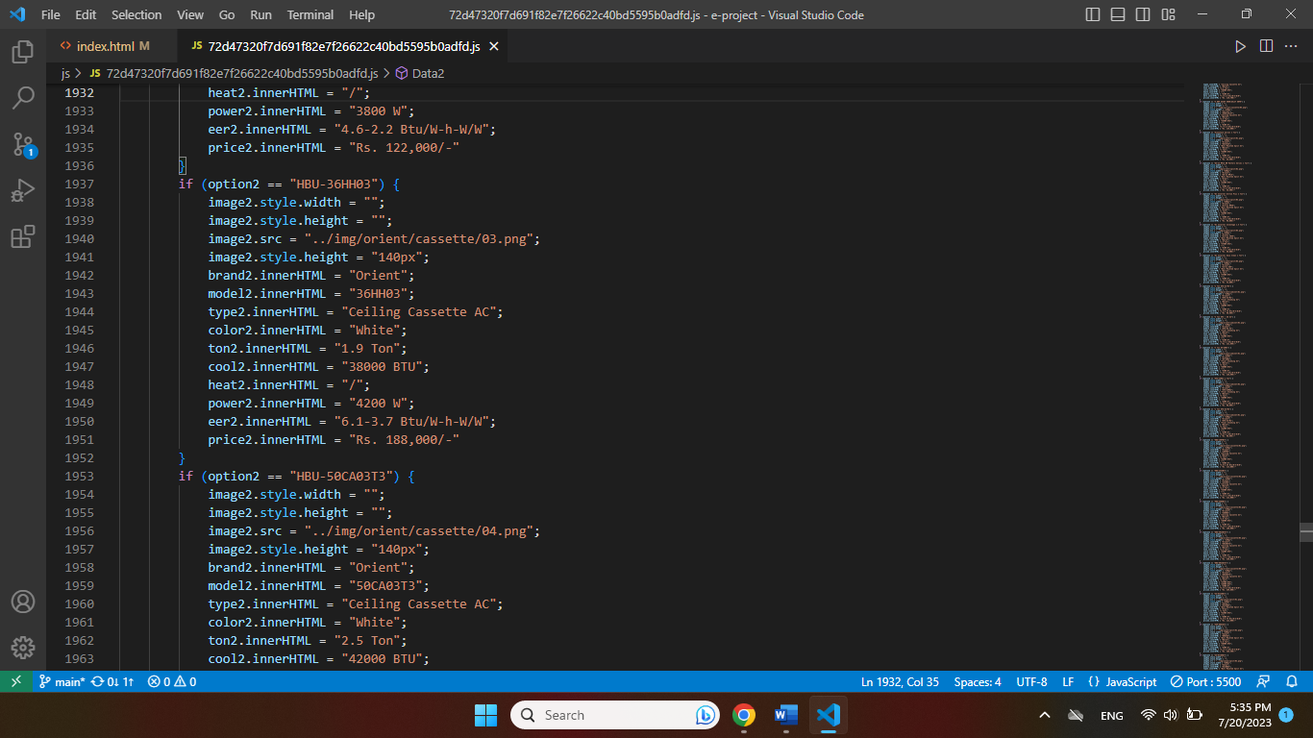 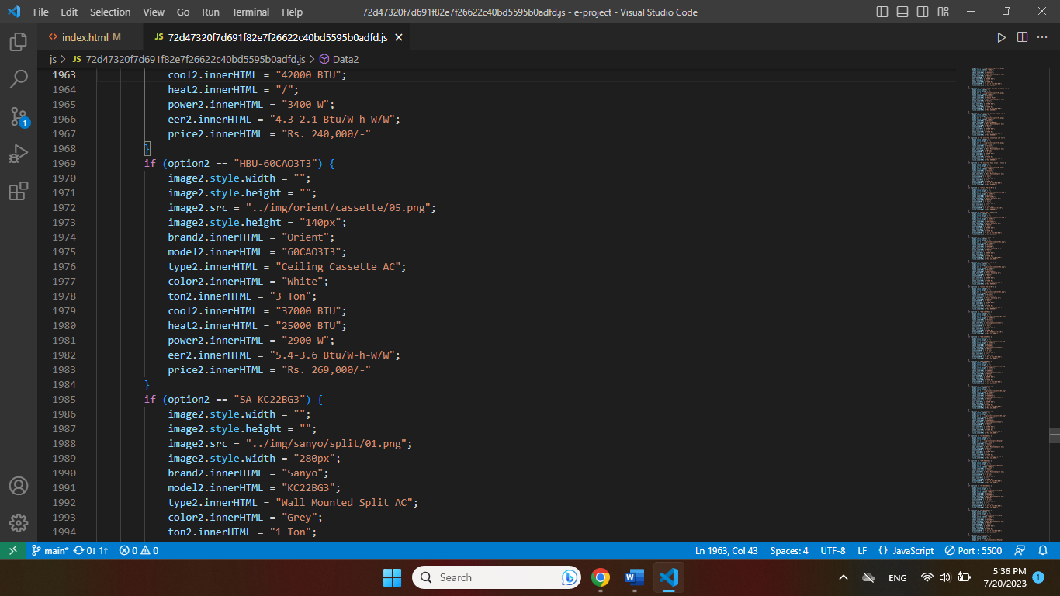 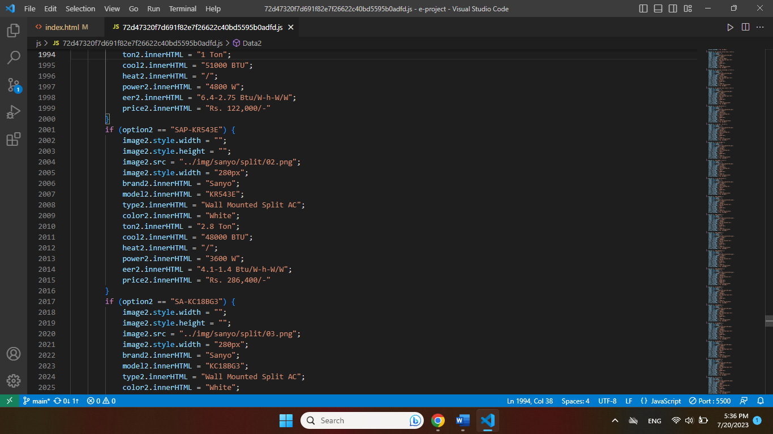 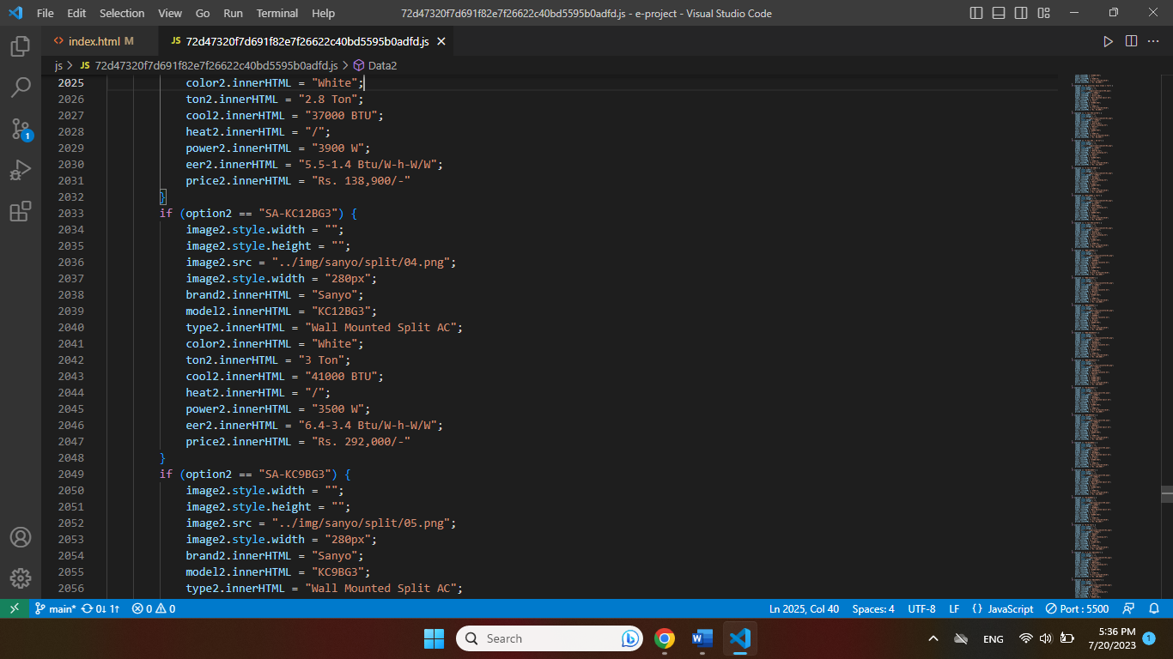 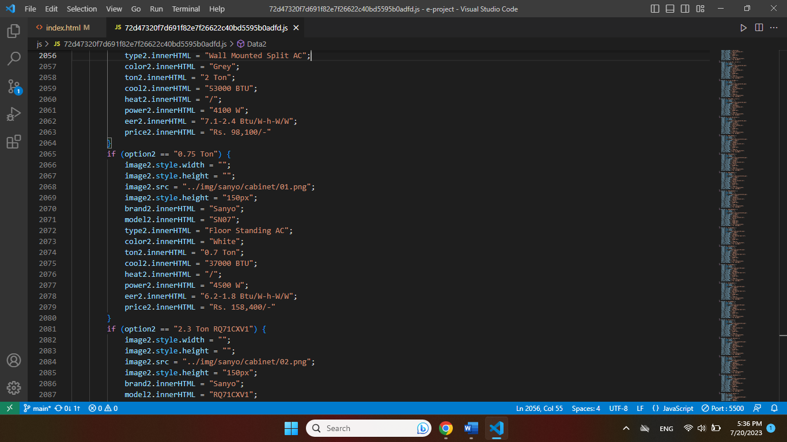 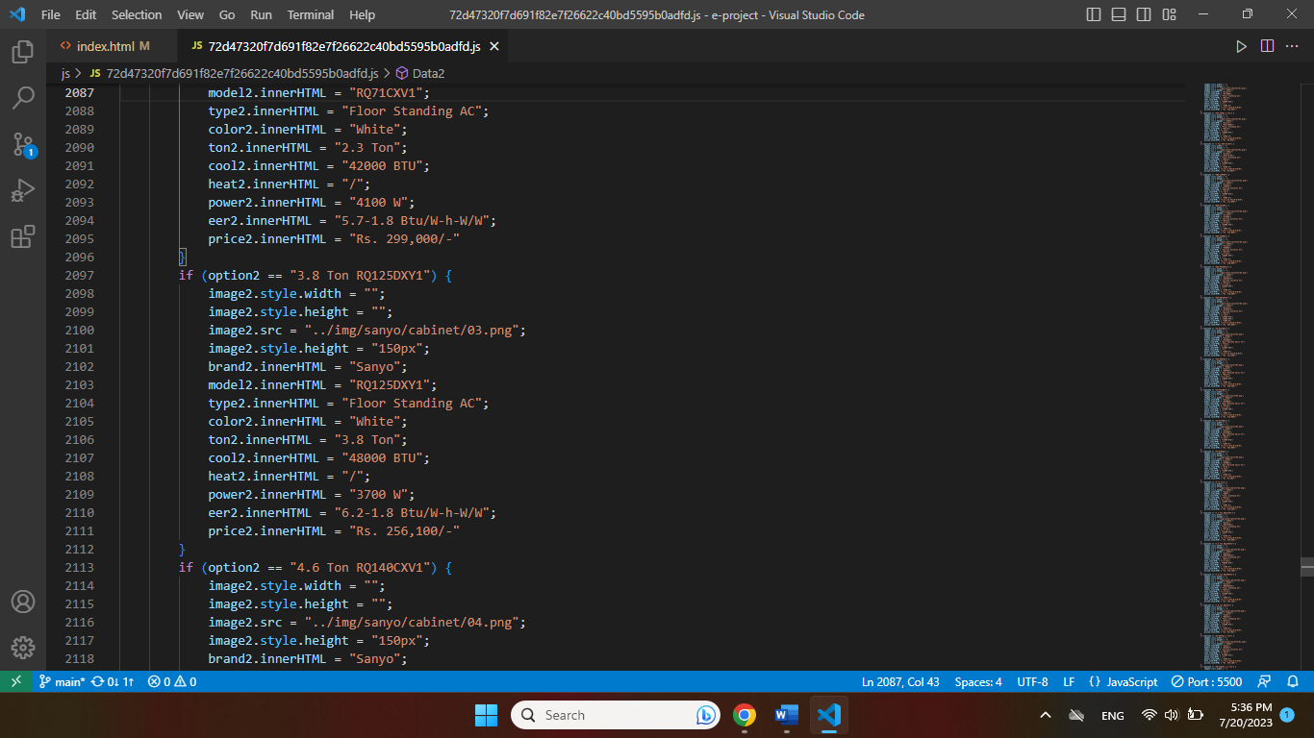 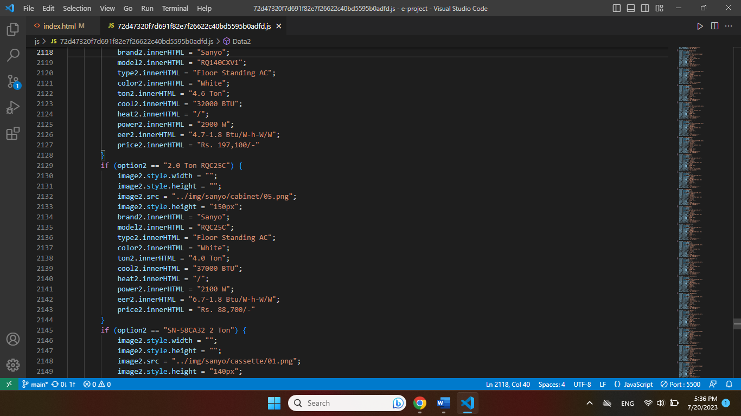 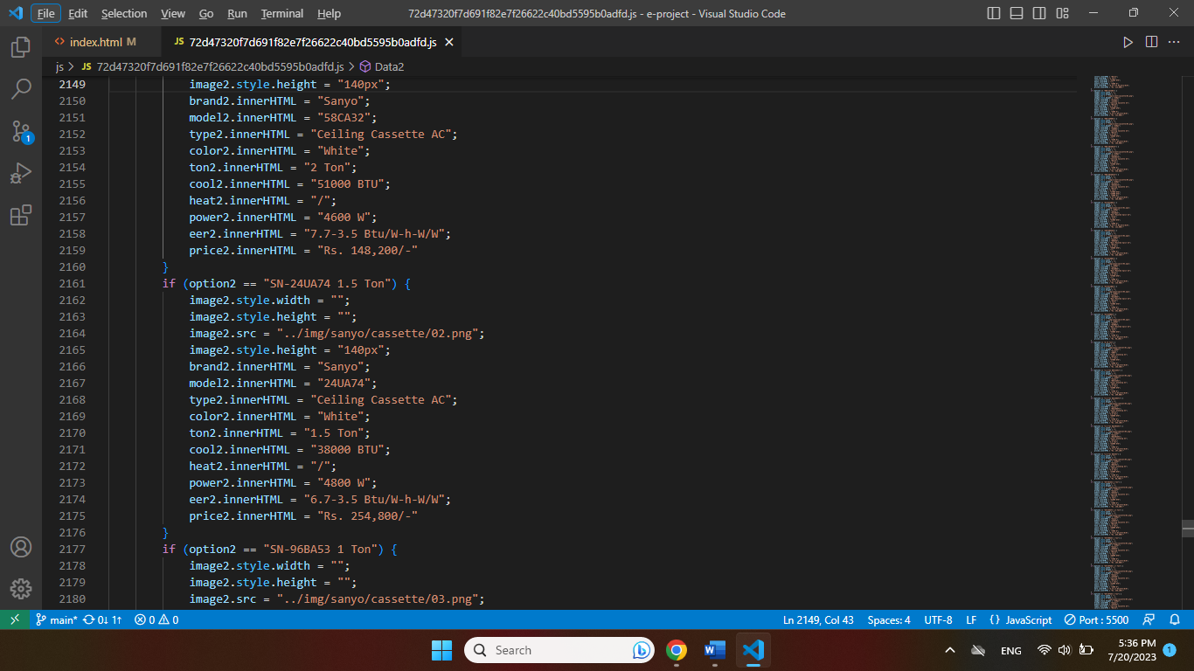 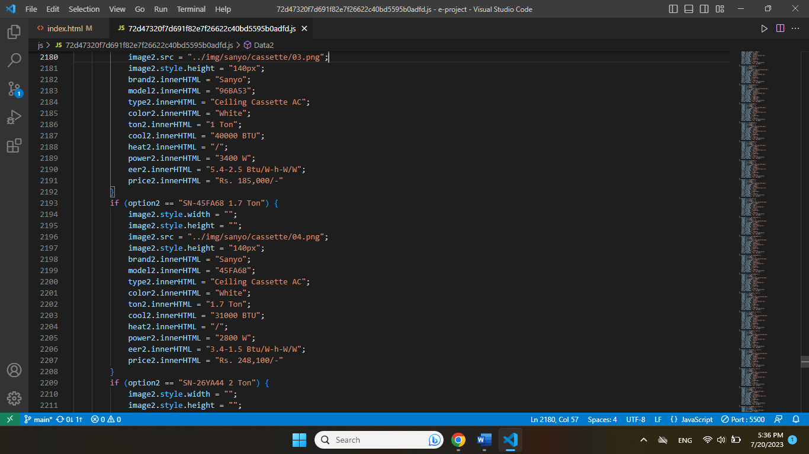 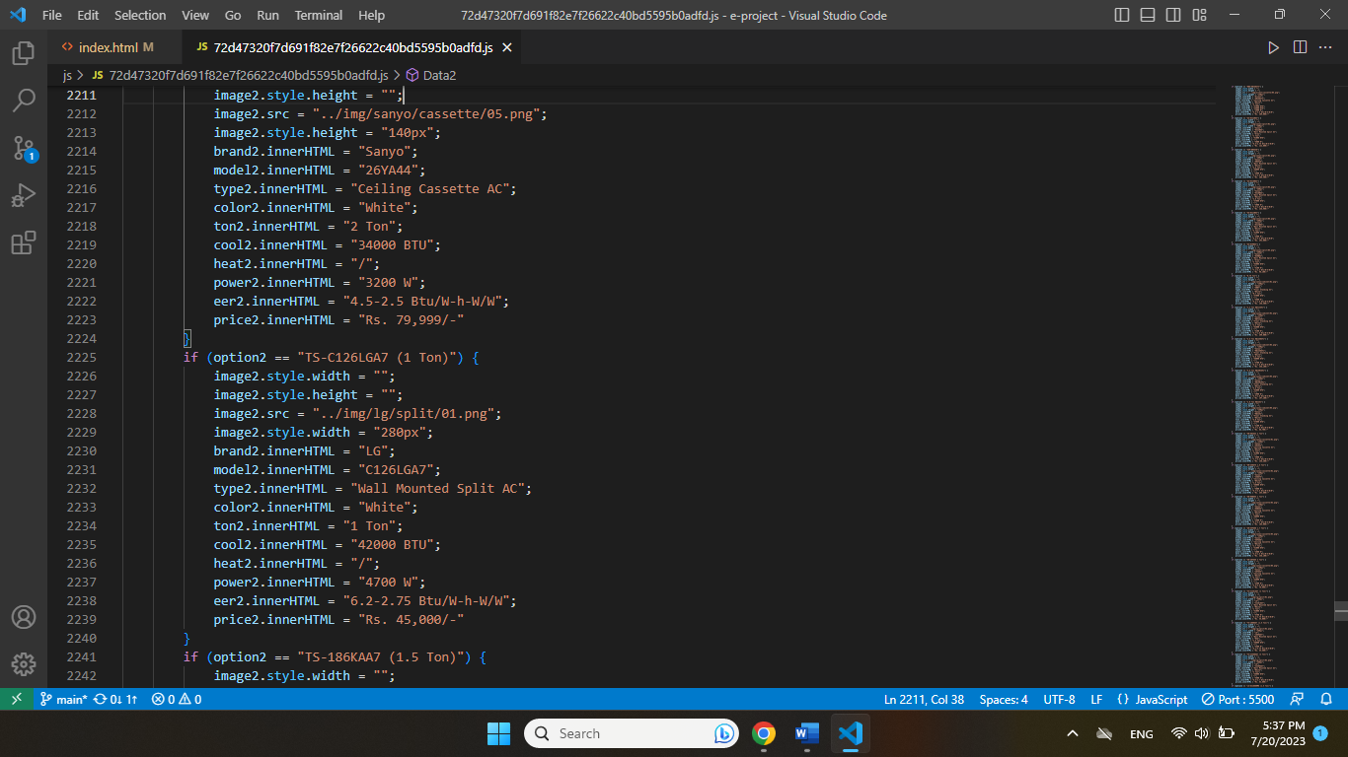 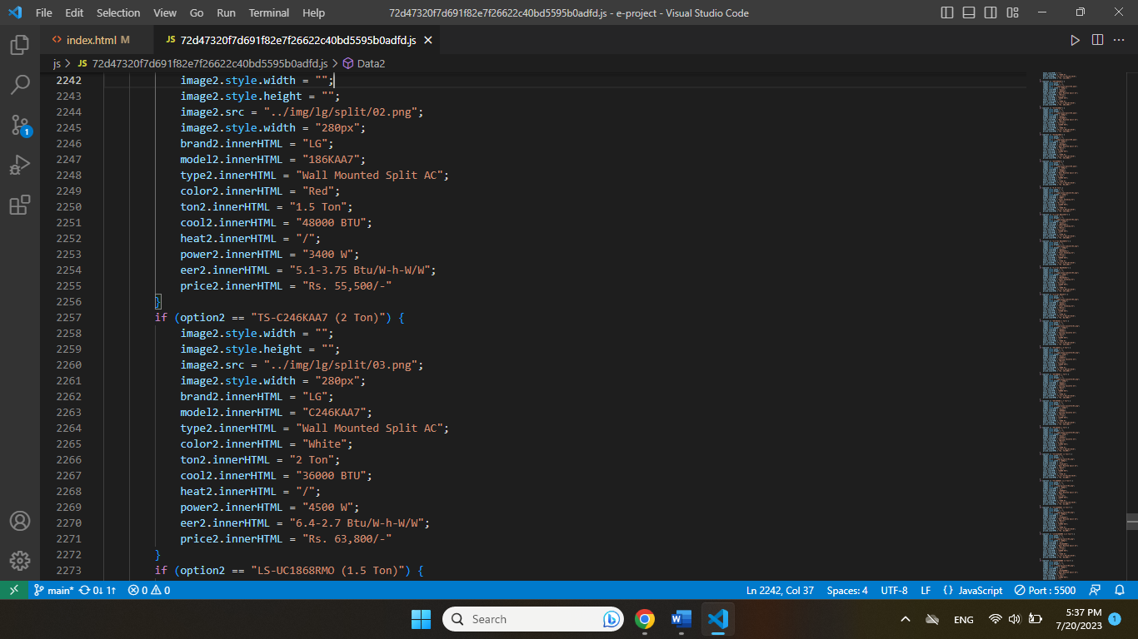 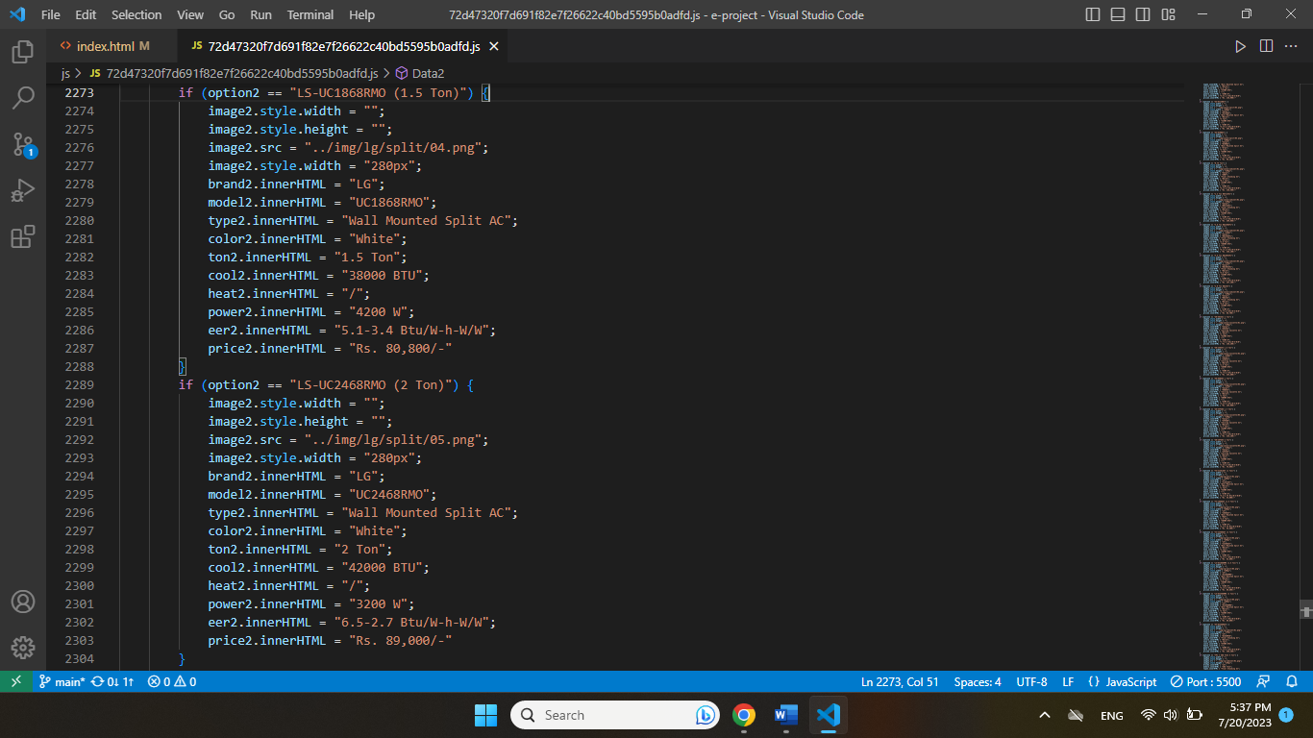 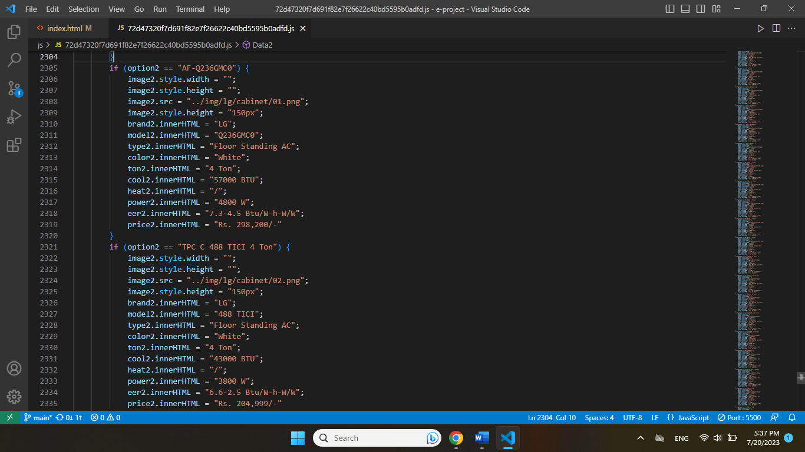 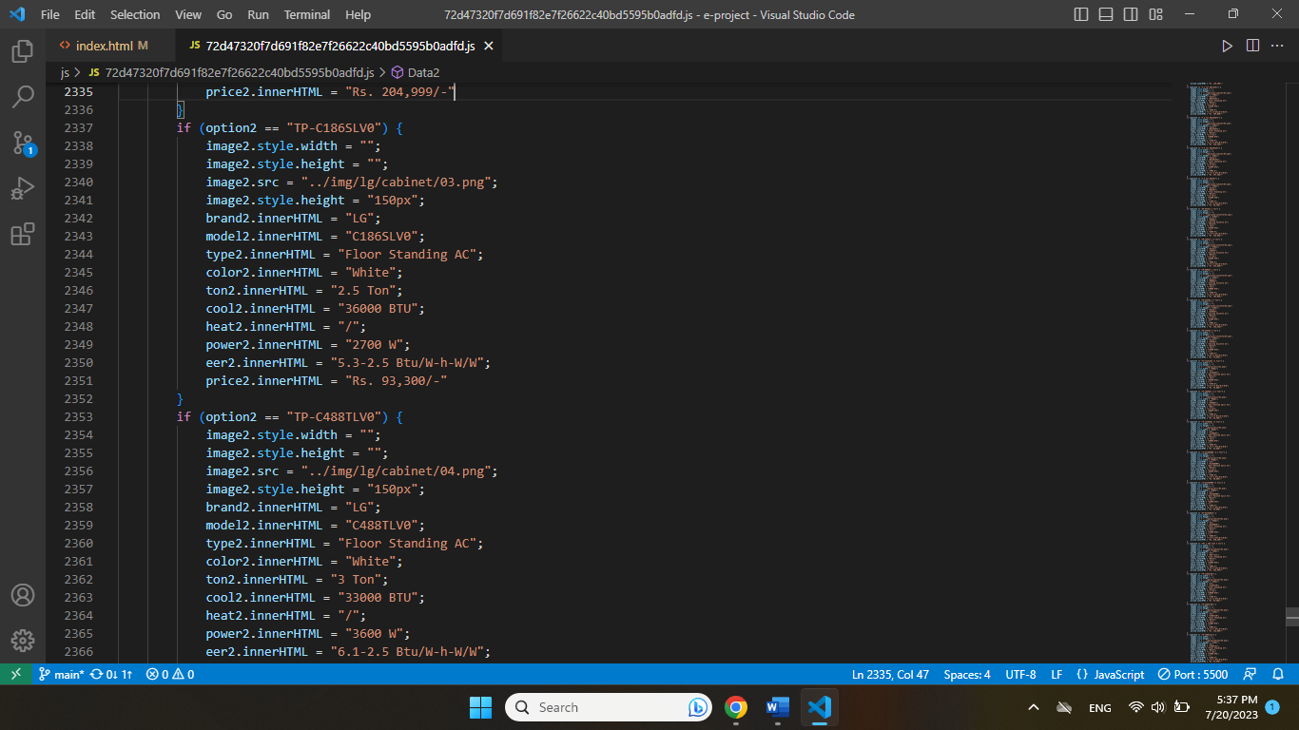 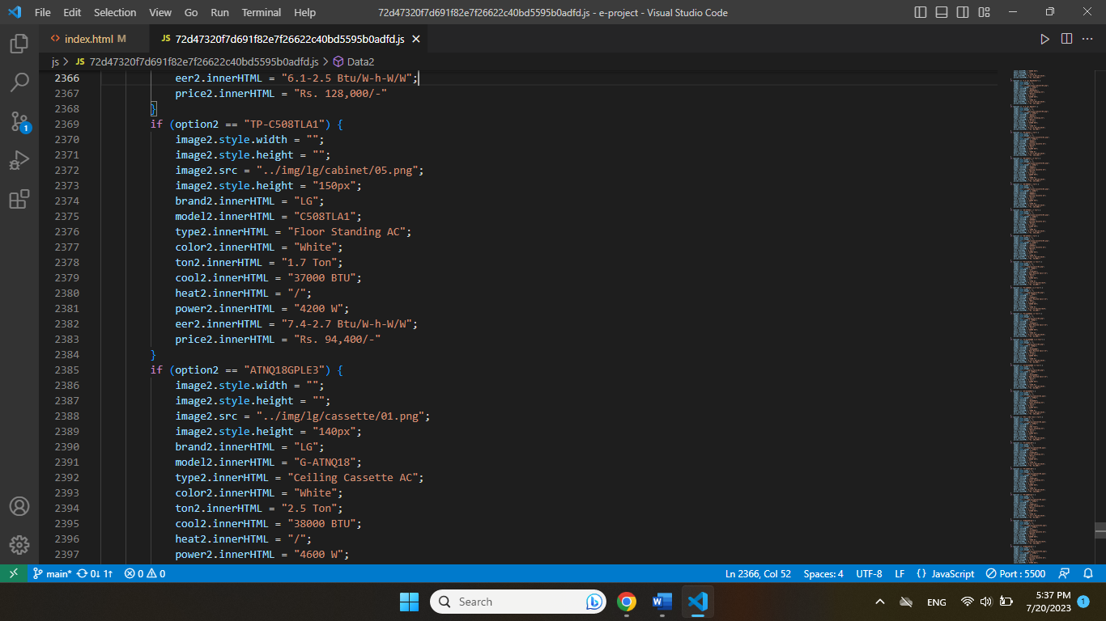 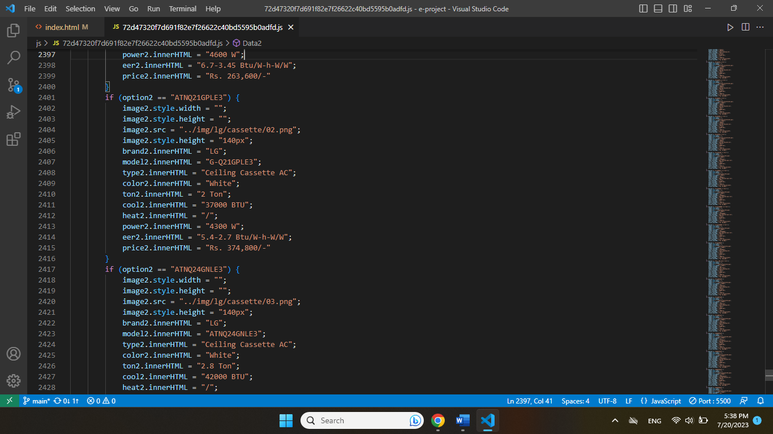 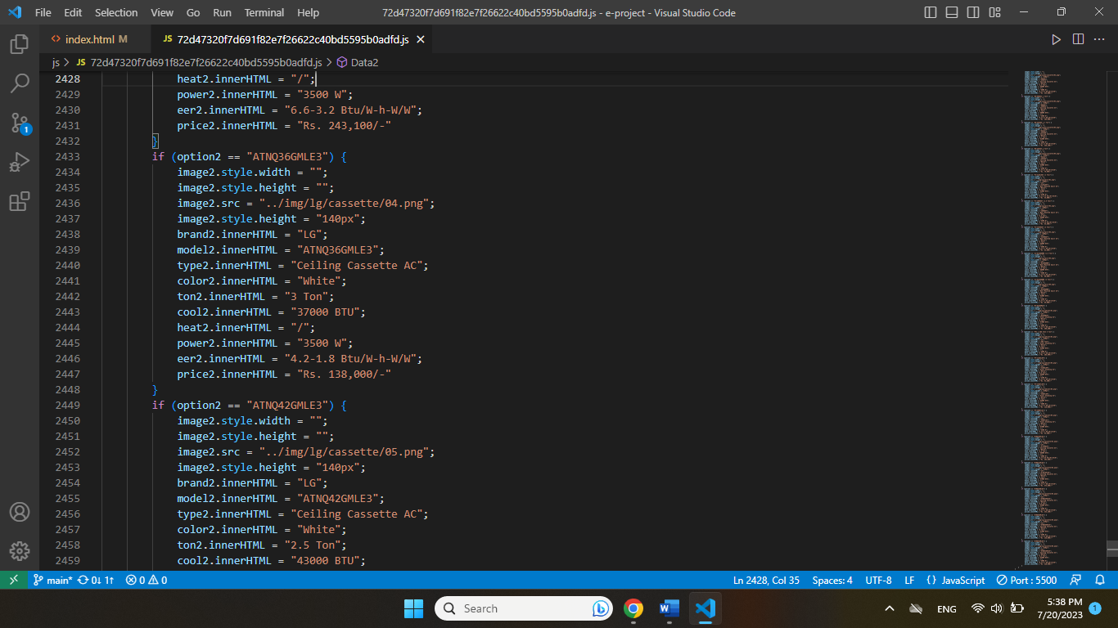 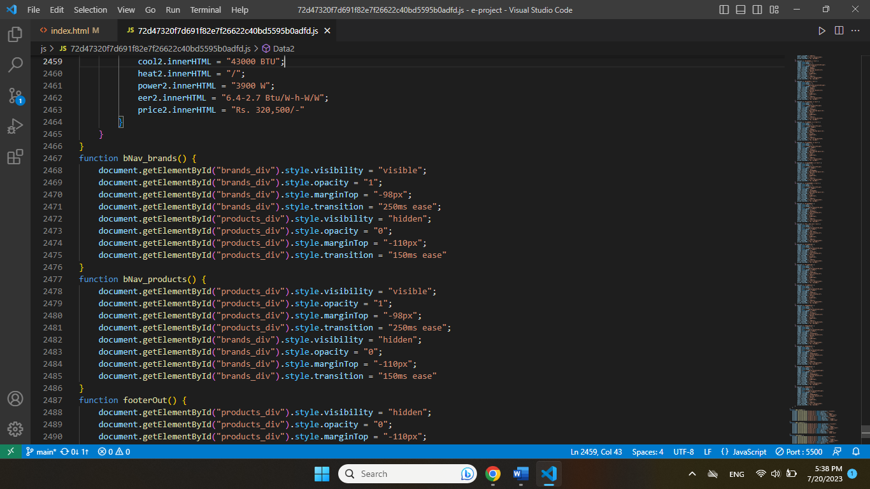 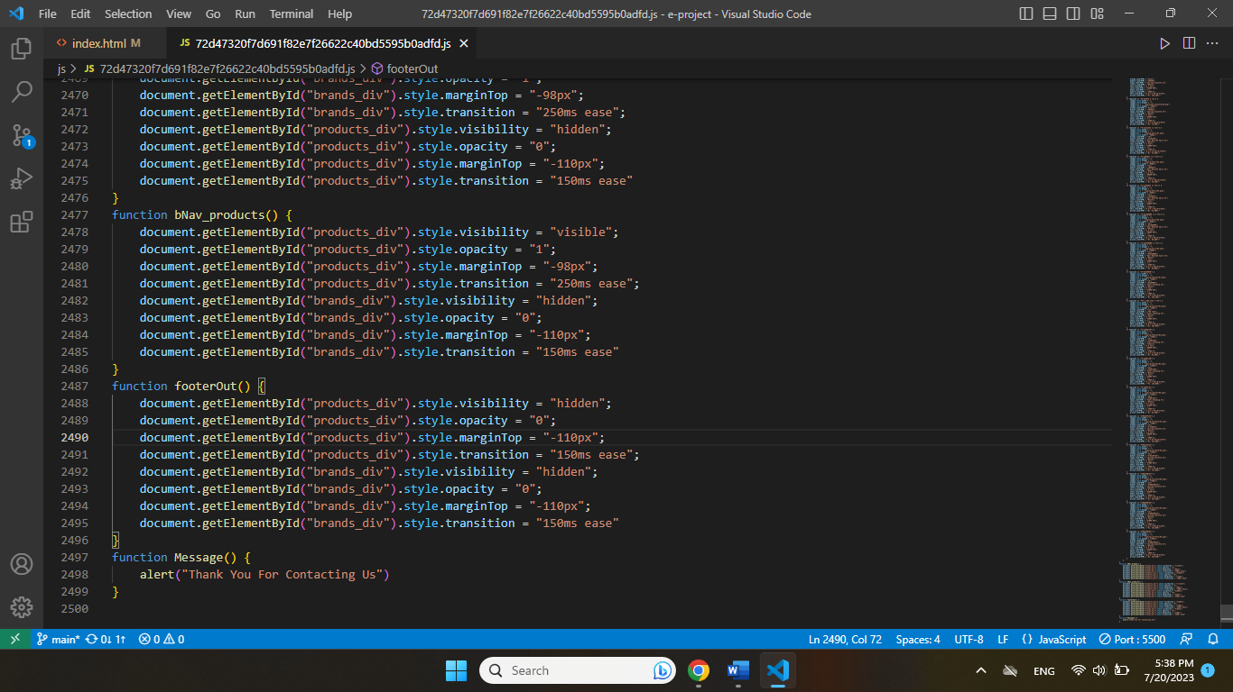

1. **Create Modal Javascript**
2. Description

This script is used to display product details in a modal format. Inside there are more products of the same type

1. Screenshot

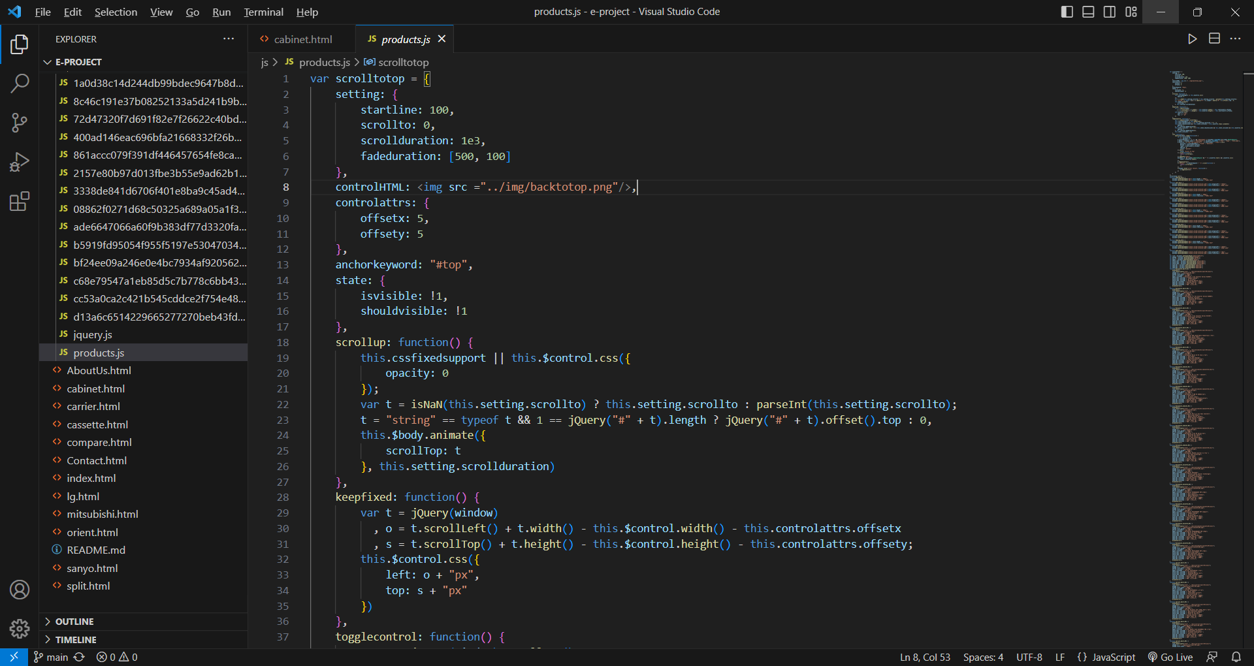

1. **Show number of products with Javascript**
2. Description

This script is used to display the number of products by type, brand and feature

1. Screenshot

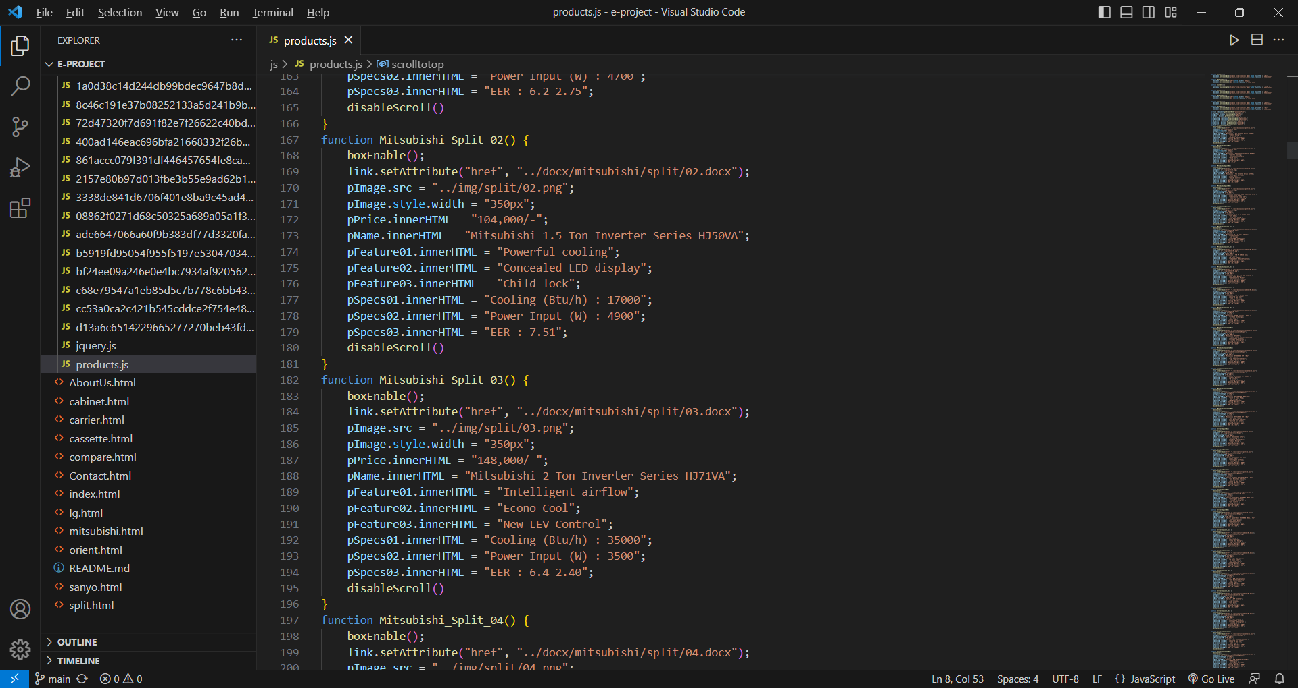

# TASK SHEET REVIEW 3

|  |  |  |  |  |  |  |  |
| --- | --- | --- | --- | --- | --- | --- | --- |
| **Project Ref. No.:**  **eP/Advertisement Portal Management**  **System/01** | | **Project Title:** | **Activity Plan Prepared By:** | **Date of Preparation of Activity Plan:** | | | |
| **Sr.**  **No.** | **Task** | **Actual**  **Start**  **Date** | **Actual Days** | **Team**  **Mate Names** | **Status** |
| 1 | Home Page | COSY AIRCONDITIONERS | Anh Khoa | 26-June-23 | 3 | Anh Khoa | Completed |
| 2 | Products | 29-June-23 | 2 | Anh Khoa | Completed |
| 3 | Brands | 5-July-23 | 2 | Anh Ngoc | Completed |
| 4 | About Us | 27-June-23 | 1 | Anh Ngoc | Completed |
| 5 | Contact Us | 27-June-23 | 1 | Anh Ngoc | Completed |
| 6 | Compare | 7-July-23 | 3 | Anh Khoa | Completed |
| 8 | Java Script | 10-July-23 | 3 | Khoa & Ngoc | Completed |
| 9 | Responsive | 15-July-23 | 3 | Khoa & Ngoc | Completed |

|  |  |
| --- | --- |
| **Date:** | |
| Signature of Instructor:  **Ms. Le Mong Thuy** | Signature of Team Leader:  **Nguyen Anh Khoa** |